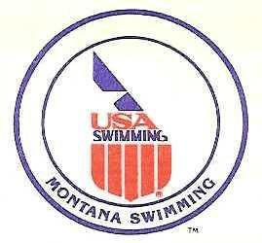

2021 MT Swimming MAC/MYST/GAC/LAKE Quad Meet
May 21-22
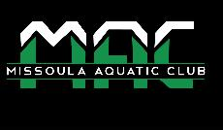

Timed Finals Meet

USA Swimming and Montana Swimming Sanction 2140

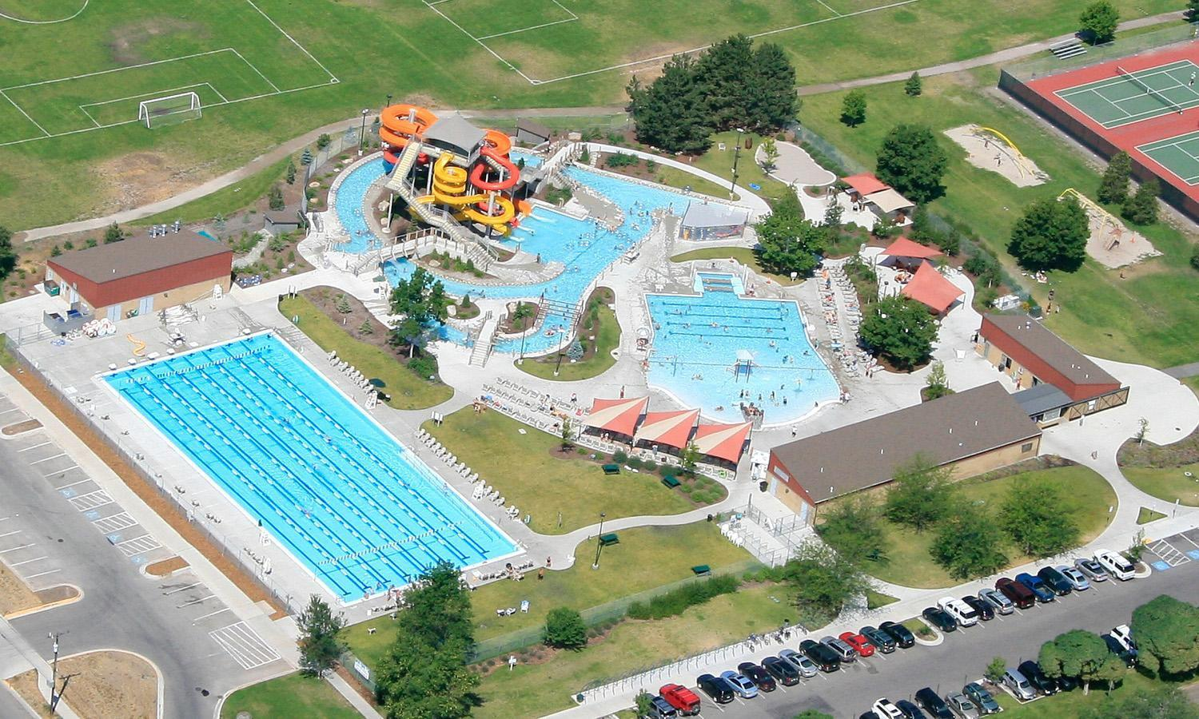

CONTACT: | ​Meet Director | ​Meet Registrar |  |  | Meet Referee
 | Jed Dennison | Jay Friend |  |  | Steve Qunell
 | 406-531-1216 | 760-333-7382 |  |  | 808-298-2575
 | jed@zillastate.com jayjfriend@gmail.com |  |  |  | stevequnell@gmail.com
 |  |  | P.O. Box 7434
 |  | Missoula, MT 59807-7434

FACILITY:​ The Lake at Splash Montana located at 3001 Bancroft, is an 8-lane, 50-meter regulation outdoor long course pool equipped with non-turbulent lane lines. The pool is a state of the art 50-meter pool by Astral Pools. Spectrum Xcellerator starting blocks give swimmers the latest advantage in racing starts. Also, Spectrum backstroke wedges are available for backstroke events. Starts and timing are controlled by a Colorado System 6 console and touchpads. The pool is 6 feet deep at the west end and 4 feet deep east end. We have access to the 25 yard, 3 lanes area for warm-up and cool down before the park opens at 11:00 am. There also is a partial lane next to lane 8 for warm-up and cool down during preliminary heats. The competition course has not been certified in accordance with 104.2.2C(4).

Directions: From I-90, take Exit 104, Orange Street. Turn south onto Orange Street, drive approximately 1.4 miles, turn left on Beckwith (at the light), drive .2 miles and turn right on Brooks (at the light), drive .4 miles then turn left on Bancroft. Bancroft Street will be the 1​^{st} left-hand turn after the light at Mount and Brooks. When you are on Bancroft you will go through a four-way stop and pass Sentinel High School on your right. The pool will be on the right-hand side after the high school fields. OVERNIGHT PARKING OR CAMPING IS NOT PERMITTED IN THIS PARK but is permitted on the street next to the park.

MEET FORMAT: This is an Age Group meet with timed finals events. Events will swim as listed on the schedule of events. Swimmers will be seeded based on their submitted times. “No time” entries will be accepted in all events. Deck seeding may be provided ​at the discretion of the referee​ if there are open lanes.

SAFETY
REGULATIONS An inherent risk of exposure to COVID-19 exists in any public place where people are present. COVID-19 is an extremely contagious disease that can lead to severe illness and death. According to the CDC and Prevention, senior citizens and individuals with underlying medical conditions are especially vulnerable.

USA Swimming Inc., cannot prevent you (or your child(ren)) from becoming exposed to, contracting, or spreading COVID-19 while participating in the USA Swimming sanctioned events. It is not possible to prevent against the presence of the disease. Therefore, if you choose to participate in a USA Swimming sanctioned event, you may be exposing yourself to and/or increasing your risk of contracting or spreading COVID-19.

By attending or participating in this competition, you voluntarily assume all risks associated with exposure to COVID-19 and forever release and hold harmless USA Swimming, MAC, Splash Montana, and the Montana Swimming LSC and each of their officers, directors, agents, employees or other representatives from any liability or claims including for personal injuries, death, disease, or property losses or any other loss, including but not limited to claims of negligence and give up any claims you may have to seek damages, whether known or unknown, foreseen or unforeseen, in connection therewith.

Missoula Aquatic Club agrees to comply and to enforce all health and safety mandates and guidelines of USA Swimming, Montana Swimming, the State of Montana, and Missoula County. Masks are mandatory while in facility.

The Montana Swimming safety guidelines are in effect for this meet and will be enforced. For circle swimming during warm-ups and cool downs, swimmers must enter the pool using a three point entry. Time to practice starts will be included in the warm-up schedule. Coaches must closely supervise their swimmers at all times. NO running or horseplay will be tolerated. A safety marshall will be on deck.

Missoula Aquatic Club and Splash Montana has taken enhanced health and safety measures for the meet management, swimmers, and coaches attending this meet. Those in attendance must follow all posted instructions while visiting Splash Montana. An inherent risk of exposure to COVID-19 exists in any public place where people are present. COVID-19 is an extremely contagious disease that can lead to severe illness and death. According to the Center for Disease Control and Prevention, senior citizens and guests with underlying health conditions are especially vulnerable. By attending this meet at Splash Montana, you voluntarily assume all risks related to exposure to COVID-19.

RACING STARTS: ​Any swimmer entered in the meet, unaccompanied by a USA Swimming member coach, must be certified by a USA Swimming member coach as being proficient in performing a racing start or must start each race from within the water. It is the responsibility of the swimmer or the swimmer’s legal guardian to ensure compliance with this requirement.

RULES: ​This meet will be conducted in accordance with current USA Swimming and Montana Swimming Rules and regulations, except where rules therein are optional and exceptions are stated. The USA Swimming Code of Conduct and athlete protection provisions will be enforced.

All persons acting in any coaching capacity on deck must be currently registered coach members of USA Swimming. Swimmer, official and coach registration will be confirmed with Montana Swimming registration chairperson prior to the start of the meet.

Use of audio or visual recording devices, including cell phones is not permitted in changing areas, restrooms, locker rooms or behind starting blocks. Operation of a drone or any other flying apparatus is prohibited over the venue (pools, athlete/coach areas, spectator areas and open ceiling locker rooms anytime athletes, coaches, officials and/or spectators are present.

Except where venue facilities require otherwise, changing into or out of swimsuits other than in locker rooms or other designated areas is not appropriate and is prohibited.

No glass containers tobacco or alcoholic beverages are allowed in the swimming venue.

This meet maybe covered by the media, including photographs, video, webcasting and other forms of obtaining images of athletes participating in the meet. Entry into the meet is acknowledgment and consent of his fact.

ELIGIBILITY: This meet is open to all swimmers currently registered with USA Swimming. There will be no on deck registration.

SWIMMERS WITH
​Missoula Aquatic Club welcomes all swimmers with disabilities as described in USA Swimming Rules and Regulations, Article 106, to compete at the meet. Disabled Swimmers or their coaches are required to provide advanced notice in writing to the meet referee and meet director to arrange for any needed accommodations including personal assistants required and/or registered service animals by the meet entry date. It is at the discretion of the meet referee to determine whether the needed accommodations can be met by the meet resources. Failure to provide advance notice may limit Missoula Aquatic Club’s ability to accommodate all requests. Entries for swimmers with disabilities should be coordinated with Meet Director Jed Dennison.
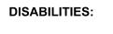

​Swimmers with disabilities will be scored and awarded as listed in the meet information.

ENTRIES: ​ Entries should be submitted as follows:

- All Teams should email entries and all reports to ​jayjfriend@gmail.com using either Hy-Tek or Team Unify software by Friday, May 14, 2021. Hy-Tek Lite entry software may be downloaded for free from the Hy-Tek website to enter swimmers. In addition to the meet entry file, please include your team entry fee report from Team Manager or Team Unify, in PDF, word or rich text format. Please do not include relay swimmer names with relay entries. Hard copies of Team Manager or Team Unify reports, signed and completed Accounting and Waiver Sheet and entry fee payment must be received by Saturday, May 22, 2021, to the address specified below.

- Individuals without access to Hy-Tek or Team Unify software may submit entries on the enclosed master entry sheet. Please submit entries via email to ​jayjfriend@gmail.com by Friday, May 14, 2021. Payment for these entries can be mailed to address specified below and must be received by Saturday, May 22, 2021. Entry information must be completely filled out as follows: First and Last name of the swimmer, swimmer date of birth, actual age of swimmer, gender of swimmer, USAS/FINA registration number for each swimmer, event number and description and entry time.

- All relay-only swimmers must be listed and pay the per swimmer surcharge.

Payment may be made via check made payable to Missoula Aquatic Club and mailed to the address below.

Missoula Aquatic Club

P.O. Box 7434

Missoula, MT 59807-7434

Late entries, ​if accepted​, must be approved by the Meet Referee and will be charged double entry fees.

NO TEXT MESSAGES AS ANY FORM OF CORRESPONDENCE FOR MEET ENTRIES, SCRATCHES OR CHANGES WILL BE ACCEPTED.

ENTRY LIMITS: ​This meet is an open invitational. Swimmers may enter one (1) event on Friday and five (5) events on Saturday for a total of six (6) individual events. Swimmers may enter one (1) relay.

DEADLINE: All email or hardcopy entries must be received by Friday, May 14, 2021. Completed paperwork, including the team entry fee report, fee calculation sheet, the USAS/Canadian registration confirmation, and the accompanying fees for all swimmers must be received by Saturday, May 22, 2021, in order to be assured of entry into the meet. Registration is on a first-come-first-served basis. We reserve the right to close registration prior to the stated deadline if the maximum number of participants is reached.

ENTRY FEES: | Fee per swimmer: | $ | 25.00 | Entry fees must accompany your entry
 | form.
 | Individual Events: | $ | 3.00 | Make checks payable to MAC.
 | Relay(s) | $ | 12.00 | One check per team please!

There will be no refunds.

SEEDING: ​Swimmers should enter their fastest officially recorded time meters (SCY and SCM times will be accepted. No time (NT) entries will be accepted. Times will be seeded in LCM first, then SCY, then SCM. Swimmers will be seeded slowest to fastest in all events except as noted. The 1500 Free, 400 IM, and the 400 Free will be swum fastest to slowest, mixed girls and boys, in the same heats.

CHECK -IN ​All events will pre-seeded.

SCRATCHES: ​There will be no clerk of course. Heat and lane assignments will appear in the program. Swimmers are responsible for taking their position behind the blocks.

Coaches should report scratches on the scratch sheet or to the meet referee prior to the start of the meet both days. There will be no penalty for swimmers who fail to scratch from an event.

SCORING: ​Scoring will be by age groups of 8 & Under, 9-10, 11-12, and 13&over.
Individual: 20-17-16-15-14-13-12-11-9-7-6-5-4-3-2-1 Scoring for relays will be by event.

Relays: 40-34-32-30-28-26-24-22-18-14-12-10-8-6-4-2
AWARDS: There will be no awards given.

RESULTS: Results will be posted to boards at the southeast entrance to the pool throughout the meet. Results will be posted to the Montana Swimming web site at http://www.mtswimming.com​and ​http://www.macmsla.org​.

HOTEL INFO: ​A list of Missoula area hotels is attached at the back of this contract.

WARM-UPS: ​In accordance with USA Swimming guidelines, there will be a published warm-up procedure for all swimmers and coaches attending the meet. The Marshal will ensure all teams, coaches, and swimmers follow all warm-up procedures. Meet Management reserves the right to change warm-up times according to the number of entries​.

We reserve the right to have warm-ups start on Friday as early as 4:00 pm and on, Saturday as early as 7:00 am based on the number of entries. Warm-up times listed on the event sheet are target times only.

A warm-up schedule will be posted on the Missoula Aquatic Club web page (​www.macmsla.org​) and the Montana Swimming web page the week of the swim meet. Following is a tentative listing for warm-up times.

We reserve the right to change these times and the warm-up schedule.

Friday, May 21st | 5:00 pm | Pool opens for warm-up
 | 5:30 pm | Start of the meet with the 1500 free
Saturday May 22nd | 7:00 am | MAC Warm-Up
 | 7:40 am | MYST Warm-Up
 | 8:20 am | GAC/LAKE Warm-Up/Officials Meeting
 | 9:00 am | Coaches Meeting
9:10 am Meet Start

OFFICIALS/TIMERS: ​We would appreciate the help of Certified Officials from other clubs. Training for new officials will be available during the meet. To the greatest extent possible, teams will be expected to provide timers. Timer sign-up sheets will be available at the meet at the announcer’s table.

- All officials shall wear a white short-sleeve polo shirt for all sessions. Men may wear either navy-blue slacks or navy-blue shorts for prelims and navy-blue slacks for finals. Women may wear a navy-blue skirt/skort, shorts, capris, or slacks for prelims and a navy-blue skirt/skort or slacks for finals. White shoes and socks shall be worn.

- Officials requesting assigned positions (deck referee, starter or chief judge) must work all sessions.

- Officials are required to show current USA Swimming non-athlete registration and official certification.
.

COACHES: All coaches on deck must be registered and certified with USA Swimming. Coach registration will be verified with the Montana Swimming Registration Chair.

PROTESTS: ​All protests will be given to the meet referee.

HOSPITALITY: There will be a hospitality area open to all coaches and officials.

CONCESSIONS: ​Missoula Aquatic Club will have on sale a selection of nutritious snacks, meals, and drinks.

SWIM SHOP: There will be a swim shop at the meet. Missoula Aquatic club and/or a vendor of their designation will provide apparel and aquatic supplies. A Jolyn representative will be holding a trunk show/sale at the swim shop.

SPECTATORS: Spectator seating will be available on the south side of the pool. Spectators will only be allowed on deck during the event their swimmer is in. Spectators will be marshalled on and off the deck between each event.

LIGHTNING POLICY: ​City of Missoula and Montana Swimming follows guidelines set forth by the facility standard or the American Red Cross. The governing rule will be whichever guideline is the most stringent.

List of Events

Friday, May 21
Warm-up 5:00 pm
Meet Start 5:30 pm

Girls | Event |  | Boys
1 | 11+ 1500 Free |  | 1
Saturday, May 22
Warm-up 7:00 am
Meet Start 9:10 am

Girls | Event | Boys
2 | 11+ 400 Free | 3
4 | 10&U 50 Fly | 5
6 | Open 100 Fly | 7
8 | 11+ 200 Fly | 9
10 | Open 200 Free | 11
12 | 10&U 50 Back | 13
14 | Open 100 Back | 15
16 | 11+200 Back | 17
18 | Open 50 Free | 19
20 | Open 200 IM | 21
22 | 10&U 50 Breaststroke | 23
24 | Open 100 Breaststroke | 25
26 | 11+ 200 Breaststroke | 27
28 | Open 100 Free | 29
30 | 11+ 400 IM | 31
32 | Open 200 Medley Relay | 33

MISSOULA AQUATIC CLUB ​2021 QUAD MEET!
ACCOUNTING AND WAIVER SHEET

MAC, P.O. Box 7434, Missoula, MT 59807-7434

Please enclose this accounting sheet with your entries.

TEAM____________________________________________________

_________________Total # swimmers at $25.00=__________________

_________________Total # entries at $3.00 =_____________________

_________________Total # relays at $12.00 =______________________

TOTAL ENCLOSED (in U.S. dollars only) =__________________

Please furnish name, address, e-mail address, and telephone number of Team Representative who may be contacted regarding these entries:

MONTANA SWIMMING - USA SWIMMING / CANADIAN REGISTRATION CONFIRMATION

By submitting our team’s entry sheets and fees for your upcoming meet and verify that the below-named coaches will be in attendance. These coaches are current in all the requirements set forth by USA Swimming or the Canadian equivalent including Red Cross Safety Training for Swim Coaches or Lifeguard Training, First Aid, and Cardiopulmonary Resuscitation.

Coach’s Name: ___________________________________________

Coach’s Name: ___________________________________________

Coach’s Name: ___________________________________________

Clubs sending swimmers without a coach should notify the referee upon arrival. They will be assigned to warm-up under the supervision of a coach in attendance at the meet. We further verify that all our entered swimmers are registered athlete members of USA Swimming or the Canadian equivalent for the current year.

WAIVER
In consideration of the acceptance of this entry, I/we, the undersigned parent, guardian, or coach hereby, for ourselves, our heirs, administrators, assigns, release and forever discharge any and all rights and claims for damages I/we may have against the Missoula Aquatic Club, MAC ​Firecracker Classic ​Swim Meet, The Lake at Splash Montana, Missoula Parks and Recreation Department, MT Swimming, USA Swimming, their agents, representatives, successors or assigns for any or all injuries arising out of travel to and from, or participating in said meet. It is agreed that the team shall be responsible for any damages caused to facilities or equipment by any members of the team.

Signature of Club Official, Parent, Guardian, or Coach |  | Club Position or Title
Address |  | ___________________
_______________________________________
E-mail address |  | Date

It is most important that the above information is completed and this form returned with your entries.

Meet Name: 2021 MT Swimming MAC/MYST/GAC/LAKE Quad Meet

Meet Date(s): Friday, Saturday May 21-22, 2021

Location: The Lake at Splash Montana, Missoula, MT

Host Club: Missoula Aquatic Club

Missoula Area Hotels

LaQuinta Inn Missoula

5059 N Reserve St

406-549-9000

Broadway Inn Conference Center

1609 W. Broadway St

406-532-3300

GuestHouse Suites

3803 Brooks St

406-251-2665

Quality Inn and Suites

4545 N. Reserve St

406-542-0888

Howard Johnson

3530 Brooks Street

406-251-2250

Towne Place Suites

3055 Stockyard Rd

406-721-6000

Hampton Inn Missoula

4805 N. Reserve St

406-549-1800

Super 8 Missoula/Brooks Street
3901 S. Brooks St

406-536-0519

