Instructions for Creating a Login for Your Account in SWIMS 3.0
(These instructions are just for creating a login to your current account with USA Swimming. This process will not renew your registration for 2023. You will use a link sent from your club to renew your registration.)
Click https://hub.usaswimming.org/landing to create a new login for your USA Swimming account. This will provide access to information available in your current Deck Pass account.
- On the page that opens you’ll need to select Create a Login.
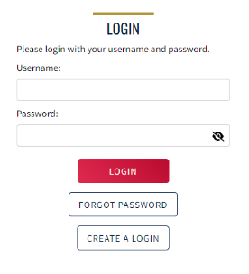
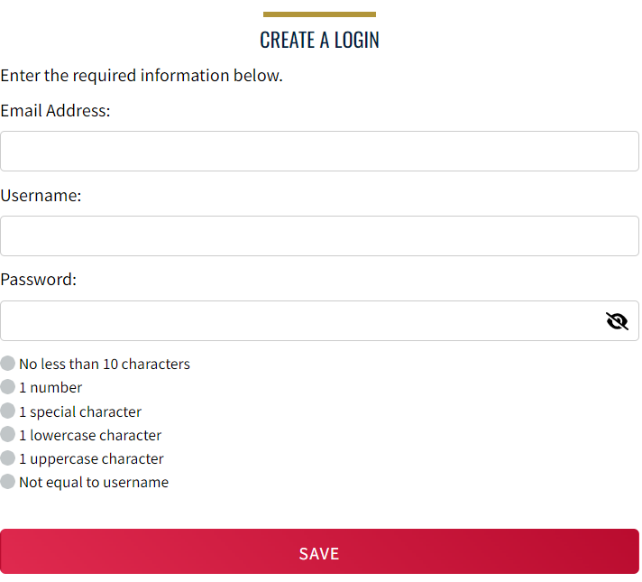
Please make sure to use a personal email address instead of a shared account since this will be linked to your individual membership or account. Shared or group email addresses such as office@abcde.com should not be used.

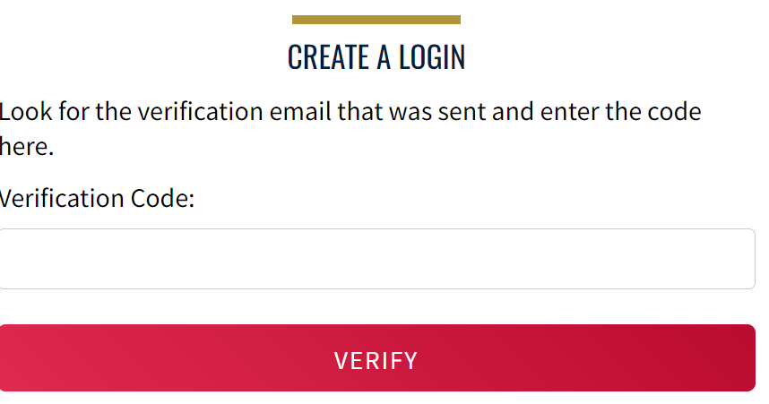
- You’ll receive an email with a verification code. Once the verification code is entered you’ll be you’ll be asked to log in using the username and password you just created.

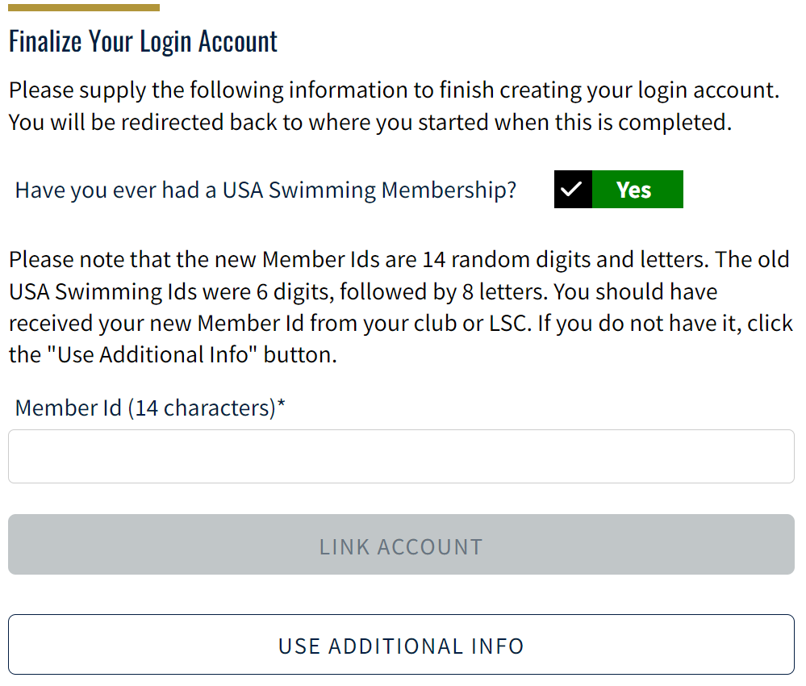
- Then you’ll be asked if you’ve ever been a member of USA Swimming in the past. If the answer is Yes (you’ll need to click on the icon for it to indicate Yes or No), select Use Additional Information unless you already have your new ID number. Be certain to enter your name as it is listed on your most recent membership card. If you’re unsure how you were registered in the past or your account is not found, STOP and contact businessoffice@virginiaswimming.org for help.
After you complete the requested information your new ID will be emailed to address shown in the form. Once received, copy and paste the Member ID in the appropriate field and click Link Account.
If you have never been a member of USA Swimming, click the icon to show No and complete the steps shown on the screen. You will automatically be logged into SWIMS 3.0.
That’s all there is to it! The username and password you entered in step 1 is the login for your new account.

