|  |  |
| --- | --- |
| Parents Name |  |
| Swimmer Name |  |
| Phone # |  |
| Email | ______________________________________________________________________ |
| Team |  |

|  |  |  |  |
| --- | --- | --- | --- |
| Item | Name for Embroidery | Size | |
| Men or Women’s | (XS-2XL) |
| *Jacket* | *e.g. S. Whited, Whited, Stacey Whited* | *Women’s* | *S* |
|  |  |  |  |
|  |  |  |  |
|  |  |  |  |

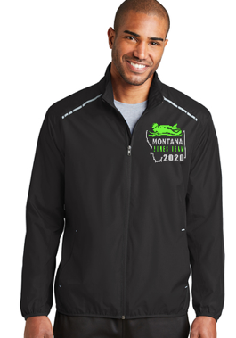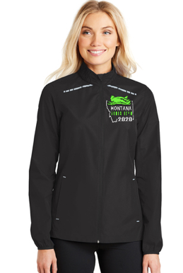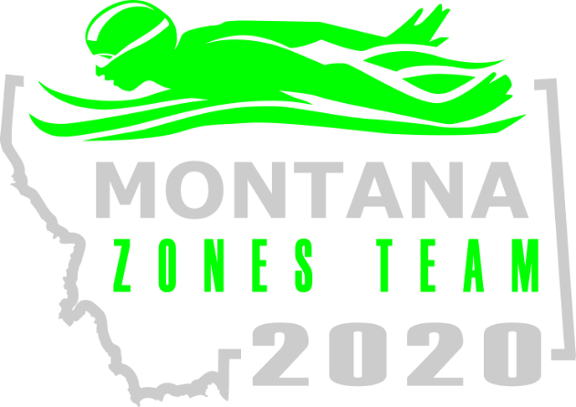

***Montana Sporting and Apparel***

***Formally Sleeping Giant Sports & Apparel.***

1018 W Custer Ave #16 | Helena MT | Hours M-F 12-5pm

(406) 996-1600 | [stacey@sleepingiantsports.com](mailto:stacey@sleepingiantsports.com)

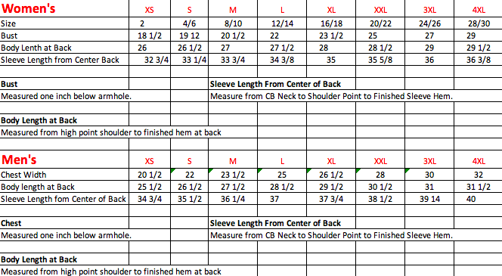

***Montana Sporting and Apparel***

***Formally Sleeping Giant Sports & Apparel.***

1018 W Custer Ave #16 | Helena MT | Hours M-F 12-5pm

(406) 996-1600 | [stacey@sleepingiantsports.com](mailto:stacey@sleepingiantsports.com)