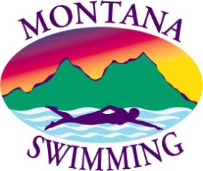

Montana Swimming Officials Application for Reimbursement

Montana Swimming will reimburse their Officials for their USA Swimming Non-Athlete Registration and Background Check fee upon receipt of this application and that have officiated at five (5) or more USA Swimming Meets in each year, time frame would be from the previous September 1 to August 31 current year. Officials and/or Clubs that pay for their officials need to submit this application to Montana Swimming General Chair by August 31 for reimbursement. Reimbursement will be sent to the following name and address by the end of October.

The meets that would count are any USA Swimming meets that are not in the official’s hometown and any home swim meet that the official’s child/children don’t participate. Also excluded are dual meets, time trials or inter-squad meets.

Name: ___________________________________
Address: ___________________________________
City: ___________________________________

Phone: ___________________________________

Meet officiated at: List all that apply – attach a copy of the printout from the Officials Tracking System (OTS).

1. ___________________________________
2. ___________________________________
3. ___________________________________
4. ___________________________________
5. ___________________________________

Verification fees paid:
USA Swimming Non-Athlete Fee: $ ______________
Background Check Fee: $ ______________

Total amount to be reimbursed: $ _______________

Montana Swimming Registration Chair: ______________________________
Montana Swimming General Chair: ________________________________
Montana Swimming Treasurer: ________________________________
Montana Swimming Check # and Date Mailed: _#________ _______________

