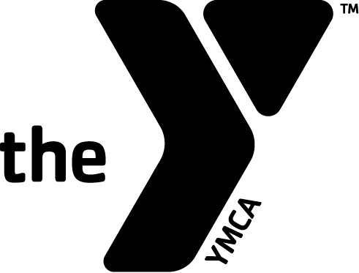
MISSOULA FAMILY YMCA
SWIM TEAM CANCELLATION FORM
We build strong kids, strong families, strong communities.

In accordance with the Program Application Agreement, regardless of how a program is paid for, written notice must be given to the Missoula Family YMCA by the LAST DAY of the month to cancel a program registration for the following month.

DATE:____/____/____ PRIMARY MEMBER NAME:__________________________________________________________________________________________
PROGRAM PARTICIPANTS NAME:_______________________________________________________________________________________________________
MONTH(S) YOU WANT TO BE CANCELLED OUT OF: _________________________________________________________________________________

HOME NUMBER:_____________________________ CELL/WORK NUMBER:_____________________________

TYPE OF PROGRAM: Please choose one.
□Pre-Comp (Tiger Sharks) □Intermediate Ages 6-8 (Megamouth Sharks)
□Intermediate Ages 9 & 10 ( Hammerhead Sharks) □Advanced Ages 11 – 14 ( Great White Sharks)
□Senior Ages 15-21 (Mako Sharks)

REASON FOR CANCELLATION: Please check all that apply.
□Dissatisfied: Please check all that apply.
□Facilities □Location
□Child Watch/Nursery Hours □Pool
□Open Swim □Hours
□Sauna □Price
□Locker Rooms □Cleanliness
□Staff
□Other (please explain):________________________________________________________________
□Financial: Are you aware of our financial assistance programs?
□Medical: Are you aware of our hold policy?
□Moving: Would you like us to look up information on the YMCA in the community you’re moving to?
□Student Leaving Missoula for the Summer/Working Out of Town: Are you aware of our hold policy?
□Other: Please explain._______________________________________________________________________

SIGNATURE:_________________________________________________ DATE:_______/_______/_______
OFFICE USE ONLY
Date Received:_____/_____/_____ Date Processed in MemberST:_____/_____/_____ Staff Initials:________________ Updated 12-21-10

