MISSOULA FAMILY

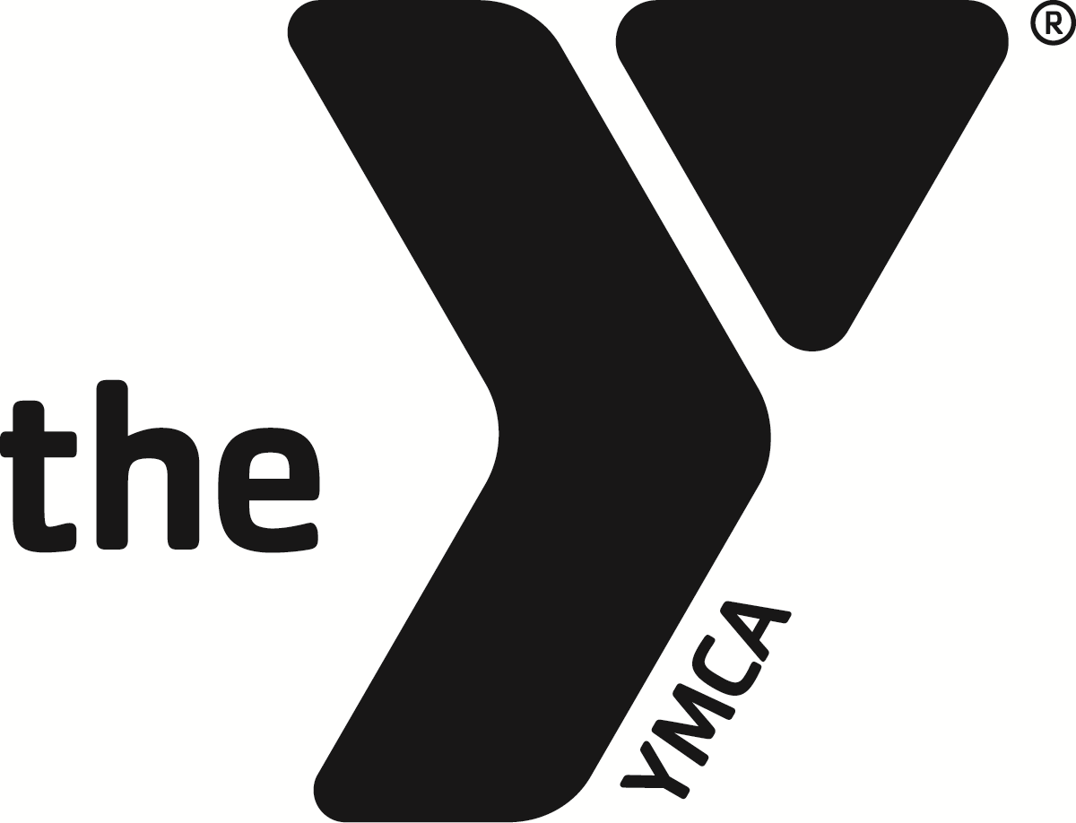

SWIM TEAM
- PARENT HANDBOOK -

Welcome:

Congratulations on becoming a part of the Missoula Family YMCA Swim Team Program.

Our YMCA swim team program is designed to meet the needs of swimmers with a wide range of ages, experience, and abilities. The practices, events, and meets help to develop skills, sportsmanship, and team spirit while emphasizing having fun. While only one swimmer can come in first in any race, all swimmers can be winners when they give their personal best.

Parents help the team by ensuring that we offer a quality program based on the YMCA core values. We encourage parents to seek out our coaches with any questions, concerns or suggestions and to attend the Swim Team Parent Committee meetings (MYST PAC).

As our YMCA swim team program continues to grow, we strive to retain the personal touch and the family atmosphere that we now have. Every swimmer and every family is important to us. Your concerns are our concerns. Your enjoyment of the time you spend with our team is the true measure of success.

WELCOME TO THE YMCA SWIM TEAM FAMILY!

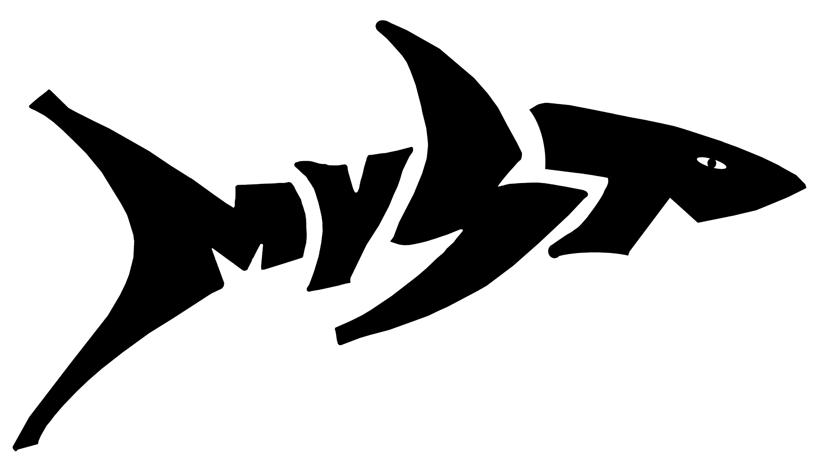

YMCA MISSION STATEMENT

The Missoula Family YMCA is dedicated to building a healthy spirit, mind, and body for each person it serves. Through programs based on Christian principles, the YMCA helps strengthen families and build a better community.

YMCA SWIM TEAM GOALS
1. Provide opportunities for all interested swimmers in Missoula to engage in a wholesome, lifetime, lifesaving sport, and personal activity.
2. Provide the opportunity for all interested people to maximize their swimming ability.
3. Provide physical development and encourage proper conditioning among all interested people.
4. Create an atmosphere in which the desire for self-improvement and goal achievement motivates the individual to develop his/her natural abilities and helps others to do likewise.
5. Create memories and moments that our swimmers will never forget.

SWIMMER’S ROLE
The swimmer plays the most important role in their success in the sport of swimming. A positive attitude, good diet, and adequate rest will ensure that practices are productive and fun. Each swimmer is responsible for their attendance, performance, attitude, fitness, nutrition, and enjoyment.

The MYST coaching staff will give the swimmers tools to acquire the skills and knowledge necessary to attain all these good habits. Swimmers also need to make sure they are following the Swimmer Code of Conduct in order to have the opportunity for all of the learning and growth that comes from being on the MYST team.

COACH’S ROLE
Our MYST Coaches are the most important resource in a swimmer’s journey in the sport of swimming. Our coaches manage and supervise training and practices. They tutor swimmers in stroke technique and racing strategies. Our Coaches set high standards for our swimmers’ behavior, both in and out of the pool,and will notify the Guardians if assistance in achieving these standards is needed.

Coaches are available to talk outside of practice times if clarification, questions, or guidance is needed in regards to the practices and training that are being given.

PARENT or GUARDIAN’S ROLE
Swimming programs provide many benefits to young athletes as they develop self-discipline, good sportsmanship, and time-management skills. Competition allows the swimmer to experience success and to learn how to deal with defeat while becoming healthy and physically fit. As a parent/ guardian, your major responsibility is to provide a stable, loving, and supportive environment that will encourage your child to continue his/her interest in sports. You can show your interest by ensuring your child's attendance at practices and by coming to their meets.

Parents are not participants on their child's team, but contribute to the success experienced by the child and his/ her team. Parents serve as role models, and their attitudes are often emulated by their children. Be aware of this and strive to be positive role models. Most importantly, show good sportsmanship at all times toward coaches, officials, opponents, and teammates.
FINANCIAL OBLIGATIONS

Monthly Dues
The current monthly dues are available in the team brochure. Dues can change annually but the Y strives to keep them both competitive for the community and feasible for the average Missoula-area Family. The Missoula Y Swim Team is responsible for paying all program costs including coaches’ salaries, team travel, financial assistance, and operating expenses. Additionally, so that the participants in the program can thrive and grow, team dues are set at a rate that supports annual coaches’ training, the Team Unify website fees, equipment, and marketing.

Financial Assistance
No one is turned away due to an inability to pay. A family just needs to complete a Financial Assistance Application (available at the Welcome Center). Once turned in and processed, you will receive a discounted rate off your swimmer’s monthly dues based on how you qualify on our sliding scale. Financial Assistance Applications must be updated every 6 months. Financial Assistance is not available for Swim Meets or the required USA Swimming Insurance coverage. The Y’s Membership Director processes applications and tells the Aquatics Director what percentage to apply as a discount. There is also an annual fee for USA Swimming dues. This amount changes each year.

Missoula YMCA Membership
MYST swimmers are required to have a Y Family or Youth Membership to allow our team to be 100% compliant to Y-USA swim team standards. MYST is a valuable part of our Missoula Y community. If your swimmer is currently not a Y member, all you have to do to get your swimmer signed up for a Youth Membership is visit the Welcome Center to sign them up and set up the monthly draft. You can also sign up on our website at www.ymcamissoula.org. Youth Memberships for Swim team Members is offered at a 40% discount from the regular youth membership rate.If you decide to get a Family Membership you will need to go to the Welcome Center to fill out the paperwork for a Family Membership. Along with your family membership, you will also receive the Y Family Membership rates on your Swim Team dues each month.

USA REGISTRATION/INSURANCE
- In order for a swimmer to be eligible to compete in sanctioned USA competitions, the swimmer must be a member of USA Swimming, the national governing body for all amateur swimming in our country. USA registration is an annual fee. This membership not only supports swimming throughout the country, it also provides very important Secondary Accident Insurance. USA Secondary Accident Insurance covers sanctioned competition, practices, and team functions and is included in the USA Membership fee. Swimmers are covered at any organized practice of the YMCA Swim Team and at every competition that is USA sanctioned. If you wish to see the insurance summary pamphlet, please contact Kirby Beierle or Rose Kahane.
- Senior, Advanced, and Intermediate team members are required to be a member of USA Swimming.
- All competitive swimmers must register and pay for USA Swimming dues either the first month in which they begin swimming during a calendar year or immediately following completion of the 30 day trial period. Unregistered swimmers will not be allowed to practice or participate in Swim Meets.
- Swimmers who are only swimming 3 consecutive months out of the year must register and pay for a Seasonal USA Swimming Registration immediately starting the first month in which they swim.

USA Swimming fees change on a yearly basis. Registration form/current fee is listed in the packet. In future years, multiple options are available for draft dates for the annual USA Swimming dues.
Membership Protection
USA Swimming's stated policy for membership protection is:
- to provide safety education for its membership;
- to provide secondary accident medical protection for USA Swimming members who
may suffer injuries while participating in insured activities;
- to provide evidence of financial responsibility so that USA Swimming clubs can
conduct insured activities.
To implement this policy, USA Swimming has adopted two major programs:
(1) Excess Accident Medical Protection (2) Liability Insurance Program

These two programs are intended to provide reasonable protection for USA Swimming athletes and clubs while stabilizing the cost. If your child is injured during swimming practice or competition, please talk with Head Coach Kirby Beierle to file a claim. In order for your child to swim with MYST on the competitive team, they must be USA Swimming registered.

NOTE: It is imperative that all incidents, no matter how minor, be reported immediately. The USA Swimming Report of Occurrence should be utilized.

FUNDRAISING
We have one major fundraiser each year to raise funds for tangible items (ie: equipment or training opportunities for swimmers and/or coaches) to help the team continue to grow and develop all swimmers in the program. The timing of the fundraiser is decided by the Aquatics Administration and the MYST Parent Advisory Committee so please attend the monthly meetings to share your thoughts and ideas on the matter. Everyone's participation -- swimmers and parents -- ensures a successful and quality swim team experience with a reasonable program fee structure. Simply put, without this fundraiser, either the program fees would have to increase dramatically or the team would become more "recreational" without things we now enjoy: professional coaching, coaches at "away" swim meets, purchasing and maintaining necessary equipment.

Although participation in the fundraiser is voluntary, every team member and family is asked to take part in this important team activity. The success of the fundraiser is directly related to the involvement of the parent volunteers.

LOCKER ROOM POLICY
While at practice for the Missoula YMCA Swim team, athletes can use any of the four locker rooms.* While in the locker room, we ask that all of our participants adhere to the Missoula Family YMCA policy that using any type of recording devices, including cameras and phones, in the locker rooms, spas, sauna, and pool area is not allowed. Anyone using the locker rooms to photograph, video, or record must have permission from the Missoula YMCA Marketing Director without exception.
*During the COVID-19 pandemic we are asking all competitive swimmers not to use the locker rooms or to limit their time in them so as to lower the risk of spreading the virus among our swimmers. Please have your suit on under your clothes so you can disrobe and dress quickly on the pool deck.

CODE OF CONDUCT
Missoula Y Swim Team Code of Conduct for Athletes
In keeping with the culture and core values of the Missoula Family YMCA, the following expectations and behaviors must be followed by all MYST member participants.
Expectations:
- All MYST members must behave and conduct themselves within the YMCA core values of Caring, Honesty, Respect and Responsibility in mind, as well as the Missoula Family YMCA Code of Conduct.
- All MYST members must follow the rules and regulations of both the USA Swimming Code of Conduct and every single swim meet that MYST attends. Our team reputation is completely dependent on how we conduct ourselves on the meet deck and in the stands. Team members are reminded when competing in meets, traveling on trips, and attending other meet-related functions, they are representing both themselves and the Missoula Y Swim Team. Athlete behavior must positively reflect the high standards of our team.
- All MYST members will follow the directions and instructions of the coaching staff, and display proper respect and sportsmanship toward coaches, officials, administrators, teammates, fellow competitors, and the public at all times.
- All MYST members must follow a strict “No Bullying” policy. This means that if a conflict arises between a MYST member and another MYST member, or a MYST member and any person at an event the team is attending, it must be reported directly to the Head Coach. Honesty about any bullying situation is expected from all MYST members.
- All swimmers will report any inappropriate behavior to the coaching staff immediately upon recognizing or hearing about such behavior.
- All swimmers will refrain from using inappropriate language or humor. All MYST members are expected to show RESPECT by not using vulgar or insulting language directed toward any persons while at any MYST activity including, but not limited to, practices, meets, trips, gatherings etc… Remember that there are younger swimmers that will be looking up to you and looking to you to see what behavior is acceptable and correct. Show that you are RESPONSIBLE for yourself and your team by your actions and the language you use.
- All swimmers will refrain from intimate displays of affections towards other participants or non-athletes while participating at any Missoula Y swim team practice, event, or activity.
- No “deck changes” are permitted. Athletes are expected to use the available changing facilities. *
*Unless otherwise directed, such as COVID-style deck changes.
Unacceptable Behaviors:
- Insubordination toward any coach, meet official, chaperone, parent volunteer, or facility staff.
- The possession or use of alcohol, tobacco/nicotine products, or any non-prescribed drug by any athlete is prohibited.
- The possession, use, or sale/distribution of any controlled or illegal substance is strictly forbidden.
- The possession or use of any form of weapon during swim team events is strictly forbidden.
- Theft, “borrowing or souvenir taking.”
- Inappropriate communication, behaviors, or interaction between any MYST members (i.e. inappropriate texting messages or pictures, as well as inappropriate messages or pictures on any social media platforms).
I understand the above expectations and that my failure to adhere to them may result in disciplinary action.
Name: ____________________________________________________ Date: __________________________
Signature of Athlete: _________________________________________
Violation of the Missoula Y Swim Team Code of Conduct for Athletes:
Failure to comply with the Code of Conduct as set forth in this document may result in disciplinary action issued by the Head Coach after consultation with Y leadership staff and MYST Parent Advisory Committee. Such discipline may include, but may not be limited to:
- Verbal reprimand, suspension, or dismissal from the team.
- Proceedings for an LSC or USA Swimming National Board of Review.
- If traveling, dismissal from the trip and immediate return home at the athlete’s expense.
- Disqualification from one or more events, or all events of a competition.
- Disqualification from future team travel meets.
- Financial penalties associated with cancelled team travel.

Missoula YMCA Swim Team Parent Code of Conduct for Parents and Guardians
The purpose of the code of conduct for parents is to establish consistent expectations for behavior by parents/guardians.

As a parent/guardian, I understand the important growth and developmental support that my child’s participation fosters. I also understand that it is essential to provide the coaching staff with respect and the authority to coach the team. I agree with the following statements:
❏ I will set the right example for our children by demonstrating sportsmanship and showing respect and common courtesy at all times to the team members, coaches, competitors, officials, parents, and all facilities.
❏ I will get involved by volunteering, observing practices, cheering at meets, and talking with my child and their coach about their progress.
❏ I will refrain from coaching my child from the stands during practices or meets.
❏ I understand that criticizing, name-calling, use of abusive language or gestures directed toward coaches, officials, volunteers, and/or any participating swimmer will not be tolerated.
❏ I will respect the integrity of the officials.
❏ I will direct my concerns first to The Head coach; then, if not satisfied, to the Aquatic Director.
I understand the above expectations and that my failure to adhere to them may result in disciplinary action.
Name: ____________________________________________________ Date: __________________________
Signature of Parent: _________________________________________
Copies of the athlete and parent code of conduct will be sent electronically to all new swimmers on the competitive team and must be signed and returned in order for your swimmer to participate on the MYST Team.
CONFLICT RESOLUTION
The Missoula YMCA Swim Team takes the job of being a safe place for all participants to learn and grow during their childhood very seriously. Ultimately, we want all of our swimmers’ time on our team to be filled with moments of great personal growth. We want to instill good habits, communication skills, establishing boundaries, and daily use of the four YMCA Core values of Caring, Honesty, Respect and Responsibility. If any issues arise, our coaching staff will address it immediately with the swimmer and/or their parents/guardians and give them a chance to correct any behavioral issues that they are working on. If the issue persists and the conflict does not resolve, we will move onto Disciplinary Action.

DISCIPLINARY ACTION PROTOCOL
The Missoula YMCA Swim Team expects each of its members to act in an appropriate and mature manner at all times. This includes anytime in which a member is representing our team, in and out of the pool. When our team rules, code of conduct, or behavioral expectations are not met, disciplinary actions will be enforced. Each member will have the right to due process during all disciplinary decisions but the ultimate plan of actions resides with the coaching staff and the Missoula YMCA. Below is the MYST Disciplinary Action Protectol but, please note, each decision will be a case- to-case basis including, but not limited to, the following situations:

Misconduct | Disciplinary Action
Repeated horseplay or disruptive behavior | The coach will set up a meeting with the guardian(s) to discuss the swimmer’s actions. If the misconduct continues post meeting, further disciplinary actions will be enforced, and possibly result in dismissal from the team.
Dangerous behavior including spitting, pushing, hitting, and/or fighting. | The coach will set up a meeting with the guardian(s) after a warning is given to the swimmer. The second offense will require the swimmer and guardian to meet with both the coach and the Aquatics Director. The swimmer will be dismissed from the team if the issue persists.
Disruptive guardian behavior toward swimmers and/or coaches, meet officials, other parents etc... | The guardian(s) will be required to meet with the YMCA leadership to discuss their behavior. If the misconduct continues, the guardian will be asked to avoid the facility. If this action does not solve the issue, dismissal from the team may be warranted.
Bullying | At the first sign of bullying, the involved swimmers will meet with the coach to discuss their actions. If the misconduct continues, the swimmer and guardian(s) will meet with the Missoula YMCA. We take bullying seriously, and this misconduct may require suspension or dismissal from the team.
Law Enforcement Charges | All MYST team members represent our team outside of the pool area. Any criminal misconduct reflects negatively on our program and will not be tolerated. Disciplinary action will be taken on a case-by-case basis and possibly result in dismissal from the team.
AGE GROUP EXPECTATIONS

Introduction
Age-group swimming within the YMCA program is designed for the physical and mental preparation for competition, as well as the opportunity for individual growth. Our swimmers will be trained to compete in both the longest individual medley and freestyle event offered in their respective age group. By gearing the training for these two events, our swimmers will have more versatility and a greater knowledge of swimming.

Outside Activities
One of the most important and often-asked questions is whether or not swimmers should participate in outside activities. Our position is that children should participate in outside activities. To accommodate this belief, younger swimmers are encouraged to experience activities other than swimming. For this reason, our practice schedule is designed to accommodate those swimmers who want to participate in other activities.

Attendance
Swimmers should attend practice as often as possible to ensure that they receive the full benefit of the practice session and our weekly/monthly practice plan. Improvement in swimming, as in any other activity, is directly tied to regular practice, attendance, and the amount of effort expended during each and every practice session. Swimmers will be asked to report to practice early to allow for adequate time to prepare for practice (i.e. changing, stretching, setting up equipment, etc.).

Progress
Age-group swimmers will progress naturally on their own as there is not a set formula or pattern to this progression. Since each swimmer is a distinct individual, progress will be faster for some than for others. The more a swimmer is interested, works hard, and attends practice regularly, then the better are his/her chances for improvement.

Parents can help by being supportive of the practice session by making sure that swimmers are well fed, hydrated, on time, and have all of their practice equipment.

Age-Group Swimming in Perspective
Competitive swimming can be a tremendously exciting experience. Age-group swimmers can be among the most inconsistent performers. Also, if allowed, they will become some of the most dedicated. Too much swimming too soon nearly guarantees that a swimmer will lose interest and quit long before he/she achieves his/her ultimate potential. A goal of the YMCA PROGRAM is to maintain a swimmer's longevity in the sport until he/she decides it is time to move on to some other facet of life. This can be accomplished through a positive age-group experience. Remember, no eight-year-old ever set a world record, and no one received college scholarships because he/she was the best in the nation at age nine!

We (both parents and coaches) must constantly remind ourselves that these are young children who need patience, understanding, and guidance from those of us who should know that there is more to life than swimming. We must encourage them to swim because it is FUN, and not because they are faster than someone else's child.

PRACTICE GUIDELINES
The following are coaching staff suggestions regarding practice. Following these guidelines will help to ensure a safe and fun practice for all:
- Arrive on time and ready to swim. Remember to bring everything you need including towel, suit, cap, goggles,water bottle, and a lock for your locker.
- Wait at the end of the pool for your coach to start practice.
- Show respect by not talking while coaches are giving directions.
- If you have questions, ask your coach.
- No diving into the shallow end of the pool.
- Do not use the ladder to get out of the pool (Every time you pull yourself out of the pool, you get stronger).
- Lastly, always strive to help your teammates. There is no "I" in "team". Helping your teammates to improve is the best way to help yourself improve.

PRACTICE ORGANIZATION
Practices are the heart of the swim team program. Each practice session is designed to incorporate skill development, fitness, team-building, and fun. Swimmers are encouraged to train hard and challenge themselves. Workouts will help the needs of individuals, as much as possible, to meet the specific needs and goals of each swimmer. Group activities are included in practice to promote team unity and spirit.

TRAINING GROUPS
Hammer Mouths, Great Whites and Makos - are divided by age. The Hammer Mouths are our 5 to 10 year old swimmers. Our Great White team is composed of 11 to 14 year old boys and girls. The Mako Team (our high school-aged swimmers) includes both males and females between the ages of 14 through 20.

Pre-Competitive Tiger Sharks
The Pre-Competitive swim team combines a fun atmosphere with an emphasis on improving stroke technique and endurance through 45-minute practice sessions. The team participates in 2 or 3 fun pre-competitive meets each year which are very low-key with no pressure to perform at any level other than the swimmer's ability or desire. It is recommended that swimmers practice two times per week to develop the stroke skills and build the endurance needed to move up to the appropriate competitive crew.

Angels
This is our Adaptive training group and was established to make sure that swimmers of all abilities and needs have a place to train with thought for their individual needs. This group trains twice a week and is registered with USA Swimming and is able to compete in USA Swimming meets. The goal for this group is to meet each swimmer where they are at and create a safe space for its participants to thrive in the sport of swimming.

Hammer Mouths/ “Littles”
Ability
Basic knowledge of the four competitive strokes. Ability to repeat distances of over 50 yards.
Emphasis
To work on refining the four competitive strokes plus starts and turns. To begin interval training, endurance
work, and preparation for racing. Games and activities to develop sportsmanship and team unity are stressed.
Practices
It is recommended that swimmers practice three times per week.

Great Whites/ “Middles” and Makos/ “Bigs”
Ability
Proficiency of the four competitive strokes, starts and turns. Ability to train for up to one and a half hours at a
time.
Emphasis
To improve physical condition through progressive, strenuous training. To introduce racing strategy and dryland
strength training. Individual goal setting is emphasized as well as team spirit and leadership.
Practices
It is recommended that swimmers practice as much as possible.

PARENT SUPPORT

Missoula YMCA Swim Team Parent Advisory Committee (PAC)
The purpose of the PAC shall be to foster interest in the Missoula YMCA Swim Team Program; to promote cooperation, communication, and unity of spirit among parents, coaches, and athletes; to encourage an understanding among all concerned individuals; and to provide a means for parents to be of service to the Missoula Family YMCA Swim Team.

The Missoula Family YMCA Swim Team (MYST) is dedicated to the emotional and physical growth of its swimmers and to the high morale of the community. The coaches, parents, athletes, and all involved in MYST will strive to make swimming a positive experience. The MYST PAC will foster (in both parents and swimmers alike) the benefits of hard work and sacrifice, the traits of good Sportsmanship, and the value of self-discipline.

SWIM MEET INFORMATION
Competing in swim meets can be the most rewarding, as well as the most stressful part, of the swim team
experience. Competition can produce a number of positive results if approached as a personal challenge. Our
goals in competing are to do our personal best, to push our limits, and continually improve our performance.
Parents, swimmers, and coaches work together to determine when a swimmer is ready for the next level of
swimming. Every swimmer is encouraged to participate in the meets appropriate to their age and ability, but
no swimmer will be pressured or penalized if they choose not to participate. When the time comes for your
swimmer to compete, MYST will work with the parent committee and set up another parent to be your contact
throughout the meet to help you through any and all questions that arise.

Transportation
In order for a swimmer to compete in an out of town meet, the parent or guardian of that swimmer must attend or attach that swimmer to another parent. MYST coaches will not act as chaperones for any travel meets, nor will they act as guardians.

TEAM MANAGEMENT
The Missoula Family YMCA's Swim Team is established and governed in accordance with the by-laws of the Association. The Head Coach for the team is Kirby Beierle. Kirby, under the direct supervision of the Aquatic Director, is responsible for the successful daily administration of the team as set forth by the Missoula Family YMCA's policies and procedures. The Aquatics Department is currently under the direction of Rose Kahane, Aquatic Director for the Missoula Family YMCA.

TO CONTACT A COACH:

To speak with a coach: (Regarding practice times, meet sign ups & schedules or team events)
Email is the best way to get a hold of the coach. The coach will return your call during office hours.

Kirby Beierle YMCA 721-9622 X6258
Kirby’s email: kbeierle@ymcamissoula.org

Team Billing Questions: Please email or call the Director of Aquatics, with your questions.

Rose Kahane YMCA 721-9622 X6255
Rose’s email: rkahane@ymcamissoula.org

Practice Times: Times are posted for each season on the team website, and in the team brochure.

Meet Schedules: Can be found on the team’s website:
https://www.teamunify.com/Home.jsp?team=mtmyst

Aquatic Supplies: Caps, suits, and team apparel are available on the team Website:
https://www.teamunify.com/Home.jsp?team=mtmyst

TEAM COMMUNICATION
The team has several different methods for distributing information to all MYST swimming families:

- Coaches -- Each team’s coach is listed on the crew swim practice schedule -- please feel free to contact them with your suggestions, questions, or concerns.
- WEBSITE – https://www.teamunify.com/Home.jsp?team=mtmyst
- Facebook: Missoula YMCA Swim Team, just ask to be a member and Kirby will add you immediately.

