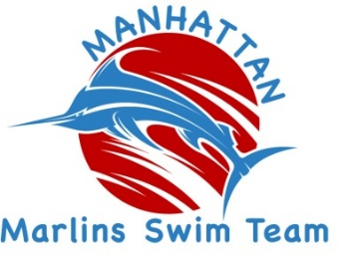
2016-2017 Manhattan Marlins Swim Team
Individual & Corporate Sponsorship

Your investment makes a difference!

We would like to thank you for your sponsorship by providing the following recognition opportunities:

Minnow Level Sponsor ($100/year): Recognition on the Manhattan Marlin Swim Team website,
www.manhattanmarlins.org.

Marlin Level Sponsor ($250/year): All benefits listed above. Business logo or name listed on team t-shirts. Business card sized sponsorship acknowledgement for the company or individual in all swim meet programs.

Bronze Level Sponsor ($500/year): All benefits listed above. Quarter-page sponsorship acknowledgement for the company or individual in all swim meet programs.

Silver Level Sponsor ($1,000/year): All benefits listed above. Half-page sponsorship acknowledgement for the company or individual in all swim meet programs, and individual event sponsor at any hosted swim meets.

Gold Level Sponsor ($2,500/year): All benefits listed above. Full-page sponsorship acknowledgement for the company or individual in all swim meet programs, and individual event sponsor at any hosted swim meets.

Platinum Level Sponsor ($5,000/year): All benefits listed above. Company or individual banner displayed at any hosted swim meets.

--------------------------------------------------------------------------------------------------------------------------

2016 Manhattan Marlins Swim Team Sponsorship

Enclosed is my check to sponsor at the following level:

$5,000 Platinum Level $500 Bronze Level Other $__________
$2,500 Gold Level $250 Marlin Level
$1,000 Silver Level $100 Minnow Level

I/we grant permission to be publicly recognized. Please contact _________________________ for logo/information related to our sponsorship. Our company website URL is: ___________________________ and we grant permission for you to include our URL link on the Manhattan Marlins website in correlation to our sponsorship level.
Please return this form and your donation payment to:

Manhattan Marlins, Inc.
P.O. Box 1003
Manhattan, KS 66505-1003

We ask that all sponsorships be received by March 1, 2017. Questions? Call ________ at ___________.
Name (print) ______________________________________________

Address __________________________________________________

City _____________________________ State _________ Zip _______

Phone ___________________________ Email ___________________

Thank you for your generous support!

