What to Expect at Your First Swim Meet:
A Guide for Aquahawk Parents

What To Bring to a Swim Meet
- Swimsuit, Aquahawks cap and goggles. It is always a good idea to bring an extra suit, cap and goggles. These items can rip or break, usually at the most inopportune times!
- Towels-we encourage swimmers to bring at least 2 towels.
- Something comfortable for your swimmer to sit on in the crash area. Some meets require swimmers to crash in a gym or designated area while parents are required to sit in the stands or bleachers. It is a good idea to bring a sleeping bag, blanket or chair.
- Something comfortable for you to sit on in the crash area or a seat back for the bleachers.
- Bring a couple changes of clothes such as sweatpants, sweatshirts or t-shirts. Swimmers need to stay warm between events and this is more easily done with dry clothing.
- Bring some healthy snacks and lots of water. Suggestions for items to bring: WATER, Gatorade, granola bars, fruit, trail mix, sandwiches.
- Sharpie marker, pen and highlighter.

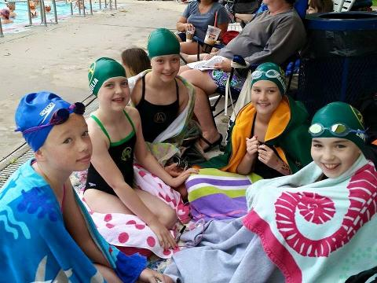
Parents’ Note:
The pool area is usually very warm. Make sure you dress appropriately. There is nothing worse than being hot at a swim meet. Time will seem to pass very slowly!

Before the Meet Starts
1. Arrive at the pool at least 15 minutes before the scheduled warm-up time begins. Estimated Warm-up times are listed in the meet information posted on the website. Coaches will email out exact warm-up times several days before a meet as well.
2. Find a place to put your swimmer’s “stuff.” The team usually sits together in a gym or commons area called the “crash area” so look for some familiar faces and then set up camp.
3. Help your swimmer find the coaches. Look for coaches on deck to let them know you are at the meet.
4. Find a heat sheet to purchase, or share with another parent. Heat sheets are usually available for sale in the lobby or concession area of the pool. It lists all swimmers in each event in order of “seed time”. This is where you will find what heat and lane your swimmer is in for each event.
5. Write on your swimmer. Write each event number, heat, and lane on your swimmer’s arm in “permanent” (i.e., waterproof) marker, like a Sharpie. This helps your swimmer remember what events he or she is swimming, what event number to listen for, and what lane to get lined up behind. This step is sometimes saved until after the swimmers are done with warm-ups. The coaches are happy to help swimmers write on their arms. Make sure if swimmers would like the coaches’ help they let them know before the start of the meet.
6. Swimmers report to the pool and/or coach for warm-ups. It is very important for all swimmers to warm-up with the team. Swimmers’ bodies are just like cars on a cold day; they need to get the engine going and warmed-up before being able to go all out. This is a good time for parents to get a cup of coffee and a donut while the kids are busy!
7. Swimmers return to crash area after warm-ups. Time to dry off, put on warm clothes, go to the bathroom, and write events on the arm if this wasn’t done earlier.
8. The meet will usually start about 10-15 minutes after warm-ups are over.

The Meet Starts

1. Know what events your swimmer is competing in. It is important for swimmer to know what event numbers he is swimming. Again, a heat sheet and sharpie are a swim parent’s best friends! Events can usually be found under the swim meet event on the website
2. Listen for event announcements. Upcoming events are usually announced over the loud speaker, asking swimmers to report to the starting blocks or to the “bullpen” (a staging area used at very large meets or for swimmers 8 years and younger). Swimmers should report with cap and goggles. Example: “Event #26, 10-Under Boys, 50 freestyle, first call to report to the starting blocks.”
3. Check in with the coaches. Aquahawk coaches ask their swimmers to check in with them before each race. This is when coaches give last minute reminders and encouragement to the swimmers about their upcoming race. Swimmers should allow enough time when reporting to the blocks for this important step!
4. Report to the blocks or the bullpen. The timers behind the starting blocks often check to make sure that swimmers are lined up in the right order. However, it is always a good idea to have your swimmer check in with the lane timers to make sure they are in the right lane and heat.
5. Parents, find a seat. According to USA Swimming rules, parents are not allowed on deck unless they are serving in an official capacity. Parents must sit in the spectator area, usually bleachers on the side of the pool.
6. Swimmers, swim your race.
7. Check in with the coaches...again! After each race, your swimmer should go immediately to their coach. Generally, the coaches follow these guidelines after a race:
a) Positive comments or praise
b) Suggestions for improvement
8. Check in with parents. Parents should follow these guidelines after your swimmer’s race:
a) Tell your swimmer how great they did! The coaching staff will be sure to discuss stroke technique with them. You just need to tell your swimmer how proud you are of their effort.
b) Take your swimmer back to the crash area and relax, find something to eat, and wait for next event to be called.
9.Repeat above steps until all events have been completed.

10. Final check in with the coaches before heading home. When a swimmer has completed all his events for the day, he is able to go home. Be sure, however, to check with the coach before leaving to make sure your swimmer is not included on a relay. It is not fair to other swimmers who may have stayed to swim on a relay where your swimmer is expected to be a member and he/she is not there.
11. Ask for help! If during any of this you feel lost or confused, be sure to ask other Aquahawk parents for help! We have all had our “first meets” and know it can be overwhelming. Once you have attended one or two meets, it will all become very routine and enjoyable.

