Class of 2018
Tarin Fisher- 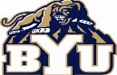 Brigham Young University
Zeke Metz-

Class of 2017
Mckinley Larson-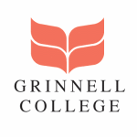Grinnell College
Jack Palmer- 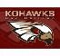 Coe College
Class of 2016
Laura Dicus-Xavier Unversity
This Photo by Unknown Author is licensed under CC BY-SA
Haley Unruh- 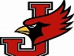William Jewell College
Walker Ricks- 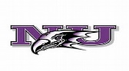Niagara University
Class of 2015
John Fritsch- 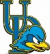 University of Delaware
Class of 2013
Sammie Schurig-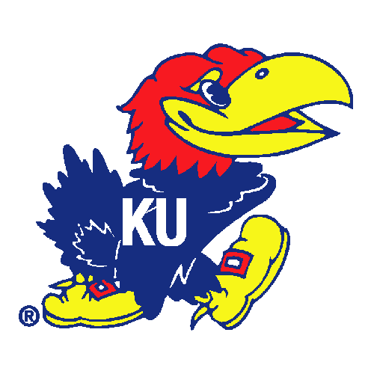University of Kansas
Class of 2012
Haley Molden-University of Kansas

Class of
Tyler Schmidt-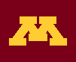 University of Minnesota
Class of
Jonathon Schmidt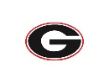University of Georgia
Class of
Emily Dicus- University of Virginia
This Photo by Unknown Author is licensed under CC BY-SA

Class of
Shara Stafford- 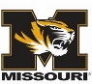 University of Missouri

