Required Equipment List for Senior 1 & 2 and National Team
All equipment can be found at Swimoutlet.com

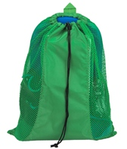 Mesh Bag
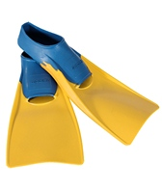 Fins (Not zoomers, trainers, or monofin)

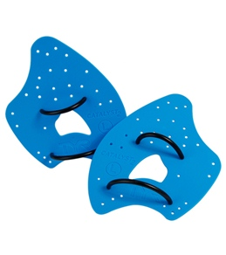Paddles (TYR Catalyst or Strokemaker preferred)
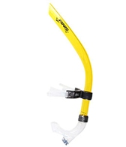Snorkel (Tyr, Finis, Arena – Forward facing)
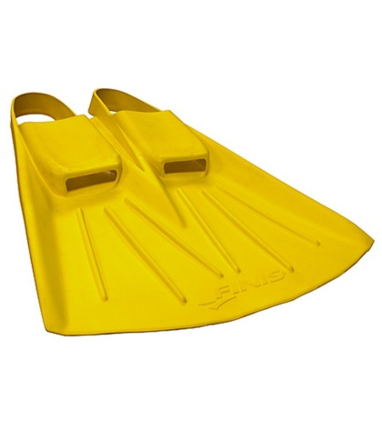
Finis Foil Monofin
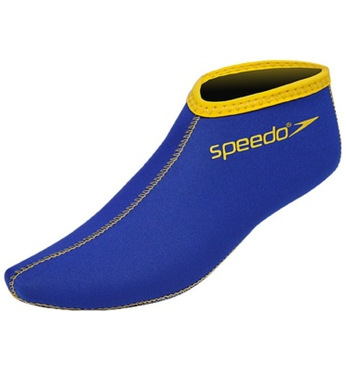
Swim Socks (Optional) Speedo, TYR, Finis- helps prevent blisters!!

