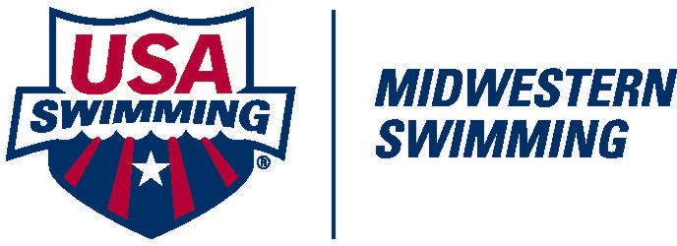
OFFICIALS REGISTRATION &
CERTIFICATION PROCEDURE – 2016/2017

- Attend the appropriate training clinic and successfully pass (80% or greater) the online tests necessary for certification.

- Complete the USA Swimming 2017 Apprentice Official Application found on the Midwestern Swimming website. After 60 days you must become a non-athlete member of USA Swimming. This registration is on a calendar year basis. Application forms can be found on the Midwestern Swimming Info / Registration page.

- Pay the USA Swimming non-athlete member registration fee of $64.00. Make check payable to Midwestern Swimming. Do the Background Check and Athlete Protection Training (APT) required to complete your registration.

- Complete the enclosed MWS Application for Certification. Be sure to include your e-mail address (print legibly) if you wish to receive updates from the MWS Officials Committee. Apprentice at the necessary number of meet sessions based on your certification level:

      - Stroke & Turn Judges: Four (4) sessions
      - Administrative Official: AO1 Four (4) Sessions

- Documentation of session requirements according to MWS Minimum Standards will be based on data within the Officials Tracking System (OTS).

Mail the Membership Application and Registration Fee to:
Scot C. Sorensen
110 N 248 Cir
Waterloo, NE 68069-4690

Mail or email the Application for Certification to:
Betsy Purcell
betsypurcell@cox.net
3345 S. 115th Ave.
Omaha, NE 68144-4505

NOTE: The Midwestern Swimming Registration Chair and Officials Chair will process your USA Swimming membership and Officials Credential. You must display your membership card while on deck during all meet sessions that you attend.

Questions: Contact Betsy Purcell, Officials Chairman at betsypurcell@cox.net
or (402) 871-7816
APPLICATION FOR CERTIFICATION

Please Print Legibly

Name: ____________________________________________________ Date: ____________________

Preferred Name: ___________________________________________

Street-City State-Zip: _____________________________________________________________________________

Phone: (____) ______________________ E-mail: _____________________________________________

Club: ______________________________ Other Certified Positions: ____________________________

You must be a member of USA Swimming to receive certification.

Certification desired: Admin Official ____ Stoke & Turn ____

Clinic Attended: Date: _____________ Location: ___________________ Instructor: _________________

Shirt Size M _________ W_____________ Size ______________

Name as you would like it on your nametag: __________________________________________________

Apprenticeship Session Requirements: S&T (4) Administrative Official – AO1(4)

Meet Date Meet Referee
1 ________________________________________________________________________________________________
2 ________________________________________________________________________________________________
3 ________________________________________________________________________________________________
4 ________________________________________________________________________________________________

When complete please send to the MWS Officials Chair by mail or email:
Betsy Purcell
3345 S. 115th Ave.
Omaha, NE 68144-4505
betsypurcell@cox.net

The required tests are online at http://www.usaswimming.org/USASWeb/DesktopDefault.aspx?TabId=690&Alias=Rainbow&Lang=en
STEPS NECESSARY TO PRINT YOUR OWN MEMBERSHIP CARD ARE AS FOLLOWS:

1. Login to your personal USA Swimming account at: https://www.usaswimming.org//secure/Logon.aspx?TabId=0&Alias=Rainbow&Lang=en&returnUrl=%2fDesktopDefault.aspx%3fTabId%3d1804%26Alias%3dRainbow%26Lang%3den
2. Under “Member Resources”, click on “Deck Pass”.
3. Click on “Membership Card”, at which time you will view all pertinent information regarding your membership status.
4. Click “Print Official Card”.
5. A color printer is not necessary, but may be used if you wish. A grey card will be produced in a B&W printer.
6. This card may then be laminated, if desired.

Updated September 20, 2015

