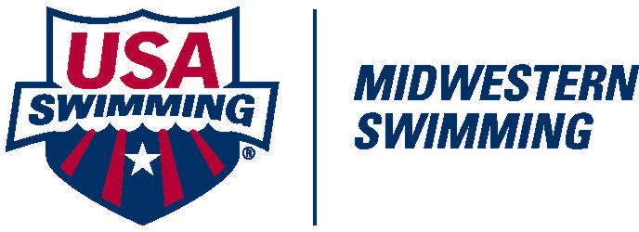
APPLICATION FOR RECERTIFICATION

Please Print Legibly

Name: ____________________________________________________ Date: ____________________

Street-City State-Zip: _____________________________________________________________________________

Club: ______________________________ Other Certified Positions: ____________________________

Phone: (____) ______________________ E-mail: _____________________________________________

Certification desired: Stoke & Turn ____ Starter ____ Referee ____ Admin Official

USA Membership Expiration Date: _______________________________________________
You must be a member of USA Swimming to receive certification.

Clinic Attended: Date: ___________ Location: ____________________________

Instructor: ______________________________________________________________________________

Recertification Tests Completed: Yes _____________

We would like to maintain a list of officials on the MWS website and participate in the MWS newsletter. Please initial the items we may include in either of these places.

Your Name: __________________ Email address (website only): ________________________

When complete, please send to the MWS Officials Chair:

Betsy Purcell
3345 S. 115th Ave.
Omaha, NE 68144-4505
Or email:
betsypurcell@cox.net

Updated September 8, 2017

