USA SWIMMING – 2018 CLUB APPLICATION
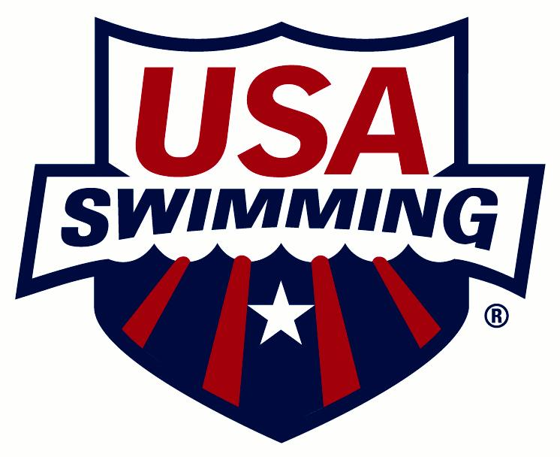

CLUB CODE: CLUB NAME:
NAME OF OWNER/BUSINESS/LEGAL ENTITY IF DIFFERENT FROM CLUB NAME:
1. 4.
2. 5.
3.
CLUB SETTING: Rural Suburban Urban
PLEASE CHECK ONE:
NEW CLUB RENEWING CLUB
(Club is defined as a group with athletes and coaches. Insurance certificate will be issued.)
FIRST YEAR AS A USA SWIMMING CLUB:
NEAREST MAJOR CITY: CLUB WEB SITE:
PRE-EMPLOYMENT SCREENING
By checking this box and signing below, I formally acknowledge that this club is conducting a pre-employment screening on all new employees who are required to be members of USA Swimming as required in the USA Swimming Rules & Regulations, Article 502.6.8.
Signature: Printed Name: Date:
Failure to check this box and sign this statement will result in the club application being rejected.
RACING START CERTIFICATION
By checking this box and signing below, I formally acknowledge that this club complies with all Racing Start Certification requirements as stated in the USA Swimming Rules & Regulations, Article 103.2.2 and maintains records for its athlete members.
Head Coach Signature: Printed Name: Date:
Failure to check this box and sign this statement will result in the club application being rejected.
CLUB/MARKETING CONTACT/REPRESENTATIVE (This person will receive USA Swimming mailings and be responsible for distributing the information.)
CLUB/MARKETING CONTACT/REPRESENTATIVE:
POSITION (board president, owner, coach, etc.):
ADDRESS:
CITY: STATE: ZIP:
HOME PHONE: BUSINESS: MOBILE:
FAX: EMAIL:
PRIMARY ORGANIZATIONAL AFFILIATION, WHO OWNS THE CLUB, CLUB TAX LISTING (To register as a club, a selection must be made for Primary Organizational Affiliation, Who Owns the Club and Club Tax Listing.)
Check if registered last year and there are no changes to the Primary Organizational Affiliation, Who Owns the Club and Club Tax Listing that were listed last year.

PRIMARY ORGANIZATIONAL AFFILIATION
(Please note the club’s primary relationship/affiliation with any one of the following organizations. Choose one only.)

- Not Applicable
- Boys & Girls Club
- College/University
- Country Club
- Health & Fitness Club
- Hospital
- Jewish Community Center
- Park & Recreation Department
- Private School
- Public School/District
- Summer Club or Home Owner’s Association
- YMCA
- YWCA
- Other

WHO OWNS THE CLUB

- Coach Owned (**MUST PROVIDE OWNER INFO)
- Boys & Girls Club
- College/University
- Country Club
- Health & Fitness Club
- Hospital
- Jewish Community Center
- Non-Profit Corporation (Parent Board)
- Park & Recreation Department
- Private School
- Public School/District
- Summer Club or Home Owner’s Association
- YMCA
- YWCA
- Other

**NAME OF COACH OWNER:
COACH’S USA SWIMMING ID#:
CLUB TAX LISTING
(Please list the club’s main tax listing and not the parent’s/booster organization if it is a separate entity.)

- Sole Proprietor
- Partnership
- LLC
- Sub-S Corporation
- Other For-Profit Corporation
- 501(c)3 Non-Profit Corporation
- Other 501(c) Non-Profit
- Other Non-Profit Corporation
- Does Not Apply

LEARN TO SWIM PROGRAM
Does the club or coach own and operate a Learn to Swim Program? Yes No
If yes, is the club a current Make a Splash Local Partner? Yes No
If no, is the club associated with a Learn to Swim Program? Yes No
FIND-A-CLUB CONTACT (To register as a club, a Find-a-Club Contact must be listed. Information will appear on the Find-A-Club page of USA Swimming’s Web site.)
FIND-A-CLUB CONTACT:
PHONE: EMAIL:
REGISTRATION DATE AND TYPE
REGISTRATION DATE: (For LSC Office Use Only)
PLEASE CHECK ONE:
YEAR-ROUND CLUB SEASON 1 CLUB SEASON 2 CLUB
HEAD COACH
COACH:
ADDRESS:
CITY: STATE: ZIP:
HOME PHONE: BUSINESS: MOBILE:
FAX: EMAIL:
CLUB PRESIDENT
CLUB PRESIDENT:
ADDRESS:
CITY: STATE: ZIP:
HOME PHONE: BUSINESS: MOBILE:
FAX: EMAIL:

FACILITIES USED BY YOUR CLUB – LIST ALL FACILITIES (To register as a club, a facility must be listed. If additional space is needed to list facilities, use a separate sheet of paper and attach to the application.)
Check if registered last year and there are no changes to the facilities that were listed last year.
If a facility is no longer in use by the club, list the facility name and the word “Delete” (example: Nathan Natatorium – Delete).
FACILITY NAME:
ADDRESS:
CITY: STATE: ZIP:
POOLS AT THIS FACILITY:
Pool 1: Length:______ Yards Meters Width:______ Yards Meters Indoor Outdoor
# of Lanes:______ # of Lanes:______ L-shaped pool
Pool 2: Length:______ Yards Meters Width:______ Yards Meters Indoor Outdoor
# of Lanes:______ # of Lanes:______ L-shaped pool
FACILITY NAME:
ADDRESS:
CITY: STATE: ZIP:
POOLS AT THIS FACILITY:
Pool 1: Length:______ Yards Meters Width:______ Yards Meters Indoor Outdoor
# of Lanes:______ # of Lanes:______ L-shaped pool
Pool 2: Length:______ Yards Meters Width:______ Yards Meters Indoor Outdoor
# of Lanes:______ # of Lanes:______ L-shaped pool
FACILITY NAME:
ADDRESS:
CITY: STATE: ZIP:
POOLS AT THIS FACILITY:
Pool 1: Length:______ Yards Meters Width:______ Yards Meters Indoor Outdoor
# of Lanes:______ # of Lanes:______ L-shaped pool
Pool 2: Length:______ Yards Meters Width:______ Yards Meters Indoor Outdoor
# of Lanes:______ # of Lanes:______ L-shaped pool
FACILITY NAME:
ADDRESS:
CITY: STATE: ZIP:
POOLS AT THIS FACILITY:
Pool 1: Length:______ Yards Meters Width:______ Yards Meters Indoor Outdoor
# of Lanes:______ # of Lanes:______ L-shaped pool
Pool 2: Length:______ Yards Meters Width:______ Yards Meters Indoor Outdoor
# of Lanes:______ # of Lanes:______ L-shaped pool

If any of the above information changes, please notify the Midwestern Swimming Registration Chair.

Club Information for Midwestern Swimming

CLUB PRESIDENT - Should be a non-athlete member of USA Swimming

CLUB PRESIDENT:

ADDRESS:
CITY: STATE: ZIP:
HOME PHONE: BUSINESS: CELL:
FAX: EMAIL:

HOUSE OF DELEGATES REPRESENTATIVE – Must be a non-athlete member of USA Swimming

HOD REPRESENTATIVE:

ADDRESS:
CITY: STATE: ZIP:
HOME PHONE: BUSINESS: CELL:
FAX: EMAIL:

HOUSE OF DELEGATES ALTERNATE – Must be a non-athlete member of USA Swimming

HOD ALTERNATE:

ADDRESS:
CITY: STATE: ZIP:
HOME PHONE: BUSINESS: CELL:
FAX: EMAIL:

CLUB REGISTRAR - Should be a non-athlete member of USA Swimming

CLUB REGISTRAR:

ADDRESS:
CITY: STATE: ZIP:
HOME PHONE: BUSINESS: CELL:
FAX: EMAIL:

CLUB TREASURER

CLUB TREASURER:

ADDRESS:
CITY: STATE: ZIP:
HOME PHONE: BUSINESS: CELL:
FAX: EMAIL:

CLUB OFFICIALS CONTACT

CLUB OFFICIALS CONTACT:

ADDRESS:
CITY: STATE: ZIP:
HOME PHONE: BUSINESS: CELL:
FAX: EMAIL:

Safe Sport Guidelines

The following guidelines will be followed by all clubs requesting new or renewal registration with Midwestern Swimming and USA Swimming. These guidelines mirror Articles 304 and 305 in USA Swimming Rules and Regulations. Club applications will not be processed without a signed guideline document.
- Parents will be encouraged to appropriately support their children’s swimming experience.
- All swimming practices will be open to observation by parents.
- Two-deep Leadership: Every attempt will be made to have one coach member and at least one other adult who is not in the water present at all practices and other sanctioned club activities whenever at least one athlete is present. Clubs and coaches should evaluate their seasonal plans and map out how to best accomplish this extremely important guideline.
- Open and Observable Environment: An open and observable environment will be maintained for all interactions between adults and athletes. Private, or one-on-one situations, will be avoided unless they are open and observable. Common sense should be used to move a meeting to an open and observable location if the meeting inadvertently begins in private.
- Coaches will not invite or have an athlete(s) to their home without the permission of the athlete’s parents (or legal guardian).
- During team travel, when doing room checks, attending team meetings and/or other activities, two-deep leadership and open and observable environments will be maintained.
- Athletes will not ride in a coach’s vehicle without another adult present who is the same gender as the athlete, unless prior parental permission is obtained.
- During overnight team travel, if athletes are paired with other athletes they shall be of the same gender and should be a similar age. Where athletes are age 13 & Over, chaperones and/or team managers would ideally stay in nearby rooms. When athletes are age 12 & Under, chaperones and/or team managers may stay with athletes. Where chaperones/team managers are staying in a room with athletes, they will be the same gender as the athlete and written consent should be given by athlete’s parents (or legal guardian).
- When only one athlete and one coach travel to a competition, at the competition the coach and athlete will attempt to establish a “buddy” club to associate with during the competition and when away from the venue.
- Communications between non-athlete adult members and athletes will not include any topic or language that is sexual or inappropriate in nature.
- Non-athlete adult members shall respect the privacy of athletes in situations such as changing of clothes, showering, etc. Non-athlete adult members will protect their own privacy in similar situations.
- Relationships of a peer-to-peer nature with any athletes will be avoided. For example, coaches will avoid sharing their own personal problems with athletes.
- Coaches and other non-athlete adult members will avoid horseplay and roughhousing with athletes.
- When a coach touches an athlete as part of instruction, the coach should do so in direct view of others and inform the athlete of what he/she is doing prior to the initial contact. Touching athletes should be minimized outside the boundaries of what is considered normal instruction. Appropriate interaction would include high fives, fist bumps, side-to-side hugs and handshakes.
- Coaches will not initiate contact with or accept supervisory responsibility for athletes outside club programs and activities without the permission of the athlete’s parents (or legal guardian).
- Coaches will not engage in sexual intimacies with a former athlete for at least two years after the cessation or termination of professional services.

My signature below represents understanding and agreed compliance with these guideline policies as a condition of club registration.

_____________________________________ ___________________ ____________________________
Signature of Club President Club Code Date

Return All Completed Forms to:

Scot Sorensen

110 N 248th Cir

Waterloo, NE 68069

