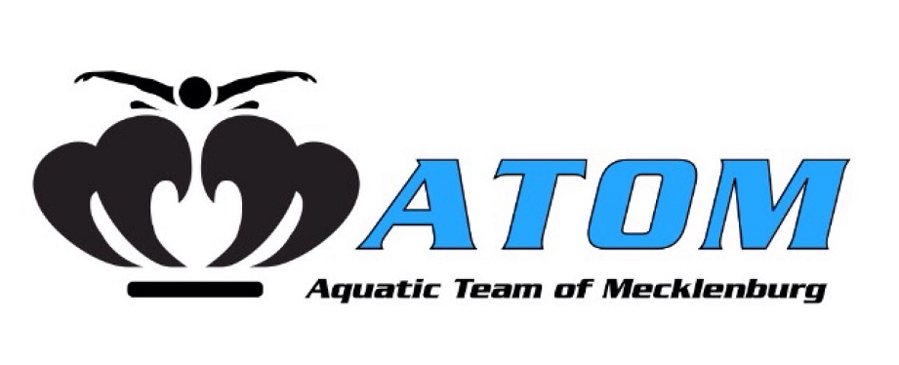
2018-2019 Required Practice Equipment
White
Jr. Kickbaord
TYR Flexfins
Jr. Snorkel- TYR or FINIS
Mesh Bag
Goggles
Swim Cap
Water Bottle
Pre Team & Purple
Jr. Kickbaord
TYR Flexfins
Mesh Bag
Goggles
Swim Cap
Water Bottle

Blue 1 & 2
Jr. Kickbaord
Jr. Pull Buoy
DMC Elite Training Fin
Ylon-a YSTI Snorkel
Catalyst Stroke Training Paddle- Small
Finis Parachute (Red)
Mesh Bag
Goggles
Swim Cap
Water Bottle
Senior 1 & 2
Jr. Kickbaord
Jr. Pull Buoy
DMC Elite Training Fin
Ylon-a YSTI Snorkel
Catalyst Stroke Training Paddle- Medium
Finis Parachute (Red)
Mesh Bag
Goggles
Swim Cap
Water Bottle
Pre Senior 1 & 2
Jr. Kickbaord
Jr. Pull Buoy
DMC Elite Training Fin
Ylon-a YSTI Snorkel
Catalyst Stroke Training Paddle- Medium
Finis Parachute (Red)
Mesh Bag
Goggles
Swim Cap
Water Bottle
Black
Jr. Kickbaord
Jr. Pull Buoy
TYR Flexfins
Jr. Snorkel- TYR or FINIS
Catalyst Stroke Training Paddle- Small
Finis Parachute (Red)
Mesh Bag
Goggles
Swim Cap
Water Bottle
Ordering Instructions: 1. Visit carolinaswimshop.com 2. Click on Team 3. Enter Access Code: atm092815

