MOR | 4904 Waters Edge Dr., Suite 295, Raleigh, 27606  919-851-3000 www.marlinsofraleigh.com  July 27th, 2022 VOL. 22. ISSUE 48  MOR Contact Info:  MOR Financial Keri Cleary marlinsfinances@gmail.com  MOR @ Riverwood John Fischetti jfischetti@aol.com  MOR @ Ravenscroft Cara Cameron coachcara45@aol.com  MOR @ Ravenscroft Ian Hilbrant morcoachian@gmail.com  MOR @ Ravenscroft Billy Thorne morcoachbilly@gmail.com  MOR @ Ravenscroft Kevin Donnelly KDonn27614@yahoo.com  MOR@Ravenscroft Mike Laubacher Michael.laubacher@gmail.com  MOR @Silverton Paul Elaisa morcoachelaisa@gmail.com  MOR @Silverton Lindsay Takkunen coachlindsaymor@gmail.com  MOR@ Raleigh Jonathan Watson 01silversurfer@bellsouth.net  MOR@Raleigh Darryl Buda darrylbuda@gmail.com  MOR Head Coach Paul Silver morsilver@bellsouth.net  MOR @ Raleigh Alexis Marshall morcoachalexis@gmail.com | 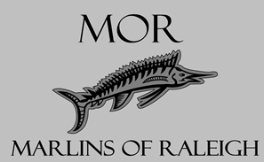  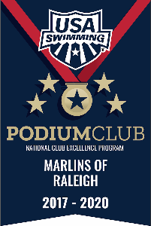
REPORT
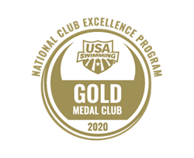

“DEVELOPING CHAMPION ATHLETES AND CITIZENS THROUGH COMMITMENT TO EXCELLENCE IN SWIMMING”

MOR 2022-2023 FALL ENROLLMENT OPEN
MOR 2022-23 Fall Enrollment opened on
Thurs. June 30. There are a few changes and important dates to note:June 30 Enrollment opens. Enrollment fee will be $120 until July 24 when it will raise to $140. Returning MOR swimmers will have their spots guaranteed until July 24th. Our coaches have been doing a number of assessments on new swimmers so we expect to fill our groups. We look forward to seeing you this Fall and feel free to contact the MOR office if you have questions.

163 MARLINS ARE SET TO SWIM IN THE 2022 TAC TARHEEL STATES MEET THIS WEEKEND IN CHAPEL
163 MOR swimmers will finish out the year at the Ncac Tarheel States Meet. This is the best meet to make qualifying times for your goal of moving to the next higher level whether it’s your first B time, A time, Sr. Sectional cut or Futures. Thursday will swim in all 8 lanes with a 15 minute warmup between the 400’s. Fri.-Sun. will swim in 6 lanes with lane 8 as warmup. Have fun. The meet is timed finals this year so just one trip to UNC each day!
Warmup times:Thursday all arrive 4:00 PM
Friday, Saturday, and Sunday:
10 and Unders arrive 7:15 AM
11 and 12s arrive 10:45 AM
13 and Overs arrive 2:15 PM
Parking: Parking on Thursday & Friday will be metered parking. The best parking option will be the Ram's Head parking deck. There is a shuttle (U and RU) that is scheduled to run from Ram's Head to the Front of Smith Center that can be taken and comes in 15-minute intervals in front of the parking deck. These are free to take. If you walk from the Rams Head lot, plan on 15-20 minute walk. On Saturday & Sunday, Parking will be available at the Manning or Williamson lot near the facility. Parking on Friday will be free after 5pm and the remainder of the weekend. Payment for parking must be done through the "Park Mobile" App. NCAC will not be responsible for any parking tickets or any other issues with UNC Parking & Transportation. No chairs are allowed for swimmers on the deck. Parents sit together to cheer for our team! Team Attire: Shirts – Thursday white, Friday white, Saturday grey, Sunday black. Caps-silver Suits-Speedo. Bring a healthy snack, water, and be ready to swim fast, cheer loud and have fun!

29 MARLINS ARE SET TO SWIM IN THE 2022 FUTURES CHAMPIONSHIP
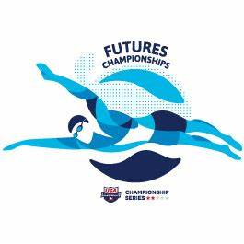
The aquatic center address is: 275 Convention Dr, Cary Warmup times:Wednesday through Saturday:
For preliminaries arrive at 7:30 AM, finals 4:40 PM
Parents should together sit in the gallery to form a loud cheering section. Spectator tickets are close to selling out. Parking will be a challenge so arrive early to get a spot. Team Attire: Shirts -Wednesday white, Thursday grey, Friday navy, Saturday Black. Caps-White for AM Black for finals, Suits- Speedo tech suits. Bring a chair to sit in, bring sunscreen and dark goggles for outdoor warmup. Bring lighter goggles for inside racing. Bring a healthy snack, hydrate and be ready to swim fast, cheer loud and have fun!

MOR FINISHES 5TH AT NC SR CHAMPS WITH 1 CHAMPION!
33 Marlin swimmers represented MOR in events at the NC Senior Long Course Championship this past weekend in Charlotte. MOR finished fifth in the combined score with 604 points. Clara Carson led the way with a win in the 1500 freestyle and two third place finishes in the 400 and 800 freestyle events. Others scoring in the top eight are Rosemary Helmedag, Saylor Penny, Drew Davis, Kyle Countie, Ian Frazer, Reiley Purcell, Molly Curran, and Garreth Parsons. MOR had seven relays score in the top eight with the highlight being the Male 400 Medley A team and the Female 400 free B team both finishing in fourth place. Congratulations to all swimmers! The next meets up for these swimmers is Tarheel States.

USA SWIMMING SCHOLASTIC ALL AMERICA APPLICATION DUE SEPTEMBER 6
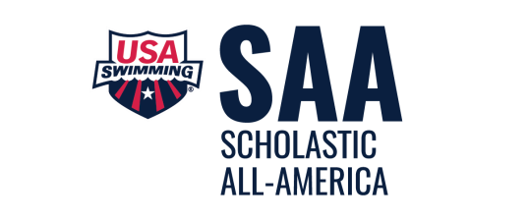
Applications for the USA Swimming Scholastic All-America Team are available and due August 31. All MOR swimmers who achieved a 2022 Winter Jr. National Time and have a 3.5 GPA should submit the application which can be found here: https://www.usaswimming.org/times/popular-resources/scholastic-all-america
Qualified swimmers must have a transcript for the complete 2021-2022 academic year available for uploading to the application. Contact your school early as schools sometimes move slowly on this. have a transcript for the complete 2021-2022 academic year available for uploading to the application.

DEADLINES
July 24 Enrollment price goes up. Returning swimmers spots guaranteed until this date.
Sept. 6 USA Swimming Scholastic All-America applications due.

CHAMPIONSHIP COUNTDOWN
July 26-30 Zone All-Star Champs Now
July 27-30 USA Swim Futures Now
July 29-31 Tarheel States Now
Aug 1-5 Jr. Nationals 1 week

TENTATIVE SCHEDULE
(TENTATIVE UNTIL HOSTS CONFIRM)
Tentative Summer Schedule
June 30 MOR 2022-2023 Enrollment opens
July 26-30 Zone All-Star Meet-Tupelo, Miss
July 28-30 Ncac Tarheel States-UNC
July 27-30 Futures-Cary
Aug. 1-5 USA Swimming Jr. Nationals-Irvine, Ca
Sept. 1-14 USA Swimming Required Registration
Oct. 21-23 MOR Kickoff Meet
Nov. 11-13 MOR Atlantic Invite-Pullen
Nov. 18-20 Yota Turkey Meet-NCSU
Dec. 2-4 Atom Invite-Charlotte 12-U 1 A time, 13-O 2 13-14 AA strokes
Nov. 30-Dec. 3 US Open-Greensboro
Dec. 7-10 USA Swimming Winter Jr. Nationals-Greensboro

