MOR | 4904 Waters Edge Dr., Suite 295, Raleigh, 27606  919-851-3000 www.marlinsofraleigh.com  Feb. 1st, 2023 VOL. 23. ISSUE 21  MOR Contact Info:  MOR Financial Keri Cleary marlinsfinances@gmail.com  MOR @ Riverwood John Fischetti jfischetti@aol.com  MOR @ Ravenscroft Cara Cameron coachcara45@aol.com  MOR @ Ravenscroft Ian Hilbrant morcoachian@gmail.com  MOR @ Ravenscroft Billy Thorne morcoachbilly@gmail.com  MOR @ Ravenscroft Kevin Donnelly KDonn27614@yahoo.com  MOR @ Ravenscroft Naomi Sanders morcoachnaomi@gmail.com  MOR@Ravenscroft Mike Laubacher Michael.laubacher@gmail.com  MOR @Silverton Paul Elaisa morcoachelaisa@gmail.com  MOR @Silverton Lindsay Takkunen coachlindsaymor@gmail.com  MOR @ Silverton Zandy Knoke morcoachzandy@gmail.com  MOR@ Raleigh Jonathan Watson 01silversurfer@bellsouth.net  MOR@Raleigh Darryl Buda darrylbuda@gmail.com  MOR Head Coach Paul Silver morsilver@bellsouth.net  MOR @ Raleigh Alexis Marshall morcoachalexis@gmail.com  MOR @ Raleigh Dakota Mahaffey morcoachdakota@gmail.com |   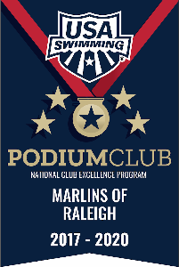
REPORT
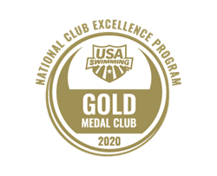

“DEVELOPING CHAMPION ATHLETES AND CITIZENS THROUGH COMMITMENT TO EXCELLENCE IN SWIMMING”

MOR SWIM-A-THON THIS WEEKEND, TOTAL OVER $47,000!

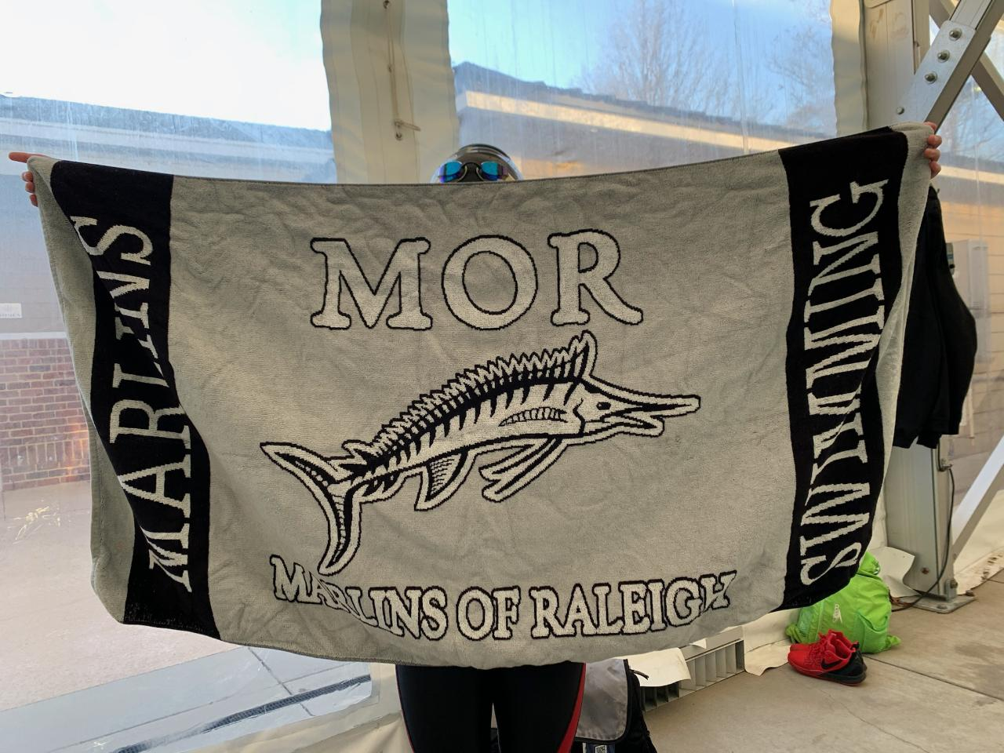
$400 $350
MOR’s Swim-A-Thon will be held this weekend. The schedule has been communicated to each group by the staff and the fun begins soon! Raleigh groups swimming at Pullen or St. Mary’s on Saturday, be aware that the Krispy Kreme run in Saturday morning and traffic will be a challenge. You have until Feb. 28 to collect money towards prizes including the $400 needed to earn a MOR towel with your name on it or the chance to throw a pie in your coach’s face. Thanks to all your help, the MOR Swim-A-Thon total is now over $47,000 with the Raleigh Sr. Elite group currently in the lead. If every family raised $100, we would far surpass our goal. Keep up the good work and earn those towels and the pies! This week’s Raffle winners are Joel Bardeen and Ava Cardenas

CHAMPIONSHIPS SEASON IS
UPON US
Championship Season is now upon us and we are excited to swim fast! Parents play a big role in the performance of their children by getting them to the pool on time, making sure they are dressed properly, making sure they rest well between session vs running around the hotel and most important have plenty of food to eat. That’s your # 1 job as a parent. Additionally parents can help by only asking these 3 questions after a race.
1-Did you have fun
2-What did the coach say
3-What do you want to eat.
These three questions have been sited by elite athletes as the ones that allowed them to take control of their swimming and helped build confidence. When you allow your child to handle their swimming they learn what to do and what not to do which is how you raise a confident swimmer. When a parent gives last second tips or post race analysis, it robs the child of being able to learn from their successes and failures and indicates a lack of belief that they can handle this. Just tell them you got this and I love watching you swim.
Parents should also be prepared with the proper swim suits. Since Speedo is our largest sponsor, all swimmers are required to wear Speedo suits in all MOR swim meets. Don’t wait until the last minute to buy a suit because all of the other 3000 swimmers in Raleigh are doing the same thing plan ahead to help keep the stress down on your swimmer. Good luck and have fun watching your child play at swimming.

SUMMER LEAGUE COACHING OPPORTUNITIES
We regularly get requests from summer league teams for coaches. Let your coach know if you are interested in summer coaching and as opportunities come in we will forward them to you.
Here is one for Silverton. We have also had a request from Shepherds Vineyard, Crabtree. You can find contact info on the Tarheel Swimming Association website.
Silverton Coach opportunities:
We are hiring for ALL positions for the 2023 season.
Are you interested in Coaching the Silverton Shark Swim Team? Go to https://silverton-sharks.swimtopia.com/
Then email the application to silvertonsharkscary@gmail.com. Applications are due NO LATER than February 19.

DEADLINES
Feb. 28 Swim-A-Thon deadline to turn in
money.

CHAMPIONSHIP COUNTDOWN
Feb. 16-19 AG Champs 2 weeks
Feb. 23-26 Sr Champs 3 weeks
March 3-5 B/C States 4 weeks
March 10-12 Atlanta Invite 5 weeks
March 16-19 AG Sectionals 6 weeks
March 24-26 Tarheel States 7 weeks

TENTATIVE SCHEDULE
(TENTATIVE UNTIL HOSTS CONFIRM)
Feb. 10-12 MOR SC Qualifier-Goldsboro
Feb. 16-19 NC AG Champs-Charlotte
Feb. 23-26 NC Sr. Champs-Charlotte
Feb. 28 Deadline for donating swim-a-thon money.
March 10-12 Atlanta Invite-Ga. Tech-1 Futures or Ncsa cut.
March 4-5 MOR Regan Rocks-B/C States-Pullen
March 16-19 AG Sectionals-Cary
March 24-26 Tarheel States-Cary
April 29-30 Ncac Quad-
May 19-21 Meet on Hill-1 A time
May 18-21 Martha McKee Open-Charlotte-1 Futures
June 17-18 MOR Liberty Meet-Optimist BB below
June 16-18 Va. Commonwealth Games-Lynchburg-1 A time
June 26-30 World Champ Trials-Indianapolis
July 7-9 MOR LC Qualifier-Optimist
July 13-16 NC AG Champs-Cary
July 20-23 NC Sr. Champs-Greensboro
July 26-29 Futures-Ocala, Fla
July 28-30 or Aug. 4-6 Tarheel States

