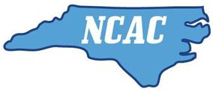
Medical Release Form for Team Travel

I, _____________________________(parent), give permission for _____________________(athlete)
to travel to out of town swim competition with North Carolina Aquatic Club. In the unlikely event that my child will require medical attention, adult supervisors, coaches, or parents associated with North Carolina Aquatic Club have my permission to have my child treated in an appropriate way by qualified medical personnel.
Date: __________________ Limitations (if any):________________________________
Signature (Parent or Legal Guardian): _________________________________________
Printed Name of Parent or Legal Guardian: _____________________________________
Home Phone: ___________________________ Cell Phone: _______________________

Minor’s Medical and Physician Information
Athlete’s DOB: _______________ Last Tetanus Booster: _________________________
Known allergies to Drugs or Foods: ___________________________________________
________________________________________________________________________
Special Medical or Other Information:_________________________________________
_______________________________________________________________________
Present Medication: ______________________________________________________
_______________________________________________________________________
Athlete’s Physician: ____________________________ Phone: ____________________
Insurance Carrier: _________________________________________________________
Policy Number: ________________________ Group Number: _____________________

