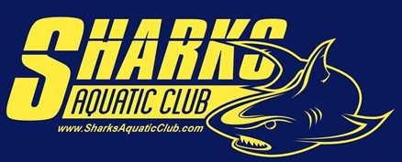
2022- 2023 Short Course Meet Schedule

DATE | LOCATION | MEET | GROUPS
September 8-Thursday | KM High School | Team and Individual photos | All Groups
September 17 - Sat morning only | Urash’s home is start point | Open Water race | For TS, Makos, Seniors only
September 17- Sat | Urash Home on the lake | Team Kick Off Celebration and cookout | For all groups and families(this is not a practice but a celebration for the entire family)
September 24-25 | TBD | Tri Meet SAC, Lifetime, Sailfish | HH1, HH2, TS, Makos, Senior
October 21- Friday | Shelby Corn Maze | Team Outing | For all groups
October 22 - Sat | Shelby HS | Blue vs. Yellow  Shark A Thon | All Groups (This will be our first annual swim a thon fundraiser)
October 29-30 | Huntersville | Great Pumpkin Meet | For HH1, HH2, TS, Makos, Seniors
November 5 - Sat | Kings Mountain | Intrasquad meet | HH2, HH 1, and RS only
November 11-13 | Charlotte, MCAC | Sailboat Veterans Day | HH 1 & 2, TS, Makos, Seniors
December 2-4 | Charlotte, MCAC | ATOM Invite | TS, Makos, Senior- BB swimmers and above(must have a BB time in 2 different strokes)
December 9-11 | Charlotte, MCAC | QCD Invite | For all B/C swimmers who were not qualified for Atom Invite(RS, HH, TS, Makos, Senior)
December 23-25 | No practice | Christmas Break | All Groups are off
January 7 - Sat | KM High School | IMX tough meet Intrasquad | TS, Makos, Seniors
January 27-29 | Middle Tyger YMCA,  Duncan, SC | February Fling in Jan | HH 1 & 2, TS, Makos, Seniors
February 11-12 | Hickory YMCA | Chris Peterson Invite | All Groups
February 16-19 | Charlotte, MCAC | NC Age Group Champs | For all qualified swimmers
February 23-26 | Greensboro | NC Senior Champs | For all qualified swimmers
March 4 - Sat | Isothermal College | Pirates Gold meet | For all groups
March 24-26 | Charlotte, MCAC | BRSL Championships | For all groups

