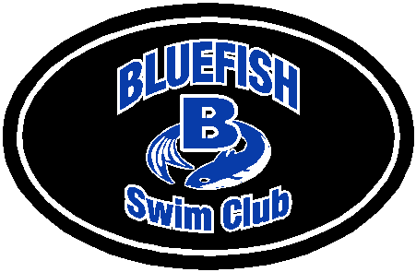 BLUEFISH FRIENDS AND FANS

The Bluefish Swim Club is a developmental program that strives to develop swimmers from entry-level competitors into senior elite athletes. This requires a tremendous amount of time, work, and dedication not only from our coaching staff, but from our children as well.

Bluefish swimmers and coaches have had tremendous success on the local, national and international level! Our success continues outside of the pool. In addition to training for up to 30 hours weekly, our swimmers are full time students. We are proud to say that Bluefish High School seniors go on to some of the highest caliber academic institutions and swimming programs in the United States.

With this success and dedication comes an experience of a lifetime for our swimmers, along with significant expense. We need your help. The Bluefish Friends and Fans are reaching out to businesses in our local communities as well as families for sponsorships and donations. Please consider sending a “Good Luck” message to your favorite swimmer or placing an advertisement to showcase your business.

Thank you for supporting the Bluefish Swim Club. Your help is greatly appreciated.

Sincerely,

Dave Thomson
President, Bluefish Friends and Fans
www.bluefishswimclub.com

Meet Program Sponsorship Opportunities

1 meet 2 meets 3 meets 4 meets
€ Business Card $50 $90 $120 $150

€ ¼ Page Advertisement $75 $135 $180 $225

€ ½ Page Advertisement $100 $180 $240 $300

€ Full Page Advertisement $200 $360 $480 $600

€ Full Page Full Year Advertisement plus Website link - $800

€ “Good Luck” Message $10 $20 $30 $40
(message limited to 75 characters, including spaces)

Name of Swimmer: ______________________________________________________________________
------------------------------------------------------------------------------------------------------------
Corporate/Business Information:

Business Name: __________________________________________________

Address: ________________________________________________________

________________________________________________________________

Phone: __________________________________________________________

Email: ___________________________________________________________

Website (if applicable): ________________________________________________

Contact Person: ___________________________________________________

“Good Luck” Message: (limited to 75characters, including spaces - PLEASE PRINT).
_________________________________________________________________

________________________________________________________________

________________________________________________________________

Method of Payment:
_____ Cash _____ Check (Make check payable to Bluefish Boosters, Inc.)

Instructions for Business Card/Advertisement Submission:
Submit hard copy text to: Bluefish Boosters, Inc., c/o Chris Choate, Bluefish Friends and Fans 145 Pokanoket path, Wrentham, MA 02093 or email your advertisement to: Chris Choate, c.choate@comcast.net . Place your business name in the subject line of your email. Please send only .jpg, .pdf, .doc or .docx files.
THANK YOU FOR YOUR SUPPORT

BLUEFISH FRIENDS AND FANS

Thank you for your support of our swimmers.

Charitable donation in the amount of: $________________

Received by: ____________________________________ Date: __________

Donated by: Name:_________________________________________________

Address:________________________________________________

________________________________________________

Bluefish Boosters, Inc. is a recognized non-profit organization under section 501(c) (3) of the Internal Revenue Code. ( I.D.#14-1875421)

BLUEFISH FRIENDS AND FANS

Thank you for your support of our swimmers.

Charitable donation in the amount of: $________________

Received by: ____________________________________ Date: __________

Donated by: Name:_________________________________________________

Address:________________________________________________

________________________________________________

Bluefish Boosters, Inc. is a recognized non-profit organization under section 501(c) (3) of the Internal Revenue Code. ( I.D.#14-1875421)

