Friends of Cape Cod Swim Club

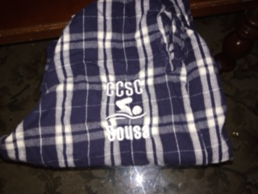
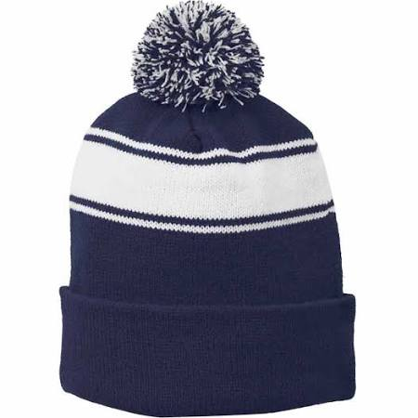

Hat: $20.00 w/CCSC & Name
Pants: $30.00 w/ CCSC & Name

Items colors may be slightly different

Sizes

Children Sizes: Small ____ Medium _____Large _____ X-Large ____ 2XL ______ 3XL ______

Adult Sizes: Small ____ Medium _____Large _____ X-Large ____ 2XL_____ 3XL ______
+ $3.00
Hats One Size: _____ Last Name__________________

(Please indicate number of each size)

Total Enclosed $________________

___________________________________________ _____________________________
SWIMMER Name Swim group

Make checks payable to: Friends of CCSC
The sale ends Saturday, October 21, 2017.

Sizes | Width(inches) | Length(inches)
YS | 20 | 23.25
YM | 23 | 26.25
YL | 26 | 28.5
S | 28 | 30.75
M | 29 | 32
L | 31 | 32.5
XL | 33 | 33.25

Size Chart

