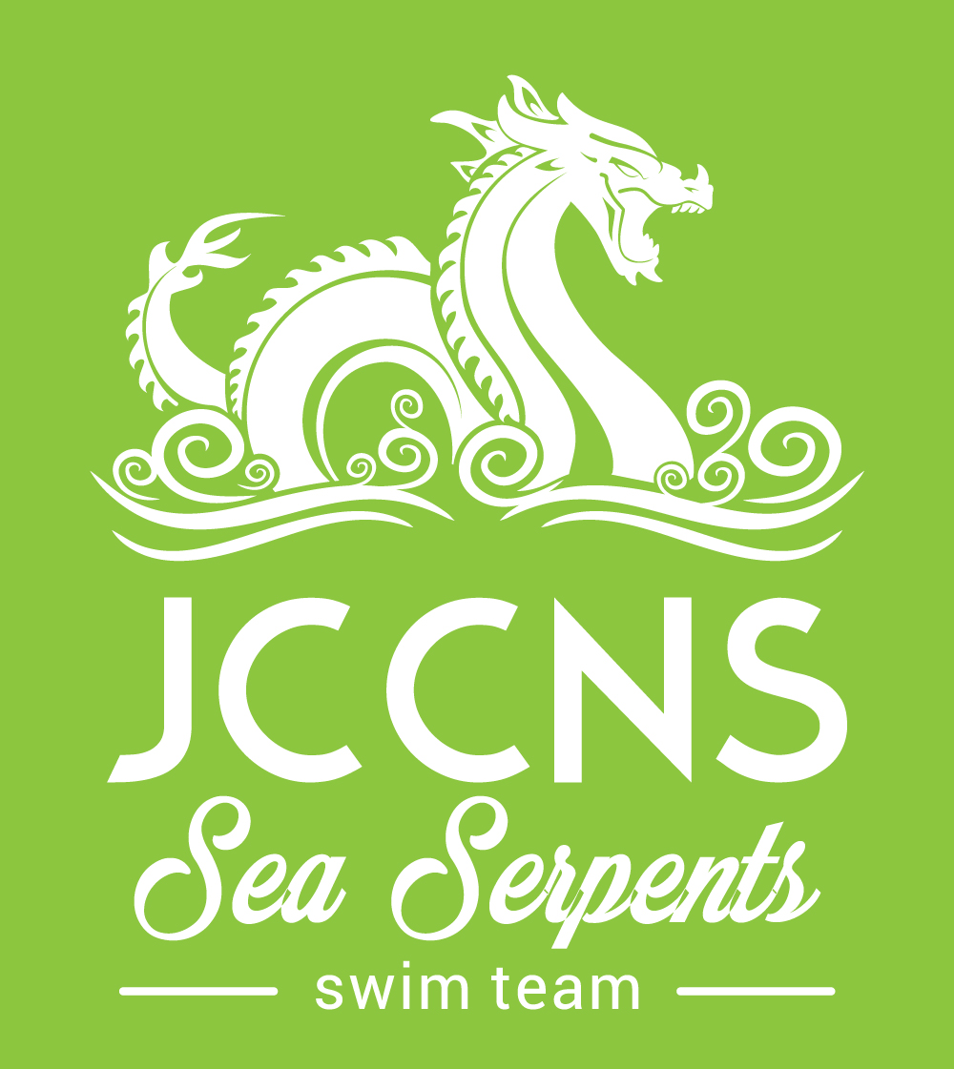
JCCNS Registration Form: 2019-2020 Season
Swimmers Information
Child’s Name:_________________________________ Gender: M / F
Date of Birth:_____________________ Age :____________ Grade: __________
Parent/Guardian Information
Parent/Guardians Names: _______________________________________________________
Home Address:________________________________________________________________
Reachable Phone Number(s):______________________________________________________
Email Address:________________________________________________________________
Additional Emergency Contact:
Name:
Reachable Phone Number:
To be completed by coaches:
Group Placement/Fee: Lil’ Lochs $105 Juniors / Olympic Way $125 USA C $165
USA B $185 USA A $205 USA Senior $225

Indicate Payment: Automatic Withdrawal Sept- June: 10 months or Full Year 5% discount

A 30 day written notice is required to pause the automatic monthly withdrawal.

Swimmers Current Membership Status: Members In process Non members
JCCNS Membership is required

I have read and will abide by the Team Uniform and Tech Suit Policy ______

I have filled out and submitted the JOT Form MAAPP Policy _______

Photography and/or video may be taken of your swimmer for educational and promotional purposes throughout the season. If you would NOT like your swimmer to be photographed and/or videotaped please let Head Coach Ashley know via email avieira@jccns.com.

_______________________________________________ _________________________ Parent/Guardian Signature Date

