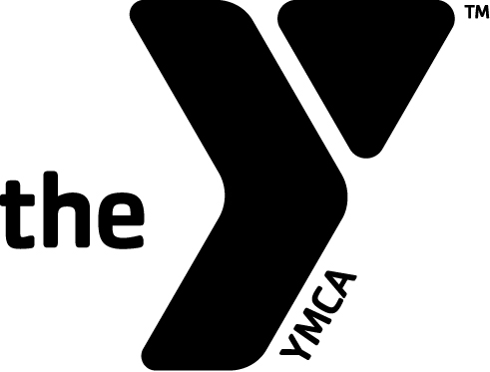
NORTH CANTON YMCA
INVITATIONAL

Date: Sunday March 4, 2018

Location: North Canton YMCA
200 South Main St.
North Canton
330-499-2587

Registration: Begins @ 12:30pm

Time: Warm ups begin at 1:00pm
Meet starts at 1:45pm

Fee: Nemesis Swim Team members: FREE
Individual event: $2.00
Relay event: $8.00
Register and Pay at the door

Timing: Hand times will be used: NO TOUCH PADS

Event Order: Dual Meet order of events will be repeated until all swimmers are done competing.

Contact Debbie Josif @ 330-499-2587 or djosif@ymcastark.org with any questions.

