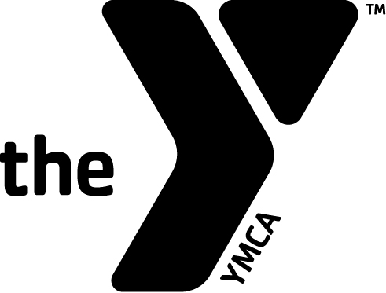
NORTHEAST OHIO YMCA SWIM LEAGUE
OUTSTANDING SWIMMER
SPIRIT – MIND – BODY COLLEGE SCHOLARSHIP
The Northeast Ohio YMCA Swim League would like to recognize 2 talented swimmers from our Northeast Ohio League who have represented their YMCA with distinction. These individuals have been outstanding competitive swimmers and contributors to their YMCA, as well as being good students, active in the church and community, and all – around good citizens. As long as the funding is available each year the Executive Committee, League President and Executive Committee Contact will select 2 swimmers from nominations submitted by a YMCA Swim Coach, YMCA Aquatic Director or a YMCA Executive Director. The recipient name (s) will be announced at the Northeast Ohio Swim League Championship Meet. Nomination Forms along with proper documentation is to be sent to the Executive Committee contact and received by FEBRUARY 7, 2020. After that date the above named committee will review all nominations, and make their choice (s) for 2020.
Each recipient will be award a Continuing Education Scholarship” stipend of $1500 that will be sent to the school (trade school, 2 year college, college or university) of their choice and may be used for tuition fees, room and board (only if living on campus), or books and supplies. This is a one – time grant and cannot be renewed. Guidelines for disbursement of these Scholarship Funds will be out-lined in a letter to each recipient.
To Qualify:
- Nominee must be a member of good standing of a YMCA that participates in the Northeast Ohio YMCA Swim League.
- Spirit – Be an active participant and volunteer by serving others, at your place of worship, or community service organization.
- Mind – Must be a graduating senior, with a minimum 2.5 GPA
- Body – Must have been a member and fully participated for at least three years in the Northeast Ohio YMCA Swim League, competed with the team your senior year and demonstrate leadership skills with your YMCA team.
Nomination requirements:
- Person nominated must submit an essay, 500 words or less typed, discussing what/who has helped him/her become the young man or women he/she is today; involve the spiritual, mental and physical attributes you have acquired.
- Nominator must complete the nomination form which must be signed by the Executive Director.
- Nominator must attach letters of recommendation. Please see attached document for more information.
- The Nomination Packet must be mailed or emailed to the following address and be received by or on
FEBRUARY 7, 2020:
North Canton YMCA
200 South Main St.
North Canton, Ohio 44720
Attention: Debbie Josif
Or
Emailed to Debbie Josif: djosif@ymcastark.org (must be received by or on February 7, 2020)

Page 2 of 3 Pages
Nomination Form
Northeast Ohio League
YMCA Outstanding Swimmer Award
Each YMCA participating in the Northeast Ohio Swim League is entitled and encouraged to send nominations to receive “The Spirit – Mind – Body College Scholarship.” This form along with the swimmer’s essay and letters of recommendation must be mailed to Debbie Josif, 200 South Main St., North Canton, Ohio 44720 or emailed to djosif@ymcastark.org.
All materials must be received by or on February 7, 2020
Please Type or Print the information on this form: Candidates Name: (Last) _______________________ (First)_____________________Age:______ Sex: (M)___(F)___
Address: ______________________________________________
City: _______________________________ Email: ______________________________________
State: ___________ Zip________________ Phone: (______) ______________________________
Citizenship Status: ____________________
Northeast Ohio YMCA Swim League Information: YMCA Name: ___________________________________________
YMCA Address _____________________________________________
Zip: ______________________ Phone: (______) ___________________
YMCA Team Name: __________________________ Number of years on team: _____________
Current Coach: __________________________ Coaches Phone: ______________________
Coaches Email: __________________________
Educational Information: High School: ____________________________ GPA: __________
Other information: Church Name: _________________________ Local Newspaper: ______________________
Nominated By: _______________________ Relationship to Swimmer: __________________________
Signatures Required: Applicant’s Signature: ______________________________________________ Date: ____________________
Executive’s Name: ______________________________ Signature: _______________________________ Date: ____________________
Coach’s Name: ___________________________________ Signature: _________________________________ Date _____________________

Page 3 of 3 Pages
LETTERS OF RECOMMEDATION
NOMINATOR: A letter of recommendation covering the items listed below must be attached to the nomination packet from the Nominator and at least two (2) other people listed: YMCA Executive, Physical or Aquatic Director, Swim Coach, Clergy, School Principle, Teacher or School Advisor, or Community Leader. Also attach any copies of newspaper clippings you may have on this individual.
- Comments on the personal qualities of this candidate such as leadership, etc.
- Indicate how this person exemplified the YMCA purpose and values in daily life such as responsibility, dependability etc.
- Why do you think this person should be considered for this award?
- School, Club Activities, and / or Organizations, which this person has been a member.
- Church Involvement and Community Activities.
PLEASE KEEP YOUR NOMINATION PACKET TO 10 PAGES OR LESS

