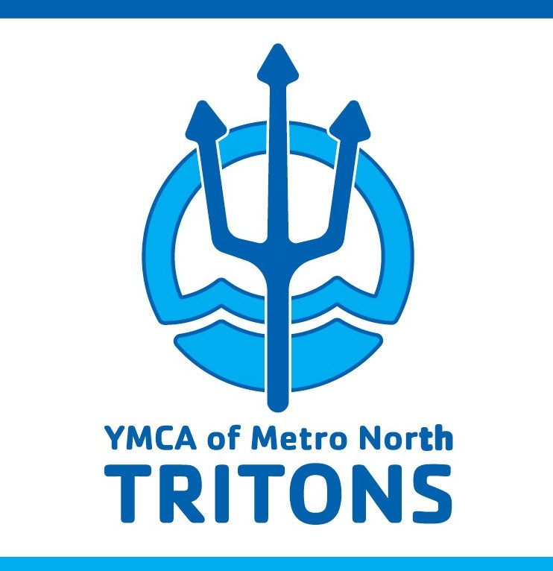

SWIM TEAM HANDBOOK

Lynn YMCA  20 Neptune Blvd  Lynn, MA 01902  781 581-3105 | Melrose Family YMCA  497 Main Street  Melrose, MA 02176  781 665-4360 | Torigian YMCA  259 Lynnfield Street  Peabody, MA 01960  978 977-9622

http://bit.ly/YMNTritonsSwim
METRO NORTH CONTACTS

Benjamin Allis
Association Aquatics Advisor
781 665-4360
ballis@metronorthymca.org

Vicky L Brienza
Team Manager
vbrienza@metronorthymca.org

TBA
Head Coach
@metronorthymca.org

Andrew Lamson
Aquatics Director
978 977-9622
alamson@metronorthymca.org

Membership Information contacts:

Lynn YMCA
Rosa Robles
Welcome Center Supervisor
781 581-3105
rrobles@metronorthymca.org

Melrose YMCA
Kelly Curtis
Membership Director
781 665-4360
kcurtis@metronorthymca.org

Torigian YMCA
Jessica Kent
Membership Coordinator
978 977-9622
jkent@metronorthymca.org
MISSION STATEMENT

Metro North YMCA Mission Statement:
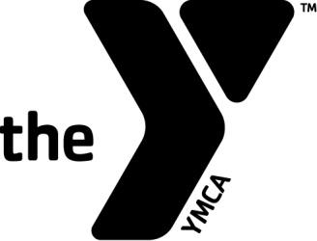
The YMCA of Metro North builds strong kids, strong families and strong communities by enriching the lives of all people in spirit, mind and body.

Metro North Triton Swim Team - - Mission Statement:

The Metro North Triton swim team is dedicated to help swimmers improve their times and achieve their goals while instilling in them the core values of the YMCA. The Team teaches that swimming can not only help you physically, but will also be your teammate in life giving you the motivation and dedication to tackle any obstacle in your path.

COMMUNICATION
- Regularly visit our Triton WEBSITE TeamUnify at YMNTritons.com. The website is constantly updated with the new information that we receive & will be the best source of information for you. Please reference it first before questions come to the pool as most of them can be answered by the site!

- If you are new to Metro North Triton Swimming, you will need to create a user name and password to access the full website. If you are a returning member, please review your information for accuracy. It is important that we have an accurate email address for you as much team communication is done via email. In addition you may wish to “enable SMS” on your account in order to receive text messages in the event of an emergency.

- While you cannot speak to the coaches during practice, feel free to come before or after practice. If you need to address a specific issue, contact Vicky Brienza, Team Manager vbrienza@metronorthymca.org

- For other information, concerns or general questions you can email YMNTritons@metronorthymca.org

- If you have any concerns regarding our swim program please contact Association Aquatics Advisor, Benjamin Allis at Ballis@metronorthymca.org.

- Questions regarding memberships, operating hours and all things YMCA can generally be answered at the Welcome Center in the YMCA Lobby. If you need confidential assistance please contact the Membership Director at your respective location.

- Please “like us” on Facebook!
- Finally, there are a couple of great apps that you may want to add to your smartphone including “on deck for parent” and “meet mobile.” On deck for parent is available for download via the home page of our website. To logon use the user name and password you use to access our team website. The team code is “nesmymcas”.

LEAGUES
We participate in two leagues: YMCA Swimming and USA swimming as YMNT. USA Swimming is optional but encouraged and is discussed in the next section.
Metro North Tritons compete in two seasons: the Winter Short Course Season (September – April) and Summer Long Course Season (April – July/August). Metro North is a year round program.
As a competitive swimming program, Metro North supports YMCA swimming and United States Swimming. The focus of Metro North is on providing opportunities for all of our athletes to showcase their hard work and dedication. As such as swimmers are encouraged to compete in the meets which they are eligible and the meets that are determined by the coaching staff of Metro North. All of our swimmers are eligible for all meets sanctioned by the YMCA leagues and USA (if registered).

Winter Short Course (SC) Season (September – April):
Short Course season is named based on the measure of distance in which the swimmer compete (25 yards or 25 meters). The SC season starts in September and the regular season lasts into mid-January. Championships for SC are held from mid-January through March/Early April, depending on the level of competition for which the swimmer qualifies. Tritons train and compete in 25 yard pools during this season.

Summer Long Course (LC) Season (April-July/August):
Long Course season is named based on the measure of distance in which the swimmer competes (50 Meters). The LC season begins in late April and the regular season lasts into mid-July. Championships for LC are held from mid-July through mid-August, depending on the level of competition for which the swimmer qualifies.

YMCA SWIMMING
Ever since YMCAs began offering competitive swimming and diving in the early 1920’s, these sports have proved to be excellent opportunities for putting into action the YMCA’s mission. Over 1000 YMCAs offer competitive swimming and/or diving with over 50,000 youth participating. Over 1400 YMCA swimmers annually compete at the YMCA National Championships, making it the largest youth swim meet in the country. YMCA competitive swimming and diving programs are for the beginning swimmer to the most competitive and skilled swimmer and helps to train individuals of all ages to compete in League, State, Area and National Championships.

The Eastern Mass. YMCA Swim League is composed of twenty-five teams separated into five divisions.
New England YMCA Swim League is composed of swim teams from Connecticut, Maine, Massachusetts, New Hampshire, and Rhode Island.
National YMCA Swim League is composed of teams from all fifty states.

YMCA meets are sanctioned by the YMCA and officiated by YMCA officials. Competition is divided by age and gender.
Class “E” is 8 and Under
Class “D” is 9-10
Class “C” is 11-12
Class “B” is 13-14
Class “A” is 15-18
A swimmer’s age is determined by his/her age as the first day of the meet. If you have specific questions regarding this matter discuss it with your site coordinator. This will be changing come 2019.
Swimmers are expected to compete in the YMCA meets for which they are eligible and the meets targeted by Metro North coaching staff.
YMCA Championship Season:
- Districts (Eastern Mass.)
- New England Championships
- National Championships
To be eligible for the Short Course YMCA Championships season (February – April), a swimmer must have competed in two (2) regular season YMCA meets prior to the beginning of Y Districts and have achieved the event’s qualifying time standards during the regular season.

Definition of closed Y meets is as follows from the YMCA of the USA Black Book: YMCA inter-association meets are closed competitions (Rules That Govern Rule I Sec. 7) in which:
• At least two (2) teams from different YMCA associations take part
• At least six (6) competitors from each team participate
• At least six (6) events are contested, including one four-person single-sex relay
• At least two (2) YMCA Certified officials are present for the conduct of the meet and
the meet is conducted under YMCA rules. USA Swimming Certified Officials may
assist with the officiating at such meets, provided that there are at least two YMCA
Certified Officials, one of whom is the Referee.
A closed YMCA invitational meet lasting two or more days may be counted as two YMCA meets for the purpose of meeting the YMCA National Championship qualifying requirement of competing in two closed inter-association meets. In order to take advantage of this special allowance, a swimmer must compete in at least two separate days of the meet. A single meet, regardless of length of days contested, may not be counted both as one of the closed inter-association meets and a sanctioned championship meet for the purpose of
satisfying those qualification requirements for YMCA Nationals.
(By this ruling the Virtual Meet counts as 1 closed meet, and Invitational like the Thanksgiving meet can be counted as 2 meets if a swimmer competes on 2 days.)
.

USA SWIMMING

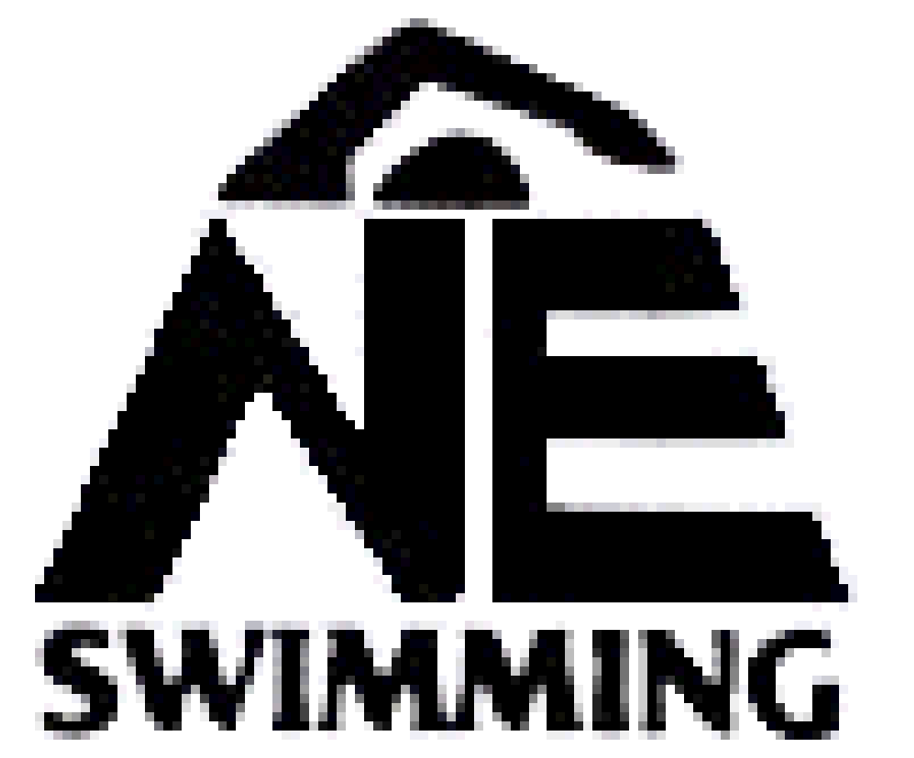
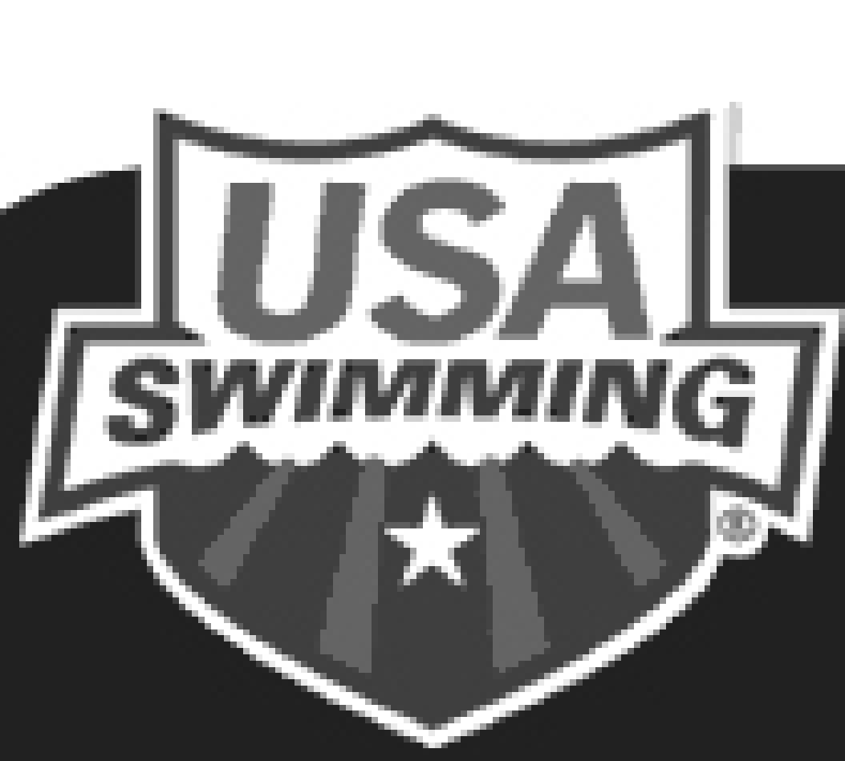

Our team also attends USA Swimming meets. Participation is optional but encouraged, especially after a full year on the team. It provides swimmers with an opportunity to compete at additional meets. USA Swimming participation must be approved by a coach.

United States Swimming is the governing body for all types of competitions involving American Swimmers. All teams for all international meets, including the Olympic Games, are selected by United States Swimming. As such qualifying time standards are often more rigorous than YMCA qualifying times and they provide an excellent pathway for athlete, coach, and program goal setting.
USA Meets:
USA Swimming meets are sanctioned by the United States Swimming Organization through New England Swimming (our Licensed Swimming Committee). Competition is divided by age and gender.
8 & Under
9-10
11-12
13-14
15 & Over
Open (Open means that events offered in this category do not have age restrictions - anyone can participate)

Meets are often classified as A, B, C or some combination of letters. These classifications refer to the cutoff times for the fastest and slowest swimmers that are allowed to swim at that meet. These A, B, or C time standards are determined based on the fastest performances in the US during the last few years, called National Age-Group Motivational Times (top 16). Motivational Times can be located on our website under ‘Time Standards’ or on USA Swimming’s website.
In USA A/B meets anyone with an A or B time can compete, but C swimmers cannot. In B/C meets anyone (even without a time) can compete, but A, or faster cannot. Still other meets have no time limits and anyone can compete. Most of meets, we attend are open to all level of swimmers.
USA meets provide swimmers with a unique opportunity to compete in an environment similar to a championship style format, quality of opposition, and intensity of racing.

USA Championship Levels:
- Regional Championships
- 12 and Under / 13-18 Age Group Championships
- Senior Elite Championships
- Senior Championships
- Sectional Championships
- Junior Nationals
- US Open Championships, Senior Nationals, Grand Prix
- Olympic Trials
To be eligible for an USA Championships meet, a swimmer must be a member of USA Swimming and have achieved the event’s qualifying time standard within one year prior to the meet start date. To be eligible for the Long Course Championship season (July - August), a swimmer must have achieved the event’s qualifying time standard within one year of championships
Please note that:
- Registration fee $125.
- New Swimmers to USA need to provide birth certificate.
- Swimmers can choose which events they will compete in.
Registration and renewals typically takes place in the Fall/Winter and are good for twelve months.

YMCA Diving

TEAM APPAREL & EQUIPMENT

We are pleased to partner with Varsity Swim Shop in North Reading, MA and Speedo to provide team apparel and equipment this season. All items can be ordered from Varsity Swim via their on-line store by following the instructions below.

To order from Varsity Swim Shop:
In order to access your Team Page, your computer must have JavaScript enabled. For help in enabling JavaScript please go to this link: JavaScript enable link

Access your Team Page through the Team Gateway at varsityswim.com.
Your team login is: MetroNorth (case sensitive)
Your team password is: Tritons (case sensitive)

The login will direct you to a page where you must create a personal login and password. Because you initially reached this page through the Team Gateway using your team password, you will always be linked to your team. Do not use your team login name (MetroNorth) as your personal login.
Once you have created your own personal login and password continue to fill out the personal information and click the Submit button on the lower right hand corner of the page. You will then be automatically directed to your team store.
When returning to our website simply enter your personal login and password at the Team Gateway and that will take you to your personal account information (at which you can edit this information). At this point, click again on the Team Gateway and that will take you to your team store.

When on your Team Page please only order items on that page, do not browse the website and order other non-team items. If you wish to purchase items outside the Team Page please log out of the Team Gateway.

If you have any questions or problems, please email us at: info@varsityswim.com.

POOL LOCATIONS

Lynn Family YMCA
20 Neptune Blvd
Lynn, MA 01902

781 581-3105

Melrose Family YMCA
497 Main Street
Melrose, MA 02176

781 665-4360

Torigian YMCA
259 Lynnfield Street
Peabody, MA 01960

978 977-9622

PRACTICE GROUPS
What to bring: Water bottle, labeled practice equipment, Goggles and caps

Practice Schedule can be found online at http://bit.ly/YMNTritonsSwim They are listed by pool location. Please be on time and ready to swim! At your respective locations.

IMPORTANT NOTE – THERE IS NO PRACTICE IN METRO NORTH
IF THERE IS THUNDER & LIGHTNING

-PRACTICE GROUPS-

Polliwog: This group of swimmers are interested in learning the basics of being part of a swim team. They are not on the team but will practice along them. Once they are ready they will be moved into a group and be part of the team and attend meets.
Guppy: This is a group designed for those swimmers who are aged 10 and under that are able to:
- Swim 25 yards Backstroke
- Swim 25 yards Freestyle with an understanding of basic rotary breathing
- Swim 25 yards of a basic Breaststroke or Butterfly
- Dive off the side of the pool

By October, to continue to swim in our “intermediate” lane, they should be able to:
- Swim 200 yards freestyle consistently, with flip turns.
- Keep a 1:30 for a 50 Freestyle at practice
- Be able to perform a 50 yard swim of each stroke legally
- Be able to show that they have made progression on their start dive.
- Show that they have the right frame of mind at swim practice (listening skills and being able to understand what ‘sets’ are at practice)

What they should be able to perform in order to move into our Fish group at practice:
- Show an understanding of drills for each stroke
- Able to perform a 100 of each stroke legally
- 100 freestyle 2:30 minutes
- 500 yards freestyle consistently, with flip turns
- Able to perform an effective dive from the starting blocks
- Can listen to direction and respect coaches and other swimmers

Minnow: This Group is for swimmers approximately 8-13 years old, who are able to:
- Swim 500 yards of freestyle with flip turns without stopping
- Swim 50 yards of breaststroke, butterfly and backstroke
- Dive off the blocks
- Swim 10 50’s of freestyle holding 1:15

By October, to continue to swim in our “intermediate” lane they should be able to:
- Swim 1000 yards of freestyle with flip turns
- Legally swim at least three of the four strokes
- Understand how to use proper technique in their strokes and have made improvements
- Swim 10 x50’s of freestyle holding 1:05
- Consistently come to at least four of the five practices a week, ready to swim
- Can listen and respect coaches and other swimmers

Fish: The group is for swimmers approximately 8-15 years old, who are able to:
- Swim 1000 yards of freestyle with flip turns without stopping
- Swim 50 yards of breaststroke, butterfly and backstroke
- Dive off the blocks
- Swim 10x50’s of freestyle holding 1:05

By October, to continue to swim in our “advanced” lane they should be able to:
- Swim 1500 yards of freestyle with flip turns
- Legally swim the four strokes
- Understand how to use proper technique in their strokes
- Swim 10 x50’s of freestyle holding under 1:00
- Consistently come to at least four of the five practices a week, ready to swim
- Can listen to direction and respect coaches and other swimmers

Flying Fish: What they should be able to perform to join this group:
- Swim 2000 yards of freestyle with flip turns without stopping
- Be able to swim 200 yards of breaststroke, butterfly and backstroke legally with no issue
- Dive off the blocks without hesitation
- Be able to swim 10x 50’s of freestyle holding under :45

By October they should be able to perform the following to continue to swim in the Flying Fish group:
- Swim 3000 yards of freestyle with flip turns
- Be able to swim all four stroke legally under 1:25 for a 100.
- Understand how to use proper technique in their strokes
- Swim 10x 50’s of freestyle holding 35 consistently
- Consistently come to at least four of the five practices a week, ready to swim

COACHES

Vicky Brienza Team Manager
vbrienza@metronorthymca.org

TBA Head Coach
@metronorthymca.org

Chris Asgain Melrose pool

Aly Arsenault Peabody pool

Amy D’Allessandro Melrose pool

Josefa Baez-Diaz Melrose pool

Sam Foley Melrose pool

John Gagnon Peabody pool

Katie Garland Melrose pool

Shane Mahoney Peabody pool

Laura McCormack Melrose pool

Connor McDaid Melrose pool

Meghan McDaid Melrose pool

Heather Sinclair Peabody pool

Jamie Zajac Melrose pool

Stephanie Forte Diving Coach Peabody pool

CODE OF CONDUCT

Rules of Practice: It is important that you attend practice only during your group's scheduled times. Due to varying training schedules, lane assignments, safety reasons and other important factors we cannot allow athletes who show up at the wrong practice to participate. You will bring all your equipment to each practice and an extra pair of goggles in your swim bag. You will RESPECT all coaches and swimmers in your lane and in the pool.

  - Be Responsible:
    - Get to practice early and get in the pool when you are suppose to. If practice starts at 6, arrive a few minutes early and get ready. Be on time.
    - Have all your equipment (fins, paddles, buoys) and water bottles (filled) prepared prior to the start of warm-ups. Use the bathroom before practice, not during.
    - Make sure your lane makes intervals and completes sets.
  - Be Respectful:
    - Allow your team mates to pass when necessary without stopping in the middle of the pool.
    - Make sure everyone in your lane can finish to the wall. Never stand in the middle of the pool or stop in the middle of the wall.
    - Listen when your coaches are speaking. Eyes watching and ears above the water.
  - Be Caring:
    - Encourage your team mates.
    - Put away all personal and YMCA equipment after practice.
    - Treat others the way you would want to be treated.
  - Be Honest:
    - Don’t skip laps. You may think no one notices, but in reality, everyone notices.
    - You are accountable for your actions. What you do now will decide if you get a best time, qualify for District’s, Regional’s, New England’s, or National’s.
    - Always try your Best.

- Rules of Dry Lands:
  - You must be dressed appropriately to participate in dry lands. Must wear laced shoes. Swimmers not dressed properly will sit out. You may wear your bathing under your dry land clothes but they may not be your dry land clothes.
    - Following items are not allowed for any reason at dry land:
      - Cell phones
      - I pods or any type of electronic devices
  - Swimmers using the weight room or other YMCA facilities, if your coach or trainer is not immediately present:
    - Respect other members of the YMCA using that space.
    - Do not monopolize an area. Share it.
    - Speak with each other and be aware of your surroundings. You represent the Tritons Swim Team.
    - Follow the rules of the YMCA.
    - Use all spaces, machines and equipment properly and respectfully. This is your home. Clean up your space, discard your trash, treat it like your own.
    - When in doubt, find a coach.

Rules for Swim Meets: You should be ready to swim in whatever event you are put in. It is expected that you be positive and supportive of your teammates and your coaches. You will not ask to scratch an event unless you are injured. You will bring water to swim meets and be properly nourished.

  - All swimmers are expected to follow the core values of the YMCA and Team Code of Conduct while representing the Metro North Triton Swim Team at any function.
    - Be respectful of other teams, coaches, athletes and facilities.
    - Be caring by showing good sportsmanship, shaking hands with other competitors.
    - Be responsible with yourself and your coaches by trying your hardest in every race.
    - Always represent your team. Team suit, caps, t-shirts, colors and PRIDE!
    - Cheer for all of your team mates.

- There is a zero tolerance on the Metro North Triton Swim Team for the following:
  - Inappropriate language.
  - Disrespect towards team mates, coaches, other YMCA employees, and YMCA property.
  - Verbal and/or physical abuse.
  - Use of alcohol, drugs, or tobacco
Failure to comply with the rules of the Shark Swim Team will result in immediate disciplinary actions including but not limited to:
    - Being asked to leave or sit out of practice.
    - Meeting with parents.
    - Missing meets and other team events.
    - Suspension or expulsion from the team.

Parents Code of Conduct:

- Meets:
  - Please be prepared to help time if needed.
  - Your involvement with the team is very important.
  - Please be sure to pack a Water for your swimmer & two towels are recommended.
  - You are not allowed to go on deck during a swim meet. Please email the coach with any questions, after or before the meet, do not attempt to speak with the coach during the meet, as it is a very hectic time and hard to get full answers.

- Practices:
  - Your child should be on time to practice every day.
  - If you are going to be late, please let a coach know via email or text.
  - If you are going to be more than 10 minutes late without notice, please do NOT come to practice. It is disruptive to those already swimming that were on time.
  - Reminder: practice are closed to parents. We ask that parents wait outside for their swimmers.

- Coach contact:
  - It is appreciated and expected that you not talk to a coach on deck at practice. It is their time with the swimmers. Please contact the Head Coach via email.

TEAM FEES

There are different fees you may need to pay depending on your swimmer’s level of participation:

- YMCA member fee. All swimmers must be a member of the YMCA in good standing. This fee is paid directly to the YMCA and processed by the front desk.

- Program fee. All swimmers must pay this to the YMCA to cover pool time, coaches’ salaries and administrative expenses. The amount will vary depending upon the age of the swimmer and can be found online. Two payment options: Pay in full and Payment Plan.

- Meet fees will vary. These payments are processed by Teamunfiy.

- USA swimming fee of $125 and processed through Teamunify

One of our goals at the YMCA is not to turn anyone away because of an inability to pay. We offer financial assistance to individuals and families so that YMCA programs are accessible to every person in our community regardless of age, gender, religion, ethnicity or income level. In some circumstances a payment plan may be offered. Please contact the Membership Director at your respective YMCA.

Program Fees:
We will be offering two forms of payment for your program fees. These fees are based on group placement as decided by the coaches. Fees are season based not weekly or monthly.
You may enroll in our automatic payment plan. Your swimmers Program fee will be equally divided by 4 payments in the Fall and 2 payments in the Spring. The YMCA will automatically charge your credit/debit card on the 4th of the designated month. Please make sure your updated information at the Welcome Center.
DELINQUENT ACCOUNT POLICY

The purpose of this statement is to formally establish our policy with regards to the handling of delinquent accounts. Members who have outstanding balances inevitably undermine the success of our team. We hope that we will always be able to resolve any problems regarding a member’s payment obligations through communication.

Your timely payments contribute to our overall financial well being and our ability to enter swim meets and cover all related team matters. We are more than accommodating and understanding that people will and do fall behind in their payments from time to time but we must adhere to the following established procedures:

- A Delinquent Account Notice will be sent to you notifying you of your account status.
- After receipt of a Delinquent Account Notice a member will have fifteen days to pay their account in full. In the event of extraordinary circumstances which have been communicated to us, we will work with the delinquent member to establish an acceptable formal payment.
- If we have not heard from the delinquent member by the end of the fifteen days, or if an acceptable formal payment plan is not established and maintained, the accounts swimmer(s) will no longer be entered in any swim meets, or attend swim team social events.
- Accounts which continue to be delinquent and where no established payment plan is in effect and maintained will be declined for renewal registration for the next season and the accounts swimmer(s) will not be allowed to practice with the team.
- All payments plans must be paid in full by the end of each swim season.

We do not want an overdue account balance to force us to deny any swimmer from practicing and/or a place on our team. We have every intention of working with our families to avoid penalties due to delinquencies and assist with acceptable payment programs where they are truly necessary. Communication, however, is the key to our ability to do so.

FACILITY USAGE POLICY
Our ability to run successful swim program is 100% reliant on good relations with our facility. Any in- fractures of these policies could result in swimmers and/or families, removal from the facility or removal from the team. The following policies are in effect and should be abided by at all times:
- Swimmers must scan their YMCA membership card each and every time they enter the building for practice.
- Every swimmer is expected to conduct themselves in a responsible manner, and refrain from loud outburst, horseplay, etc. on the pool deck or in the locker room.
- Parents are not permitted on the pool deck, during practice or meets.
- Parents refrain from talking to the coaches during practice. This is disruptive and distracting to the swimmers. We suggest scheduling a meeting either via phone or email with the coaches.
- All water bottles, trash and debris are the responsibility of the swimmers and shall be picked up and disposed of by the swimmer at the end of practice.
- Locker rooms are to be left clean of debris, trash, etc.
- After practice swimmers may shower (rinse off) quickly but need to be respectful of other YMCA members and not overtake the entire shower area.

PARENT VOLUNTEERS
The Metro North YMCA Triton Swim team has a strong tradition of parent involvement. We depend on our volunteers to run swim meets, host social events and lend a hand where needed. The team simply cannot run without this help.

In past years we have utilized a “credit” system that required that all families earn a specified number of credits through volunteering. While this may have encouraged volunteering, we found it difficult to set up and track - for both the parents and the volunteers. Accordingly, this year we have decided not to use the credit system. Instead, we are going to rely on everyone to step up and volunteer as they have in the past to run all of the great events we have planned. If we don't get the participation necessary, we will be forced to return to the credit system.
Remember that without your help we cannot run a meet, a fundraiser or a social event so please look for ways to get involved and help out. It is a great way to meet fellow swim parents and to learn more about the sport. Volunteer opportunities will be posted throughout the season via emails and on the website!

Parent Volunteering Responsibilities;

Every meet we host needs parent volunteers. Job signups will be posted on the website under that individual event. Descriptions of the jobs are listed at the end of this document. Please be sure to review and be familiar with the different jobs. Once voluntary signups are closed, jobs will be assigned to parents who did not have a chance to sign up. PLEASE REMEMBER you are required to work each time you have a swimmer swimming. So if your swimmer(s) are there all three days you will be required to volunteer all three days. Every volunteer is responsible to work the ENTIRE session so please be sure to plan accordingly. The times are always approximate, and can vary meet to meet.

***** If the meet is Trials / Finals, you will be expected to help time the finals session if your swimmer / swimmers qualifies for the evening finals. ******
Roles CAN be changed that day depending on need and staffing of critical roles. If you have extenuating circumstances please email Laura lmccormack@metronorthymca.org BEFORE THE SIGN UP DEADLINE if possible If you’re swimmer scratches PLEASE cc Laura when emailing your coach if you will not be showing up for your job.

Job descriptions

Admissions desk:
This task involves being at the meet an hour before first warm ups. You will be setting up for the meet/sessions Set up admissions desk, hang signs at restricted/designated areas. Then be AT the admissions table prior to the start of the first warm-up (not necessarily OUR warm up). You will be greeting people the door, collecting money for admission, sell heat sheets just prior to the start of the meet and other meet related activities as needed. You will mark each person’s hand with a marker to indicate a paid admission. You will be provided with the necessary supplies and start up money. Please never leave the money unattended
Time involved: 4-5 hours

Back up Timer:
1 hour prior to the start of meet to check and with head timer and volunteer coordinator. Attend timer meeting. They will time each event using a stopwatch. They will relieve timers as needed for breaks throughout the session. You may be moved into a timer lane if needed.
Time involved 4-5 hours

Clean up:
The responsibility of the clean up crew involves arriving at the meet at the end of the last session (although, you may be called in earlier). Each session runs for 4 hrs. You will collect trash from the deck and locker rooms, cleaning up hospitality, putting all leftover belongings in a “lost and found” site, positioning chairs, hosing the deck, vacuuming carpets and/or sweeping floors.

Food concession:
Help sell snacks and food at concession table in the gym.
Time involved: 4-5 hours

Gymnasium helper:
Arrive 30 minutes prior to start of session Oversee swimmers go to coaches for line up, keep order, clean up trash, keep floors free from puddles.
Time involved 5 hours

Safety Marshal:
Arrive prior to the start of THE FIRST WARM UP! Sit at door on deck to be come onto pool deck, keep kids safe, ie no running. Maintains order. Stands behind starting officials to stop people from walking past starters during a start.
Time involved approx. 5 hours

Head timer:
This person will arrive one hour prior to start of meet. Check in all timers. Check stop watches to be sure all are working. Organize timers into lanes. Hold timer meeting explaining what the timers responsibilities and job duties entail. Supervise timers, relief timers and back up timers, and meet runners. Uses a watch to function as an additional back up timer. Assures relief timers relieve timers as needed. Just need timers experience to do this job.
Time involved: approx. 5 hrs.

Timers:
These people will arrive 30 minutes prior to start of meet. Attend timers meeting, will be shown how to use stop watch. Will be getting wet – as you must be pool side looking over when swimmer touches the wall at finish. Record all exact earned times. Watch fails – raise your hand and the Head timer will assist.

Hospitality:
This person will assist in keeping the hospitality room well stocked with snacks and water throughout the session.
Time involved: 4 hours

Meet runner:
The meet runner will arrive to check in and be available to the meet director and the head timer to distribute paperwork to on-deck officials, coaches and timers. The runner responsibilities will be split between 2 people and will include: posting heat sheets at designated areas, collecting heat sheets at the end of each race, and post results in the pre-arranged area in a timely fashion.
Time involved: approx. 5 hrs

SWIM PARENT Advisory Committee

The Parent Advisory consists of parents wishing to take a more active role in supporting the team and how its run. They will meet throughout the season. Meeting times will be announced and minutes will be posted to the team website. All are welcome and encouraged to attend meetings and get involved! It is a great way to get information about our team, as well as influence how we do things. Some items that will they group will be responsible for: organizing team bonding events, fundraising, concessions at meets and banquet at the end of the Season.

PHOTO RELEASE
I hereby give permission to the YMCA of Metro North, or its representative, to take, or allow to be taken, photographs of my swimmer.

For use by the YMCA in the YMCA web site, news media, its own publications, MMTV, for the purpose of YMCA art, advertising, education or promotion and for any other purposes consistent with the YMCA mission. I agree that the photograph becomes the exclusive property of the YMCA of Metro North and I waive all rights thereto. I waive all rights to inspect and/or approve any print matter that may be used in conjunction with the photograph and the use to which it may be applied.

