SWIMMING
This is a GPS of entering into the sport of swimming with Fairport Swimming. FAST is a bannered program with a wealth of fun and opportunity. We were voted the “Best Swim Team in Rochester” by WHEC TV. Swimming is a wonderful lifetime sport and your enjoyment is our utmost priority. To help you ease into the program we recommend the following options depending on your available time and interest. Transition to the next level can be done when the swimmer(s) are ready with payments made going towards the next level.
INTRO TO SWIM TEAM Ages 5-12 9/9/19-10/4/19 $110.00 + $20 INS
Easing into the sport with stroke development of the 4 competitive strokes, dive, push offs and turns. Simple language and demonstrations by FAST coaches and swimmers at Minerva Deland School. MONDAY - FRIDAY 5-5:30 PM. (Time Frame Tentative due to school schedules)
JUNIOR MEMBERSHIP Ages 5-12 9/9/19– 12/31/19 $351 + $20 Flex or $82 Premium INSURANCE/ Upgrade to premium insurance anytime
The program is for new to the sport and returning 10 and under swimmers, total fee $371/$433 included mandatory insurance fee ($20 or $82) is good through 12/2020. Family max for multiple swimmers is $600.00 + insurance fees. More advanced stroke development with the use of equipment, starts, turns and novice racing. Intra-squad meets and novice mini meets will be part of the program. Transition to team groups can start at any time during this program practices are in the evening, coaches will advise. There are several appropriate meets included with minimal fees. There is an explanation on the website.

ONCE YOUR SWIMMER THINKS SWIMMING ROCKS,
THE LANE PROGRAM IS NEXT!!

SEASONAL LANE PROGRAM AGES 5-12 9/10/19 - 4/30/20
Fees correspond with the practice group level. The fees are tiered by practice group appropriate for Lane 1, Lane 2, Lane 3. Coaches will explain placement. Age, ability and length of practice time will be taken into consideration. Lane 1 (8 + u) 45 min. in length, Lane 2 (9-10) 1 hour, Lane 3 (11-12/13) is 1 ½ hours in length.
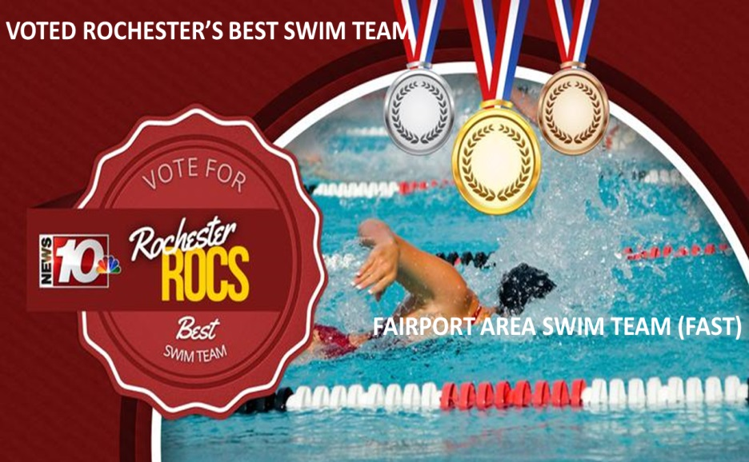
YEAR ROUND SWIMMING IS NEXT WHEN YOU’RE READY!
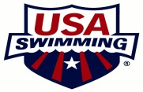
Any questions, contact Head Coach Marci Callan mcallan@fairport.org

