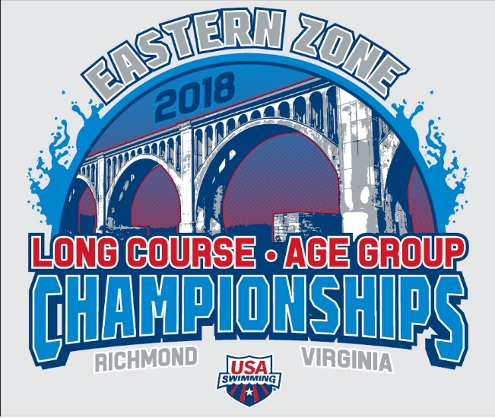

Warm Up Schedule
2018 EZ LC Age Group Championship, August 8-11, 2018
Warm Up Schedule: 13 and Over Sessions:
Wednesday and Friday Morning – Prelim Session
Warm up A – 6:45 to 7:25 am – MA, PV, NI, VA, NJ
Warm up B – 7:25 to 8:05 am – AD, AM, CT, MR, MD, NE, ME
Thursday and Saturday Morning – Prelim Session: Warm up B goes first (6:45 to 7:25) and Warm up A goes second (7:25 to 8:05)
Warm up Schedule: 12 and Under Sessions: 25 minutes each session
Wednesday and Friday Afternoon
Warm up A – CT, MA, PV, VA
Warm up B – AD, AM, MR, ME, NE, NI, NJ, MD
Thursday and Saturday Afternoon – Reverse order, with Warm up B starting first.
Approximate beginning time for 12 & Under warm-up sessions:
- Wednesday: begin at 12:30
- Thursday and Friday: begin at 11:30
- Saturday: begin at 12:00
During all preliminary warm up sessions, coaches are expected to monitor the lanes and determine how they are used. (ie general, pace, sprint).

All Finals Sessions
Finals warm up session will start at 4:30 PM or immediately following the completion of the 12 & U session, whichever is later. The warm up session will last 50 minutes. During the last 25 minutes of warm ups, Lanes 1 and 8 will be pace, Lanes 2 and 7 sprint, and Lanes 3, 4, 5, and 6 General. Referees will open additional lanes for pace or sprint as needed. The competition pool will be cleared at 5:20 pm.
The Warm up, Cool Down pool will be open for General warm up during all warm up sessions and during competition.

