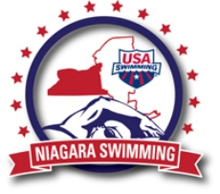
Safe Sport Incident Reporting

The following details proper procedures for reporting alleged Safe Sport Violations and or Club Policy Violations
Any victims are instructed to immediately report the incident to the Coach or Safe Sport Coordinator and ask that the incident be recorded on a “Letter of Correspondence” form.
In any such instances the Safe Sport Coordinator will:
- Email Niagara Safe Sport Chairperson Leo Gbbins asap after the violation occurred with an account of the incident (who, what, where, when, etc.).
- Assist the victim or parent in filling out a “Letter of Correspondence” with copies sent to
the club Board of Directors & Niagara LSC Safe Sport Chair Leo Gibbons as soon as practical.
- Once the club has come to a resolution of the violation (or not) another email will be sent to Niagara LSC Safe Sport Chair Leo Gibbons that the incident has been resolved (or not) for record keeping purposes.

Below is the link for reporting any Safe Sport concerns/issues to the appropriate people at USA Swimming: https://www.usaswimming.org/articles-landing-page/2017/05/08/safe-sport-report
Thanks for your help in providing our athletes a safe environment to train and compete in.
Mercury Swimming

