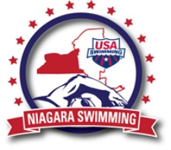

Niagara LSC Whistle Blower Policy
No person shall in any manner discriminate against anyone because that person has: (a) Filed any complaint under or related to Safe Sport; (b) Instituted or caused to be instituted any proceeding or investigation related to Safe Sport; (c) Testified or is about to testify in any proceeding regarding any Safe Sport concern; or (d) Exercised on his own behalf or on behalf of others any right afforded by this policy.

Approved by Niagara LSC Board on April 25, 2018

Safety Chair 4/25/18

