HAMILTON AQUATIC CLUB
2023 Long Course TARGET
MEET SCHEDULE
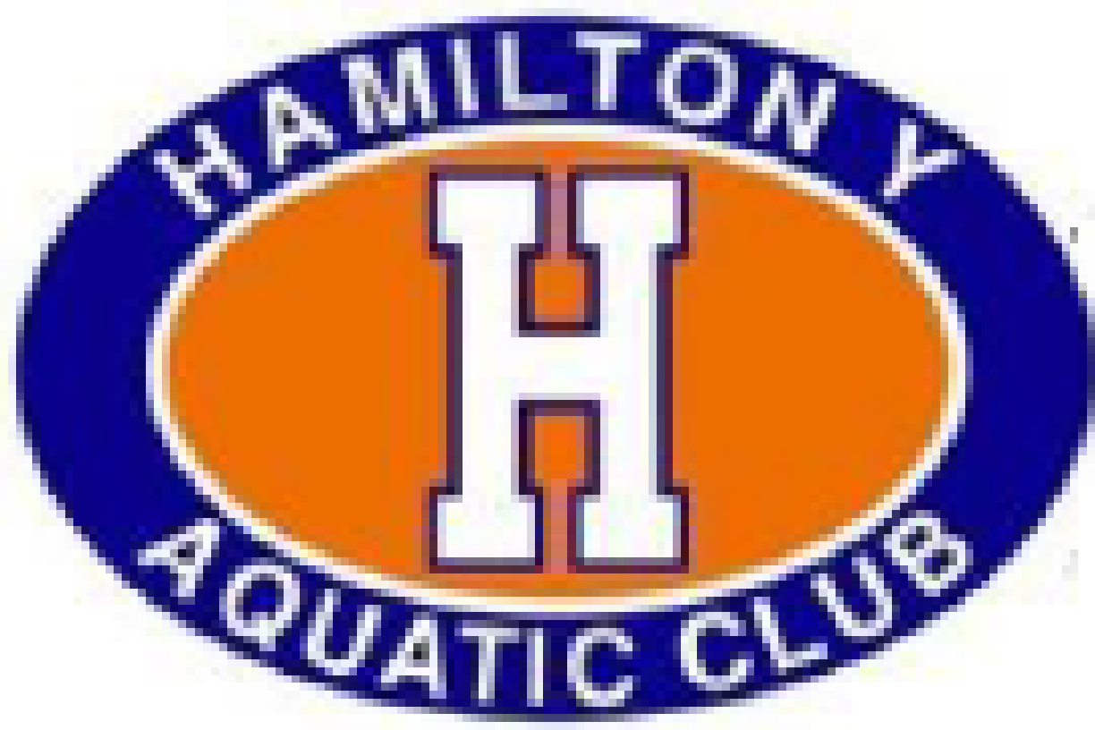
Date | Days | Meet | Location | Time Standards | Notes
May 20 | Sat | Ray Stakes | Glocester County Institute of Tech (GCIT) | None
May 19 & 21 | Fri & Sun | PTAC Tiger Challenge | Princeton University | None
June 3, 4 | Sat, Sun | *HACY Summer Solstice | Princeton University | None
June 10, 11 | Sat, Sun | XCEL Meet of Excellence | Princeton University
June 16? | Fri | ?RY Friday Night Distance Lights | NJ Aquatic Center
June 23,24,25 | Fri, Sat, Sun | EEX Summer Sizzle | Rutgers | Yes
July 8,9? | Sat, Sun | ? MAY Heat Wave | Princeton University | Silver

CHAMPIONSHIPS
July 14, 15, 16 *HACY NJ Swimming Silver/Bronze? Champs Princeton University
July 28,29,30 NJ Long Course Gold Championship Rutgers University
July 25-29 YMCA National Long Course Championship Greensboro Aquatic Center
Greensboro, NJ
August 3-6 Eastern Short Course Zone Championships Collegiate Aquatic Ctr –
Richmond, VA

