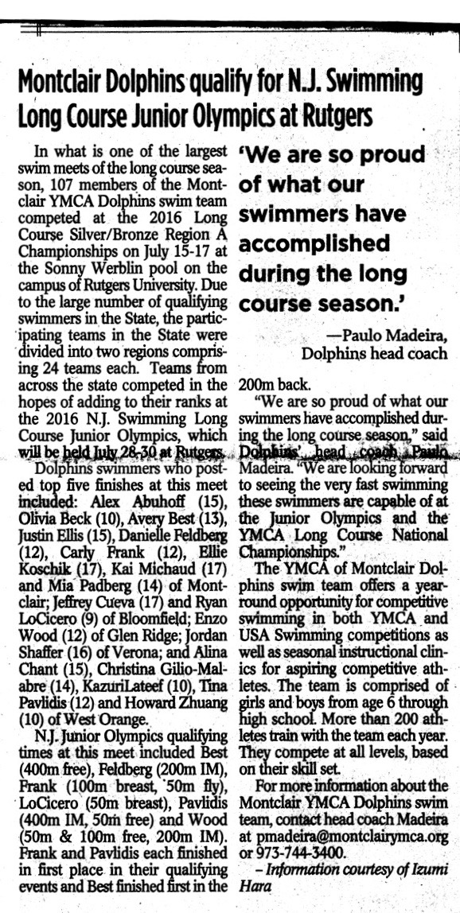

Montclair Times

July 21, 2016

p. C-3