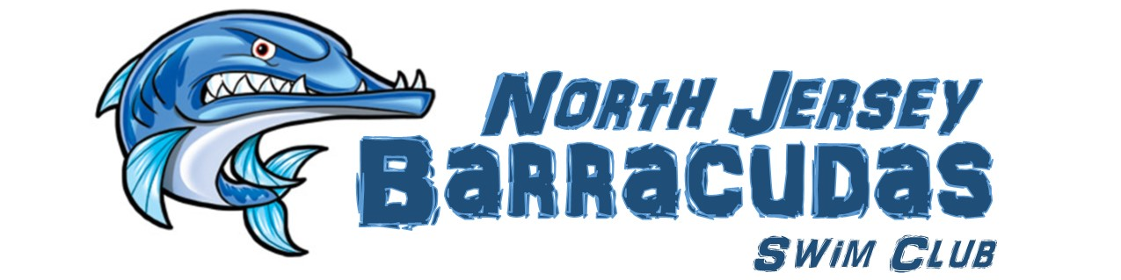
PO Box 304, Sussex, NJ 07461
Email njbarracudas@gmail.com
phone/fax (973)702-7585

Spring/Summer Tryout Registration

Tryout fees: $10 per swimmer.

- Pre-register by scheduling your tryout time. Email njbarracudas@gmail.com or call (973)702-7585.
- Fill out this form and bring it in to your tryout along with tryout fee.
- Final Groups will be selected and all tryout participants will receive an email by April 3, 2018.
(please print neatly)

7-12 Year Olds

Swimmer’s Name:
Swimmer’s DOB (MM/DD/YY): |  | Swimmer’s Age on day of Tryout:
Parent’s Name:
Address:
Phone: | Email:
Prior competitive swimming experience (if any):

Time Trials (Filled out by Coach at tryouts)

SWIM TEAM Swimmers will complete a timed 100 IM, 50 Free, and at least one other 50 of their choice.
Event | Time | Comments
100 IM*
50 Fly
50 Back
50 Breast
50 Free*
Start: |  |  | Turn:

OFFICE USE ONLY | Cash | Check # |  | Initials
Amount:

