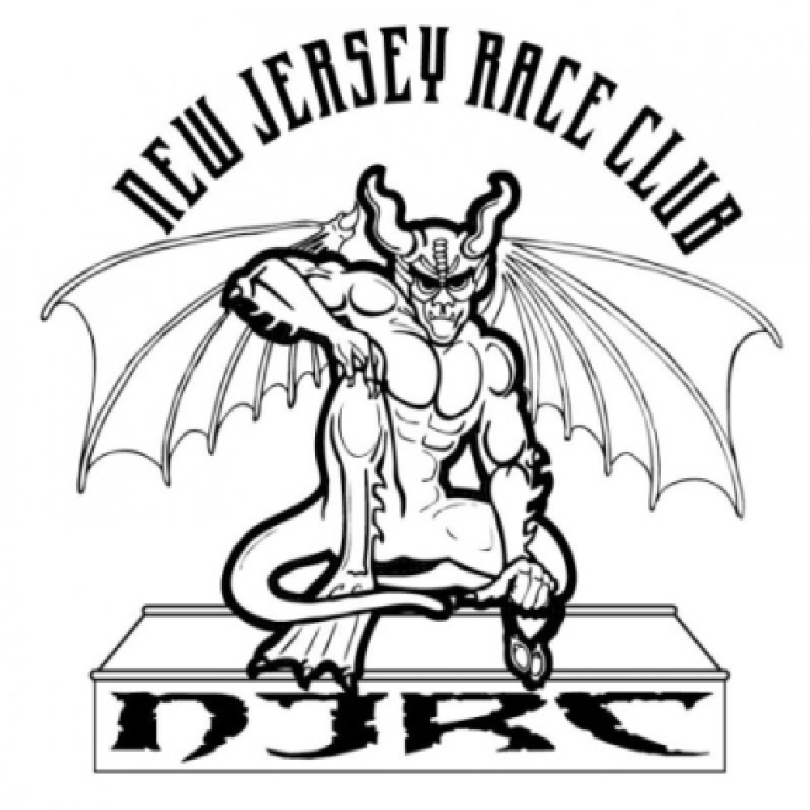
NEW JERSEY RACE CLUB
Head Coach: Andreas Roestenberg 732-299-4772
E-Mail: andreas@newjerseyraceclub.com
Head Age Group Coach: Kyle Williams 732-546-4401
E-Mail: kyle.williams3@hotmail.com
Website: www.newjerseyraceclub.com
*2861 18th Ave Wall ,NJ 07719

2017/2018 NJRC SWIMMER
NJRC/USS Registration Form

Name (first, middle initial, ,last):________________________________________

Swimmer date of birth: _____________________________
Age________________________

Parent name (s): _________________________________________________________

Parent email:
Mom _______________________
Dad:_________________________________

Home address: _______________________________________________________________

Home Phone ______________
Mother cell: _____________
Father cell: ________________

Emergency contacts (not parent or guardian)
1. ______________________________ Relationship ______________________________
Phone: __________________________________
Family Physician: ___________________________ Phone Number: _____________________
Medical Insurance Company: ________________ Insurance Phone Number: _______________
Insurance Group Number: ___________________ Insurance Policy Number: ______________

Permission for Medical Treatment: This authorizes a licensed physician, surgeon, or other medical staff to carry out emergency medical care deemed necessary for my child/ward in an emergency when parental permission is unavailable during a practice or swim meet/event. I also guarantee payment of all charges incurred during this medical treatment (i.e., physician, hospital, x-ray, lab, medication, ambulance, etc.)
Parent/Guardian __________________________________ Date: ______________________

Permission for Publicity: On occasion, NJRC make take photographs or make audio or video recording of swimmers involved in NJRC activities. I consent to the use of any such photographs, or audio/video recordings or the individual named above to be distributed or displayed as agents of NJRC see fit (ex.: website, social media, newspaper, promotional materials).
Initial: _____ I give permission for publicity Initial: _____ I do not give permission for publicity

Medical Information:
Does this athlete require any medication on regular basis or carry medicine on his/her person? Yes/No If yes, Name: _____________________________ Purpose: _________________________________
Is this athlete under the care of a physician? Yes/No If yes, please explain: ______________________
Has this athlete ever had any surgery, injury, or medical condition which could affect training? Yes/No If yes, please expand: __________________________________________________________

NEW JERSEY RACE CLUB agreement/permission/waiver form:
By signing this waiver form, I grant permission for the child named above to participate in and engage in New Jersey Race Club practices, training, meets, and events. I have provided truthful answers to all medical questions and declare that my child is physically and mentally able to participate in these activities. I acknowledge that there may be certain risks involved in said activities and am aware that the NJRC has my child’s safety and well-being as its priority and will take all reasonable steps to ensure his/her safety.
I release the NJRC, its affiliates, volunteers, and employees of all responsibilities for any injuries to body or property which may occur to my child during the course of these activities. In the event of an emergency in which I or the alternate contact cannot be reached, I authorize adult leaders to administer first aid, if necessary, and/or to obtain medical treatment for my child on my behalf. I further agree to indemnify and hold harmless the NJRC and its affiliates, volunteers, and employees of any and all claims arising from the participation of my child in activities or as a result of injury or illness of my child or mine during activities. As the parent/guardian of___________________________________, who is under 18 years of age, I authorize his/her participation in New Jersey Race Club practices, training, meets, and events. I have read this permission/waiver form and am fully aware of its contents.

Additionally, I agree to the payment plan set forth below on this agreement. There are no other payment options. We do not accept payment by check on a monthly basis, all payment plans must be agreed upon prior to season start with a CC or a check. I understand that once my child has started swimming, with a spot on the team confirmed) if the swimmer or the parent chooses not to continue with NJRC at any time for any reason during the season there will be no refunds issued. We have limited pool time and space and your spot on the team is confirmed for the year. If my swimmer has an injury and cannot swim for a certain amount of time based on the injury, time involved for rehab and a signed doctors a credit will be issued towards the swimmers next season fees. Lastly, if your account falls into default at any time during the payment time period NJRC has the authority to temporarily suspend your swimmers membership with NJRC. The swimmer will have to sit out of practice and/or may be scratched from a meet until the swimmers account becomes current.

Parent/guardian signature: _________________________________
Date: ____________________

If your swimmer starts in one group and gets moved up to the next group during the season which happens quite often or additional days are added, even on a part time basis. It must be submitted in writing to andreas@newjerseyraceclub.com. The swimmer will have an adjustment made in the invoice retroactive to the permanent move date and an adjusted invoice will be emailed.

*A non-refundable $500 commitment fee is due as soon as possible to confirm your spot on the team for all returning team members, regardless of the payment option. The deposit will be deducted from your balance.

*Once you have paid your $500 commitment fee you are responsible for the remaining balance for the season regardless if your swimmer decides to not finish the swim season.

*NJRC swimmers are also responsible to participate in our annual NJRC Swim A Thon which usually happens in January. This is a team fundraiser where each swimmer is responsible for raising atleast $300 which is used for team dry land and pool equipment. Fundraiser funds are also used for Championship tee shirts, caps and Sectional swimmer gear.

By signing the below you agree to all the terms listed above.

Signature_________________________________________________________________

Questions ? Please e-mail andreas@newjerseyraceclub.com or kyle.williams3@hotmail.com

Please circle: $500 commitment fee check enclosed made out to NJRC

Payment Method:

Check Amount __________ Date _________

