Metro Swim Shop
Team Portal
User Guide

September2018
Version 1
Step 1: Login by typing the following url
https://www.metroswimshop.com/teamname
Example: (https://metroswimshop.com/svy)

You will see the following screen.

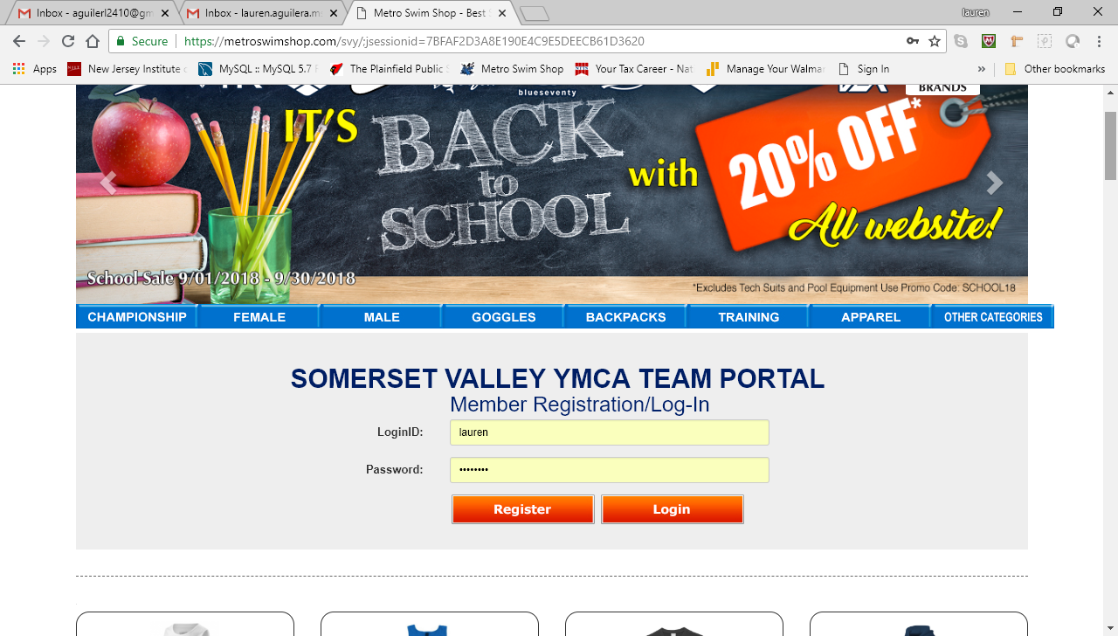

Type in your User Login ID (your e-mail address) and password and then click “Login”; this will only work if you have already registered, in case you have never register for the team you will have to click on the Register button . You will login into the team portal site and see your team order form.

Step 2: Order Form and Place Order

Once at the Order Form, one will automatically be sent to the Place Order screen.
- To order suits to be shipped to your home, select suit size and quantity for all the items you want to order and then got to the bottom of the page to click “Place Order”.
- To order the same item in different sizes, enter the size first and then the quantity and click “Add”. Repeat for each size, and then click “Place Order”

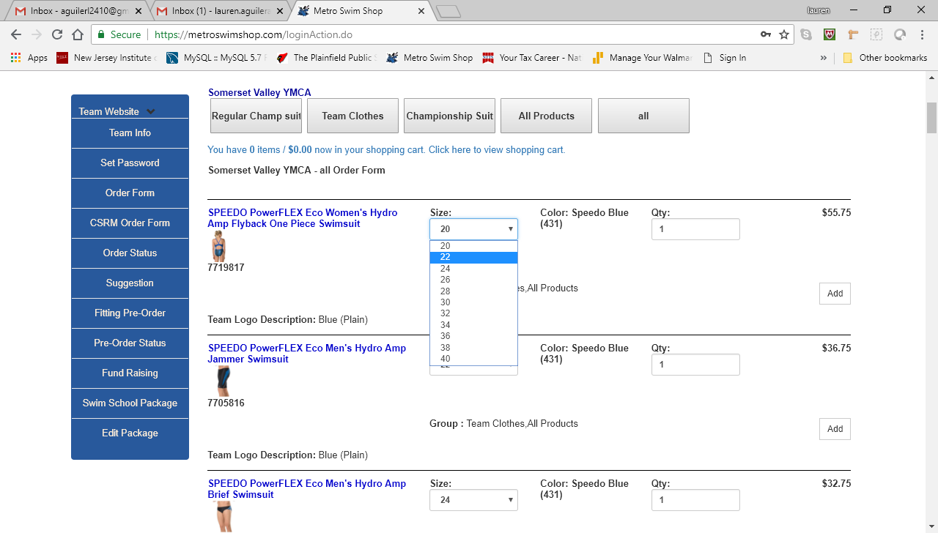
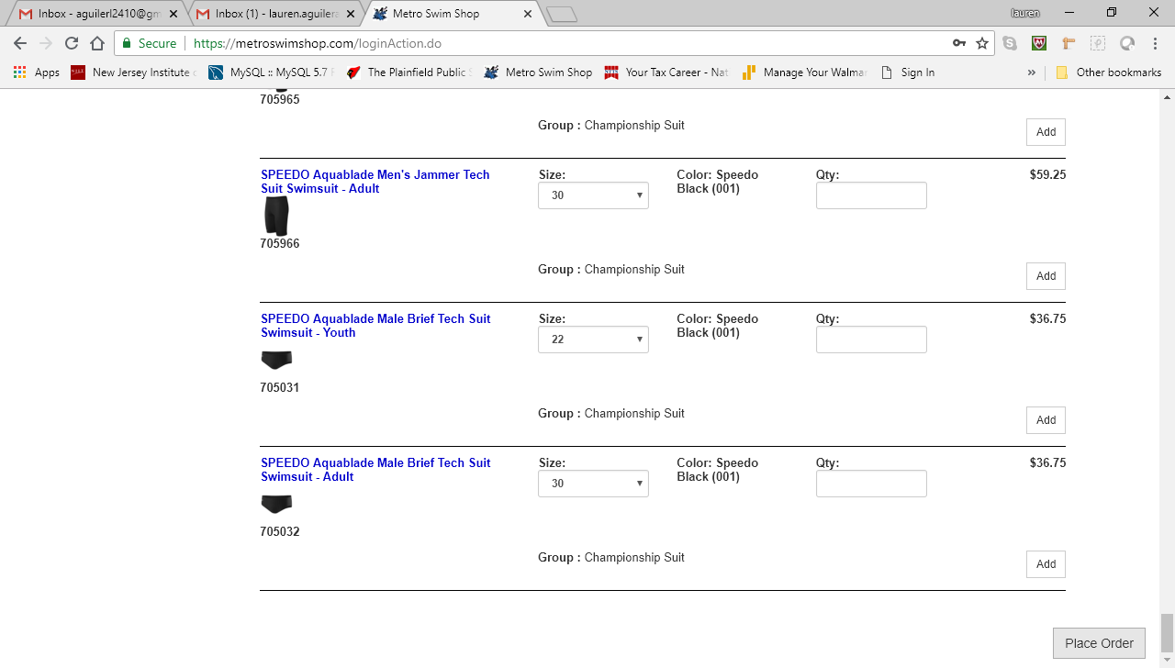
Step 3: Check Out and Continue Shopping
After filling in the quantity and clicking the “Place Order” button, you should see the following screen.
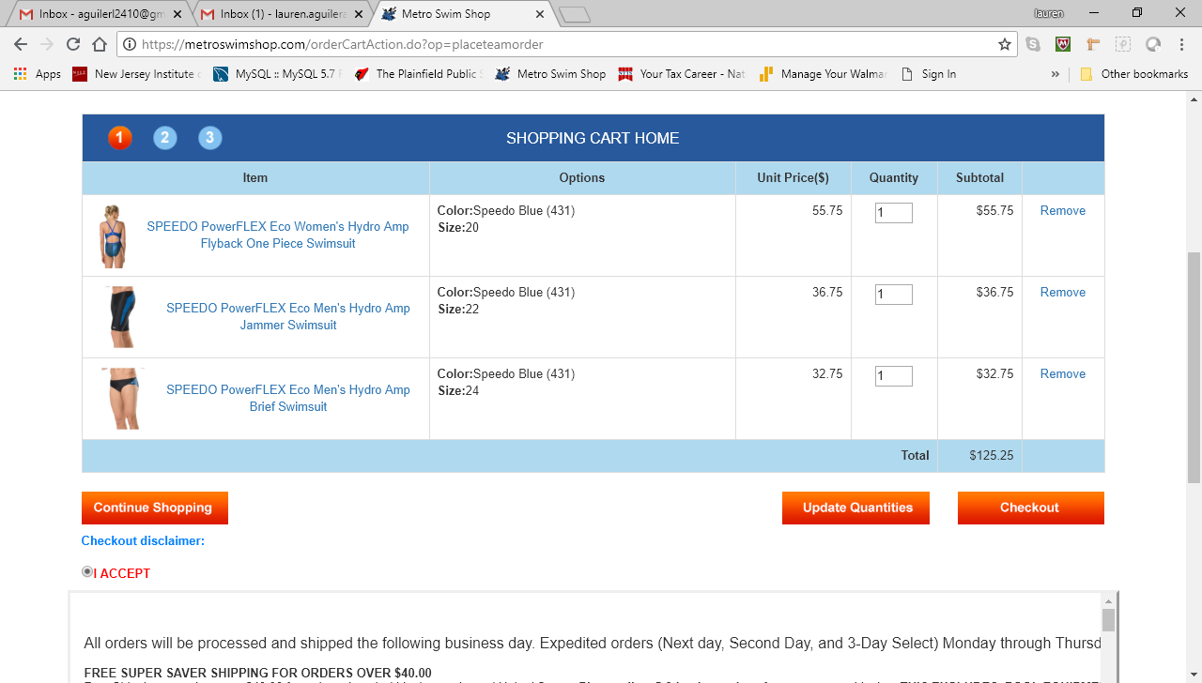

Click the I ACCEPT radio button
Click “Continue Shopping” to continue ordering.
Clock “Update Quantities” to update the number of each item you wish to order.
Click “Check Out” to type in your credit card information.

Step 4: Payment Information and Shipping Information

After clicking the “Check Out” button, you will see the following screen. To enter your Shipping information , click “Checkout”.
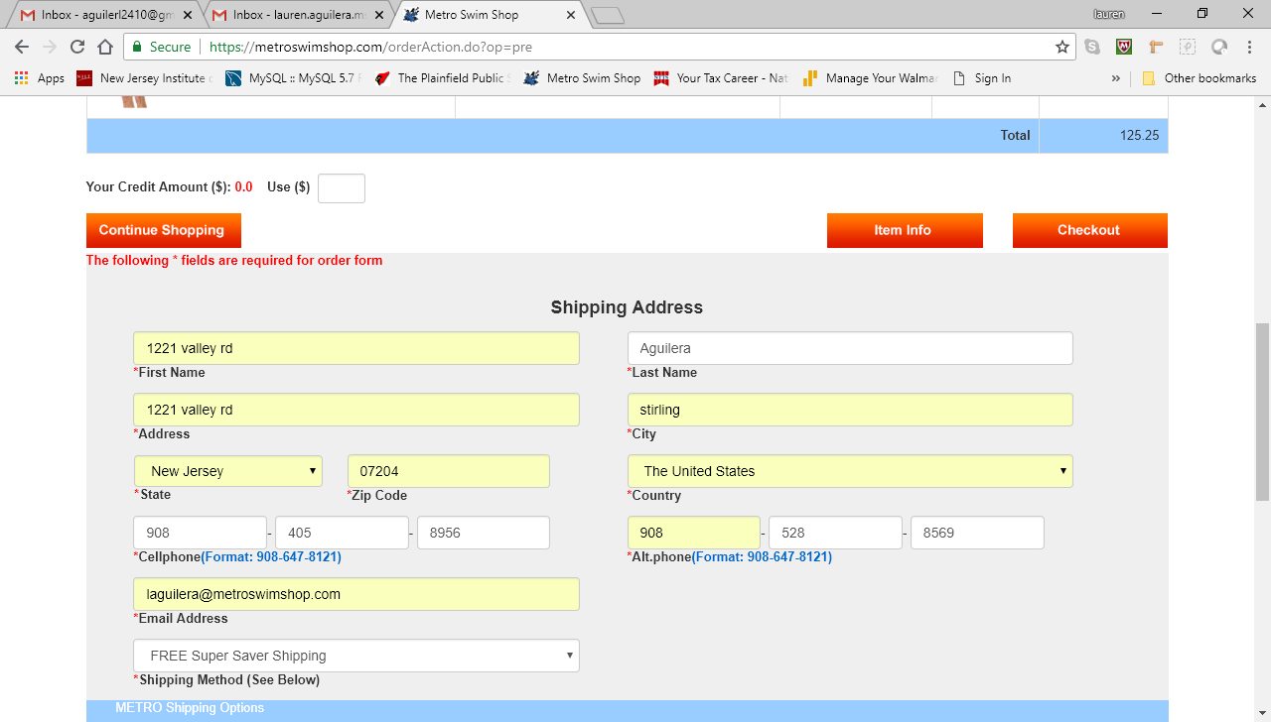

After clicking “Checkout”, you will see the following screen:

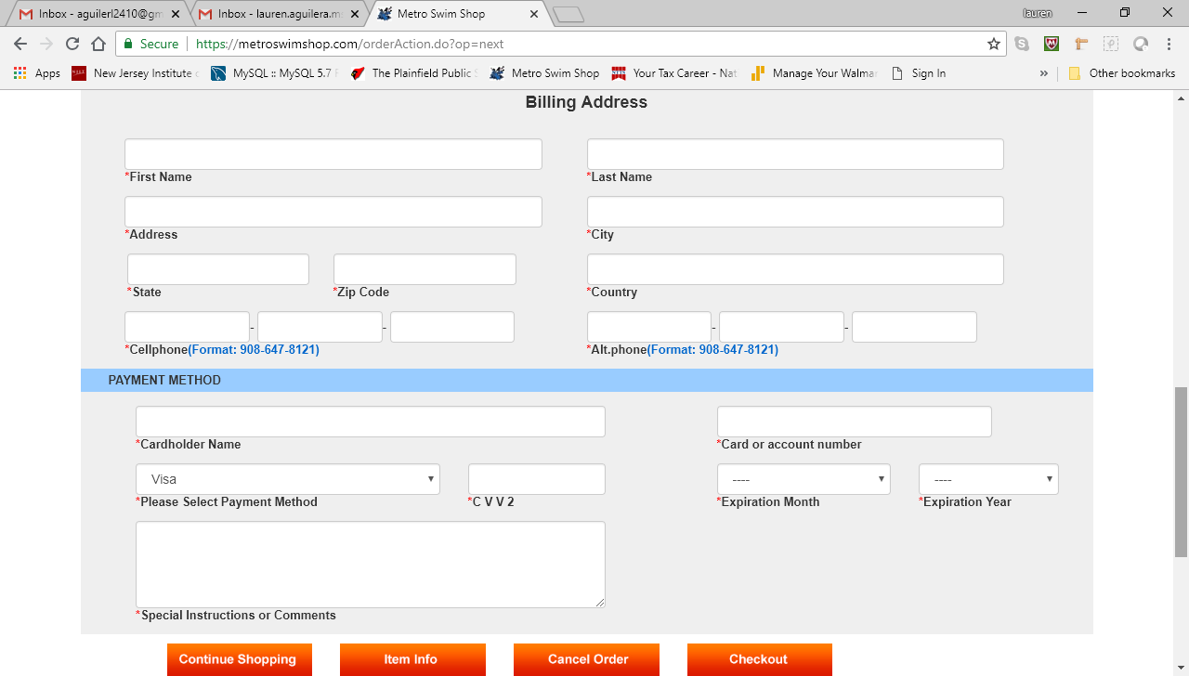
Enter your payment method and billing address and then click “Checkout”

Step 5: Completing an Order

Congratulations! Your team order has been placed with the Metro Team Portal. Thank you!!!!
Clicking the home button will lead you to the Team Info home page.
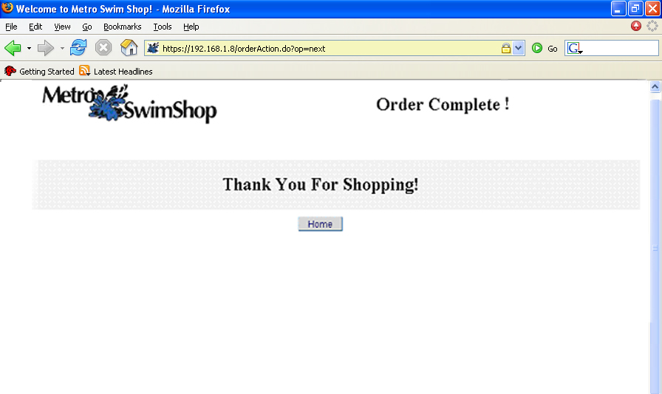
Step 6: Register for the team if you have not done so:
After typing the url for the team you will see this screen on this one click Register

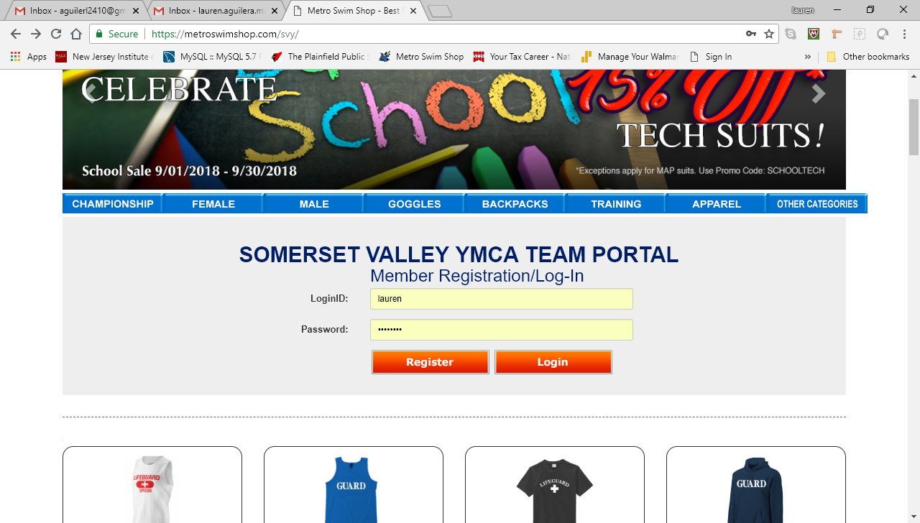

Step 7:Fill out the registration form:
Some browsers may ask for team id so please make sure you ask your coach the team id or call metro swim shop to get that information
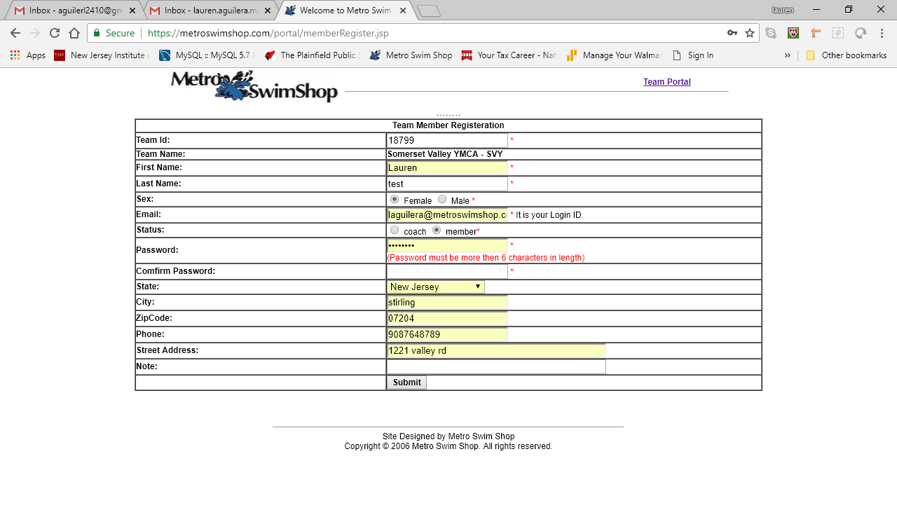
Click Submit and them click on Click here to Team Portal to access the team order form and place order by following the previous steps (2-5) on how to place order


