Metro Swim Shop
Team Portal
Password Reset and login by using Account

2018

Version 1

Team Portal Login by using Account

Step 1: Open Browser, type in url: http://www.metroswimshop.com/
You will see the following screen. Click Account to go to the Account Login page

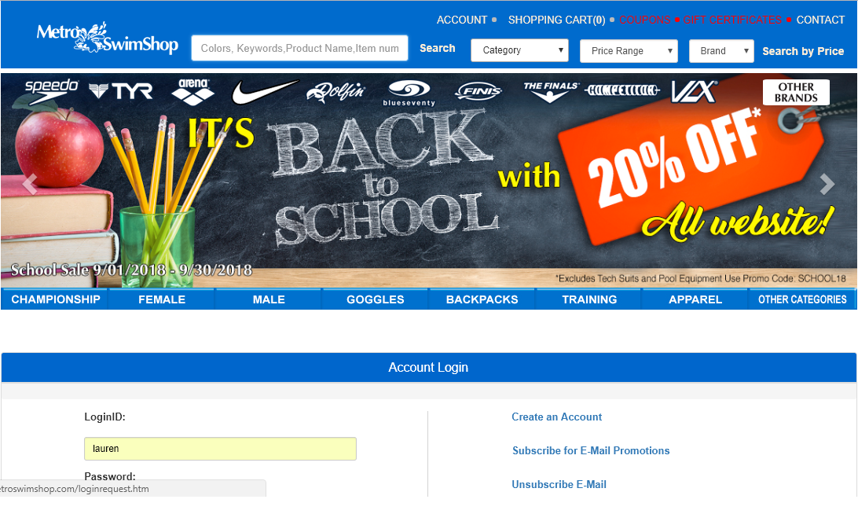

Step 2:On the LoginID type in your email address and on the password type the password you have used to register as member of the team portal, and on the drop down menu please select the team name form which you registered before.
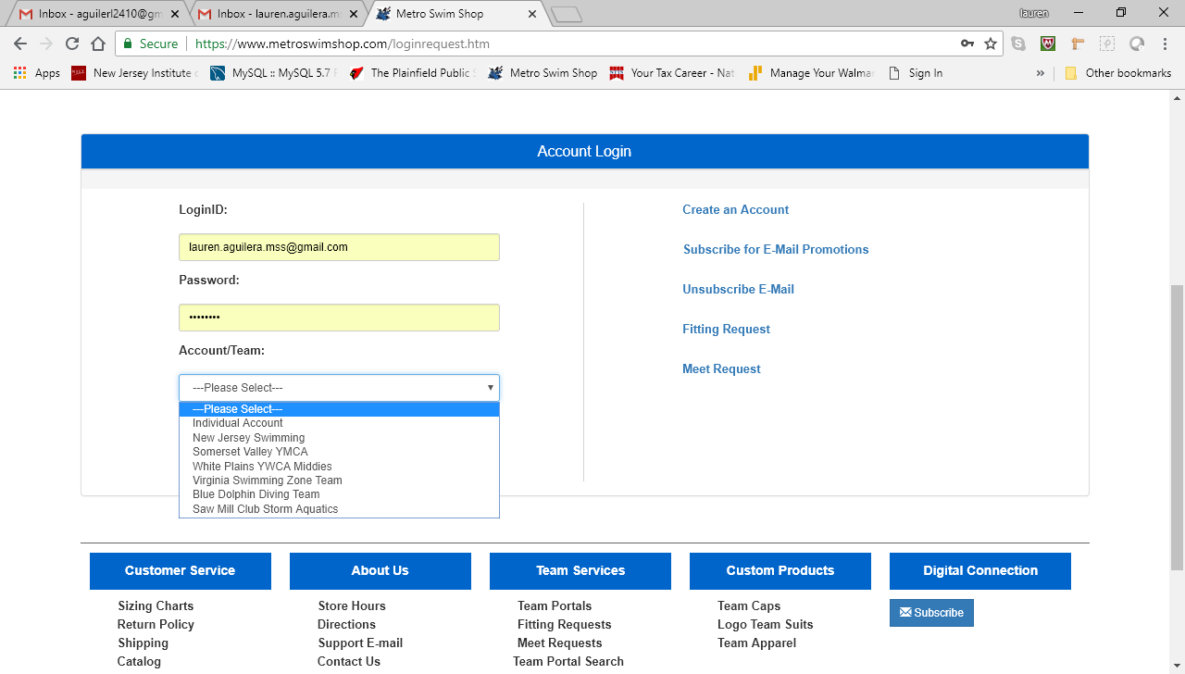

Step 3: After you selected the team form the drop down menu, you can click login and you will be redirected to your corresponding team portal
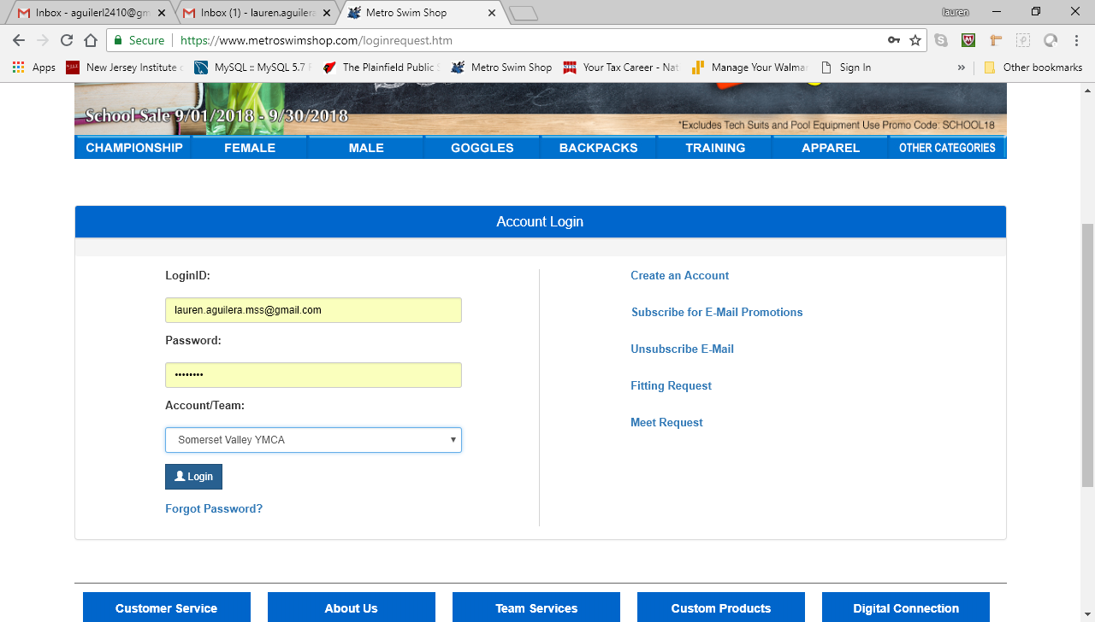
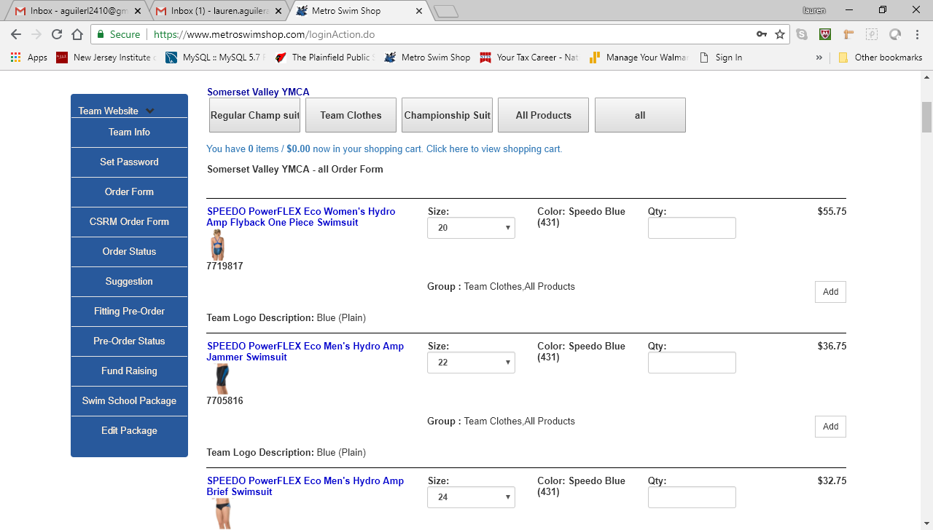

Step 4: In case you forgot the password, you can click the forgot password link
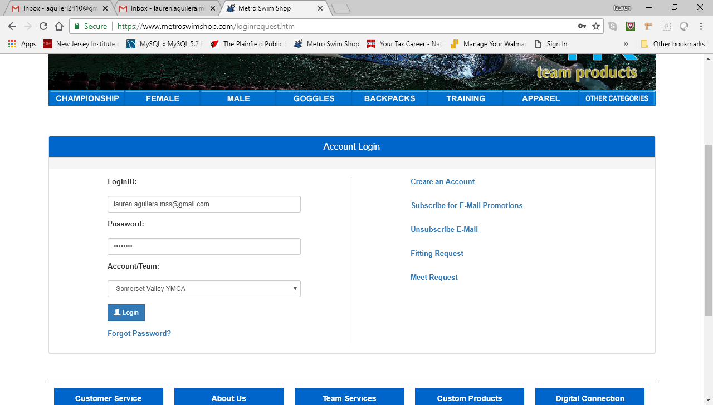

After you click on the forgot password you will be asked to enter your email address (note: it has to be the same as the one you use as LoginID) and also you will need to select the Team you are trying to reset the password for form the drop down after that you click submit and an email address with you password will be sent to you


