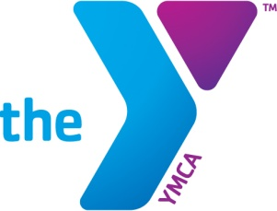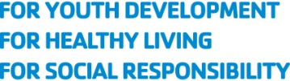

PHOTO AND VIDEO/AUDIO RECORDING RELEASE

The Community YMCA

I _____________________ represent that I am eighteen years of age or older, and if not, then my Mother/Father/Legal Guardian has also signed below under my signature.

For my participation in activities sponsored by or related to _____________________________, I hereby give my permission and consent, now and for all time (without any further compensation, claim or demand by me) to the National Council of Young Men’s Christian Associations of the United States of America (“YMCA of the USA”), and to any YMCA of the USA Association, advertising agency, entities and third parties collaborating with YMCA of the USA and their representative, if any (the “Organizations”) to make, reproduce, edit, broadcast or rebroadcast any video film, footage and other sound track recordings, or photo reproductions of me, and my narrative account of my experience with YMCA activities (“Materials”) for publication, display, sale or exhibition thereof in promotions, advertising and legitimate business uses without any further compensation to me. I may or may not be identified in such reproduction, however I shall not be stated by name to have endorsed any particular commercial products or commercial services.

I further agree to the following:

- Any Materials that I authorize pursuant to this Release shall belong to YMCA of the USA as its property, with full right of disposition of them;
-The Materials will not be subject to any obligation of confidentiality and may be shared with and used by the Organizations, as well as with any third parties as YMCA of the USA may elect.
-YMCA of the USA shall not be liable for any use or disclosure to a third party of any of the Materials.
- YMCA of the USA shall exclusively own all known or later existing rights to the Materials worldwide and shall be entitled to the unrestricted use of the Materials for any purpose without compensation to the provider of Materials.

I agree that my consent and this release is irrevocable. I hereby release and discharge the Organizations and their representatives from any and all claims in connection with the uses and reproductions of my image and voice and my narrative account as described herein.

Signature: _______________________________________

Printed Name: ___________________________________
Age: ____________________________________________

Address: ________________________________________

________________________________________________

I am the Mother/Father/Legal Guardian of __________________________ (print name). For the consideration contained herein, I hereby consent to the foregoing on behalf of my minor child.

Signature of Mother/Father/Legal Guardian: ___________________________________

Date: __________________

