------------------------------------------------------------------------------------------------------------------------------------
------------------------------------------------------------------------------------------------------------------------------------

Send an 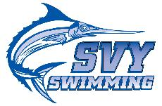

------------------------------------------------------------------------------------------------------------------------------------
------------------------------------------------------------------------------------------------------------------------------------
Parents – send a note of encouragement, pride, or good wishes to your swimmer.
Swimmers – thank a coach, your parents, carpool driver, or teammate.

Gratitude * Encouragement * Pride * Team Spirit

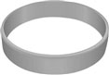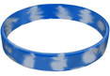
Your swim note will come attached to a wristband, customized with the SVY name, and different inspirational sayings.
Several different styles and sayings.
Collect them all! Trade them!

--------------------------------------------------------------------------------------------------------------------------------------------------------------
--------------------------------------------------------------------------------------------------------------------------------------------------------------

Here’s how it works …
Write your message on the attached form. We’ll attach your personalized message to one of the assorted wristbands and deliver just in time for championships!
2 Notes for $5
5 Notes for $10

Orders will be accepted until January 25. For more information, please contact cherylmil@verizon.net

