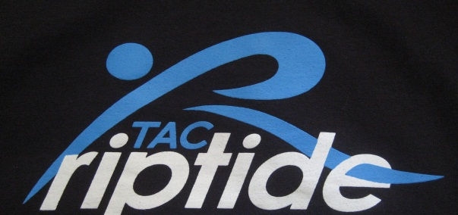
Atlantic Club Swim Club 2013 -2014
WINTER Swim Team

Date________Name_____________________________________________
Address_______________________________________________________
Phone #_______________________________________________________
Email Address__________________________________________________

Winter Suit Speedo Navy Flyback with TAC imprinted Size_____$48.50

Winter Suit Speedo Navy Jammer with TAC imprinted Size_____$34.00

Team Drag suit imprinted. . . . . . . . . . Size______$29.50

Latex Imprinted caps with name ………….. Size______$2/15.00

Silicone Imprinted caps with name…………………… Size______$2/30.00

Speedo Split Fins . . . . . . . . . . . . . . . Size_____$27.50

ZOOMER K12 . . . . . . . . . . . . . . Size_____$24.00

Pull Buoy . . . . . . . . . . . . . . . . . . Qty_____$10.00

Mesh Bag . . Imprinted TAC. . . . . . . . . Qty______$14.50

Strokemaker Paddles . . . . . . . . . . . . . Size_____$20.00

Kickboard . . . . . . . . . . . . . . . . . . Qty_____$10.00

Finis swimmers Snorkel…… . . . . . Qty______$34.50

Backpack imprinted …………………………………………….. Qty______$60.00

Checks payable to: The Sport Spot:
(The Sport Spot 732-747-0585) The.sportspot@verizon.net
The Sport Spot 660 Broad Street
Shrewsbury, NJ 07702

