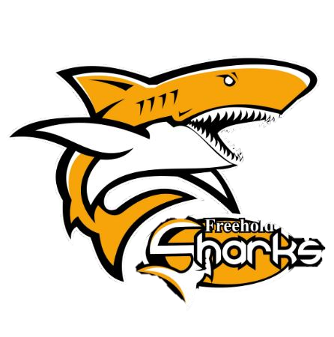
Name: ___________________________________________
Phone #: _________________________________________
Swimmer’s Age Group: ____________________________
 | Amount | Size | Total
T-Shirts –
White w/ Freehold Sharks Logo
$10.00
Youth L
Adult – S, M, L, XL
Adult XXL - $12.00
Sweatshirts –
Black w/ Freehold Sharks Logo
$25.00
Youth – L
Adult – S, M, L, XL
Adult XXL - $27.00
Shorts – (Long)
Black w/ Freehold Sharks Logo
$15.00
Youth – M, L
Adult – S, M, L, XL
Adult XXL - $17.00
Shorts- (Soffe)
Black w/ Freehold Sharks Logo
$15.00
Youth- M, L
Adult – S, M, L, XL
Adult XXL- $17.00
Sweatpants –
Black w/ Freehold Sharks Logo
$20.00
Youth – L
Adult – S, M, L, XL
Adult XXL - $22.00
Total:

Total Amount Paid: _________________________
Please make all checks payable to the YMCA. All orders must be in by Saturday June 8th. Orders should arrive around June 24th. Any questions contact Danielle Wright at dwright@ymcanj.org. You can give you orders to any coach at practice if I am not available.
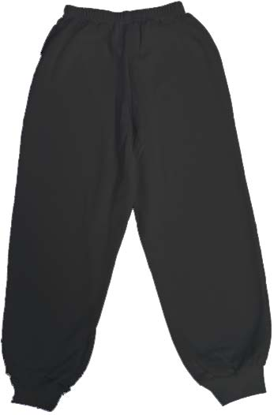
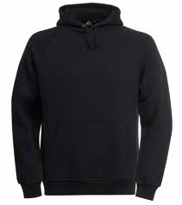
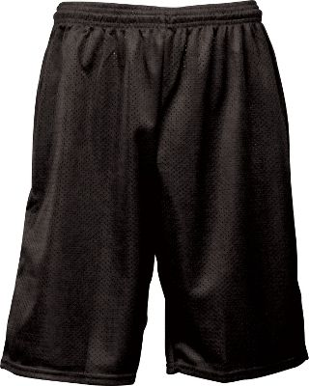
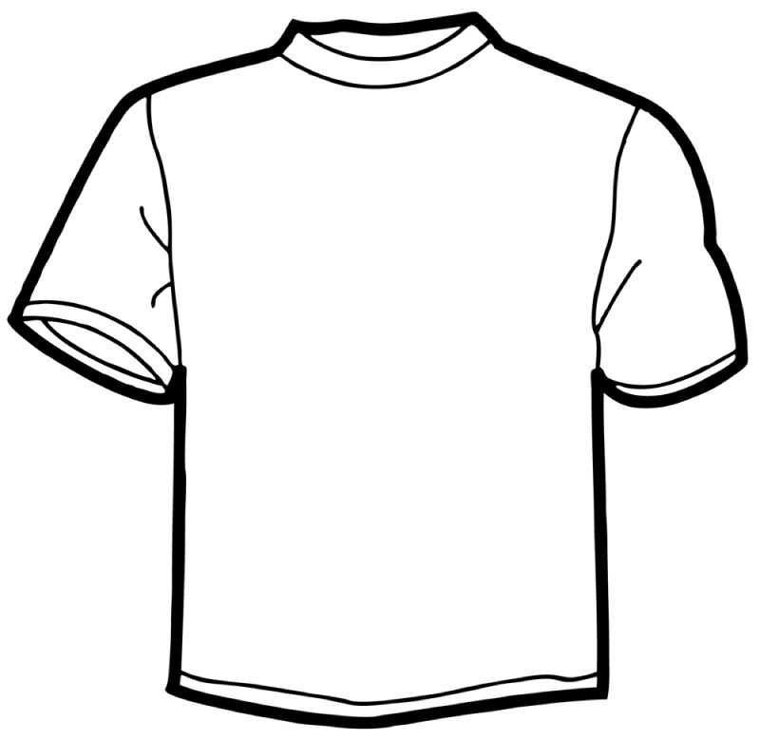
Sample Apparel:

