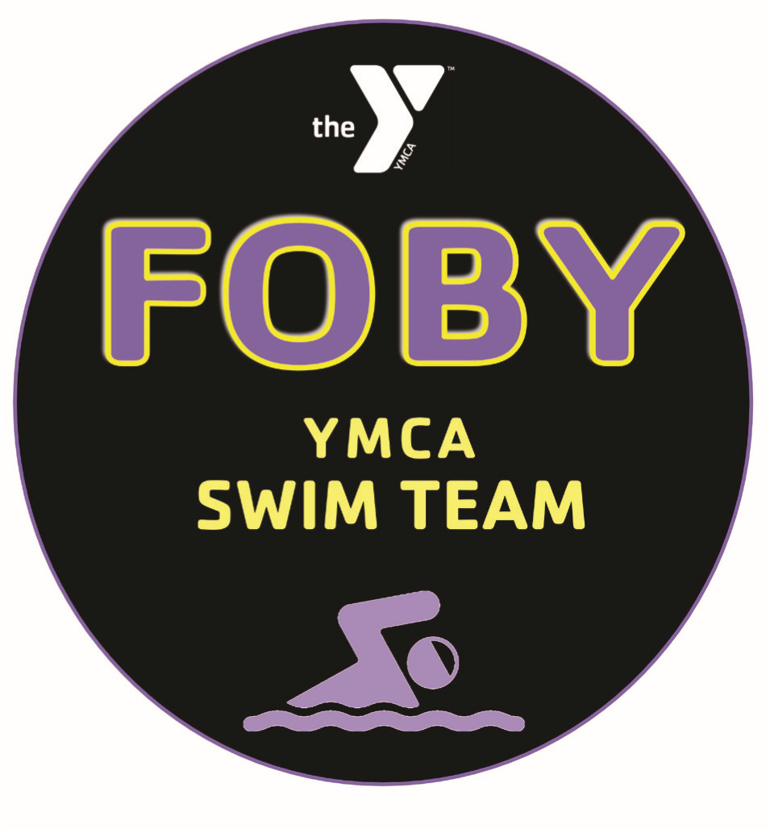
Freehold-Old Bridge
YMCA Swim Team
2017-18 Handbook

FOBY Philosophy
The FOBY Swim team exists solely on the strength and character of its swimmers. Each member of the team must believe that no one swimmer is bigger than the team. We recognize that by coming to practice prepared to do our best we are setting ourselves up for success. The rewards for our dedication can be measured not only by our results in the pool, but by the self-confidence, discipline and time management skills that come through hard work. The coaches will set the tone for a safe, challenging and motivating environment by continually learning and striving for improvement. The same demands that we make of our swimmers: attendance, attention to detail, accountability and a positive attitude are standards to which we also hold ourselves.

It is our goal for every level of our team to build a love of the sport. The swimmer that enjoys the challenges associated with the demands of hard work will be successful both in and out of the pool. There are no shortcuts; consistent and persistent effort is a pre-requisite for achievement in swimming. The process of setting and achieving goals allows us to grow as individuals and helps swimmers learn to take responsibility for their actions. Technique and drills will be stressed in practice to improve all strokes. Practice does not make perfect, but perfect practice yields improvement.

Mission Statement
The values of the YMCA: honesty, caring, respect and responsibility will be instilled upon individuals via our commitment to sport and fitness. Through dedication to youth development our goal is to not only have all swimmers achieve success and reach their goals in the pool, but also to become individuals who contribute positively to the community.

Practice Group Placement:
Swimmers are placed in their practice groups based on: skill level, age, commitment. The placement of everyone is made by the coaching staff and is in the best interest of the swimmer for long term development and the team.

A swimmer is encouraged to attend all practices offered. The Senior Prep, Senior I and Senior II training groups have attendance requirements.

Practice Group Descriptions:

Mini II
Predominate ages 8 & under
Required equipment: fins and pull-buoy

This is the beginner level of our swim team. At this level the emphasis is on teaching skills that develop good stroke technique and learning practice etiquette. Freestyle and Backstroke are the primary strokes. The primary objective is swimming the strokes legally.
Old Bridge

 | Monday | Tuesday | Wednesday | Thursday | Friday | Saturday
Mini II | 4:15 – 5:00 | OFF | 4:15-5:00 | OFF | 4:15-5:00

Mini I
Predominate ages 9 & under
Required equipment: fins and pull-buoy

Butterfly and Breastroke will be introduced and TECHNIQUE and SKILLS will continue to be emphasized.
Old Bridge

 | Monday | Tuesday | Wednesday | Thursday | Friday | Saturday
Mini I | 5:00-5:45 | OFF | 5:00-5:45 | OFF | 5:00-5:45

Junior
Predominate ages: 9-10
Required equipment: fins and pull-buoy

While the teaching of skills and technique continues, endurance begins to take on a more important aspect. Training of all four strokes is incorporated more often and dryland training is introduced.

Old Bridge

 | Monday | Tuesday | Wednesday | Thursday | Friday | Saturday
Junior I | 5:45-7:00 | 5:30-7:00 | 5:45-7:00 |  | 5:45-7:00

Senior Prep II
Predominate ages 9-12
Required equipment: fins and pull-buoy
The emphasis is still on proper skills and stroke technique. Coaches will begin to build cardiovascular endurance through drills, sets and activities. (Schedule Next Page)

Old Bridge

 | Monday | Tuesday | Wednesday | Thursday | Friday | Saturday
Junior II* |  | 4:15-5:30 |  | 4:15-5:30 |  | 2:15-3:45  @ Freehold

Senior Prep I
Predominate Ages: 11 & 12
Minimum required attendance: 4 of 5 practices
Required equipment: fins, pull-buoy, and paddles

At this level, the focus is on stroke technique while working on overall athletic conditioning and cardiovascular endurance using a variety of training methods. An emphasis will be placed on learning and applying basic race strategies and techniques. More advanced dryland training with an emphasis on core strength and stability will be done more regularly to strengthen the primary muscle groups.
Old Bridge

 | Monday | Tuesday | Wednesday | Thursday | Friday | Saturday
Senior Prep | 7:00 – 8:30 | 7:00-8:30 | 7:00-8:30 | OFF | 7:00-8:30 | 12:45-2:15  @ Freehold

Senior IIA and IIB
Predominate Ages: 13 & up
Minimum required attendance: 3 of 4 practices
Required equipment: fins, pull-buoy, and paddles

Stroke technique and basic race strategy will be emphasized with swimmers in this group. Endurance and aerobic training using freestyle and IM-based interval training sets will be utilized daily. Focus is on perfecting the strokes using drills and detail-oriented training.
Freehold (& Old Bridge on Thursday)

Senior 2A * | 7:00-8:30 | 7:00-8:30 | OFF | 5:30-7:00  @ Old Bridge | OFF | 2:15-  3:45 | OFF
Senior 2B * | OFF | 7:00-8:30 | OFF | 5:30-7:00  @ Old Bridge | 7:00-8:30 | 2:15-  3:45 | OFF
*Senior 2A & 2B will swim from 7:30-8:30 at Old Bridge rather than 5:15-6:45 from Nov. 6 – Mid February depending on Old Bridge High School Swim Meets

Senior II
Predominate Ages: 13 & up
Minimum Required attendance: 4 of 5 practices
Required equipment: fins, pull-buoy, and paddles

Swimmers continue to build endurance using detailed training sets. Dry land training will be used as an important tool to supplement and accentuate the training done in the water.
Freehold

 | Monday | Tues. | Wednesday | Thursday | Friday | Sat | Sunday
Senior 2 | 7:00-8:30 | OFF | 7:00-8:30  Dryland  TBA | 7:00-8:30 | 7:00-8:30 | OFF | 7am-7:45 DL  8:00-9:30AM

Senior I
Predominate Ages: 13 & up
Minimum Required attendance: 90% attendance
Required equipment: fins, pull-buoy, and paddles
Swimmers are prepared for competition in all distances as well as stroke specific training. Training will incorporate sets that work on stroke technique, race strategies and endurance. Coaches emphasize personal accountability.
Freehold

 | Monday | Tuesday | Wednesday | Thursday | Friday | Saturday | Sunday
SENIOR1 | 5:00- 7:00  Dryland TBA | 5:00-7:00 | 5:00- 7:00  Dryland  TBA | 5:00-7:00 | 5:00- 7:00  Dryland  TBA | OFF | 6-8 am  10/1

General Practice Rules:
All swimmers must scan in at the front desk before each practice.
  - Swimmers should arrive 15 minutes prior to practice to stretch.
  - Equipment must be brought to every practice. Swimmers should have
  - TWO pairs of goggles, TWO caps & a water bottle.
  - Swimmers will ONLY be permitted to practice with the group into which they were assigned.
  - Parents are NOT permitted on the pool deck during practice.
  - Swimmers must be respectful of teammates at all times. Swimmers must respect each other’s personal space.
  - All swim team members are guests while at the facility and must act accordingly. All swim team members must respect the facility, especially the locker room. DO NOT LEAVE BAGS on benches or the Floor of the locker room.
  - There is NO PARKING or leaving unattended vehicles in the fire lanes at either facility.
  - If swimmers do not meet the minimum required attendance for their Senior Prep I, Senior II and Senior I group, they will be assigned to another group.

Prohibitions:
The use or possession of tobacco, illegal drugs, or alcohol by any team member is strictly prohibited during any team activity. Any malicious defacement or destruction of property at home or away pools will not be tolerated. The individual or individuals, not the team, are responsible for any vandalism or damage. If such occurs, the swimmers and his/her parents will be held financially accountable.

Practice Discipline Policy:
Swimmers will be told of the unacceptable behavior. If the behavior persists, the swimmer may be told to sit out a portion of the practice or the entire practice.
After the first infraction, parents will be notified in person or by phone by the coach of the behavioral situation. After the second infraction, the swimmer will not be able to return to practice until their parent has met with the necessary coaches. After the third infraction, the swimmer’s team status will be reviewed.
Any swimmers with reoccurring injuries that force them to stop often will be required to see a doctor. While pain is not good, soreness is normal. Lane space is limited. Any swimmer with a problem must get out of the water and talk to a coach. Standing on the wall interferes with swimmers trying to complete the set.

Bullying Policy Agreement:
As defined by the New Jersey Coalition for Bullying Awareness and Prevention, “Bullying is an act or threat that is unprovoked, repeated, aggressive, intended to cause fear, distress, harm, may be physical, verbal, or psychological in nature or combination, and may be bias/prejudice.” “Acts of bullying may include name-calling, slurs, epithets, put-downs, taunts, teasing, bodily harm, hitting, kicking, tripping, shoving, taking or damaging personal property, saying/writing inappropriate things, starting rumors, public humiliation, deliberate exclusion, and coerced actions.” (New Jersey Coalition for Bullying Awareness and Prevention.) Any Freehold-Old Bridge Swim Team member observed bullying will have their parents notified by the coach. If the problem persists, the FOBY swim team may remove the offender from the team.

Types of Swim Meets:
Your Pre-Meet Entry Fund or PME that you paid for during registration is used to pay for individual events your child swims during invitational and championship meets. If your child swims in a relay you will be charged an additional fee. If you sign up to attend an invitational meet and does not attend you will be charged the fees for that meet.

YMCA Dual Meets:
A dual meet is one YMCA competing against another YMCA. Swimmers in the Mini, Junior Senior Prep II, and Senior II compete in dual meets. Dual meets take place on Saturdays, October through December. FOBY will host some dual meets at the Old Bridge YMCA. Directions to all facilities can be found on our website.

A dual meet consists of events in every stroke for every age group. Swimmers remain in the same age group the entire season. The swimmers age as of December 1, determines their YMCA age group. Dual meets begin and with relays. Swimmers are usually entered in at least two individual events, determined by the coaching staff. All swimmers must stay until the conclusion of the meet. A swimmer should not get changed until after all the relays are completed.

Tri-Meets:
In the place of dual meets, some swim team members participate in meets against two other local YMCAs. There is no transportation provided to these events and there is no entry fee.

USA Invitational Meets:
USA Invitational meets are run similarly to YMCA Invitational meets with one notable differences For USA swim meets, swimmers compete in the age group based on their age as of the first day of competition.

USA Swimming Junior Olympics: a mandatory meet held in March. Swimmers 9 & over who meet or surpass USA Gold times can participate.

Zones:
This is a USA Swimming regional meet for Age Group level swimmers. New Jersey Swimming sends its top swimmers to this meet, and there are meets in the Spring and Summer.

Mini Meets:
These meets are YMCA Invitational Meets sponsored by the local YMCAs. Some of the meets invite 9-10 year olds while others only include 8 & Unders. These meets are designed to provide an opportunity for our younger swimmers to develop their competition and racing techniques and swim other strokes and distances. Swimmers choose what events they would like to compete in and transportation is not provided by the team. Though participation is optional, the coaching staff encourages the swimmers to participate as a way to gain experience. All swimmers ages 10 & Under in all levels can participate.

Championship Meets:
Championship meets are held February-March, and ALL championship meets have qualifying times and must have attended Three (3) YMCA Meets. This can be ANY combination of Dual Meets and Invitationals. These meets are the culmination of the competitive season.

YMCA Bronze Championships: This meet, usually held in February, is for all 9 & over swimmers who achieved YMCA Bronze time standards, but fewer than 4 Silver or State Times. Silver Times achieved from this meet may be used to qualify for the next championship level. Swimmers may only swim events they have that are in the Bronze level

YMCA Silver Championships: This meet, usually held in February is for all 9 & over swimmers who have achieved YMCA Silver time standards but fewer than 4 State Times. State times achieved at this meet may be used to for the YMCA State Championship Meet in March. Swimmers may only swim events that they have that are in the Silver level.

YMCA State Championship: A mandatory meet held in March that requires travel and possibly hotel lodging. Swimmers must meet YMCA State qualifying times to be eligible. The coaching staff will determine events and relays for each swimmer. There are two YMCA State Meets: one for 12 & under swimmers and one for 13 & over swimmers.

YMCA Nationals: Highest level of YMCA Competition. This meet is a major goal of our swimmers.

How to Attend Swim Meets:
When completed, the 2017-18 short course invitational meet schedule is posted on the FOBY website. The Dual meet schedule will be posted when it become available.

In order to attend a swim meet, the swimmer must commit via the FOBY website on Team Unify. All of our swim meets will be posted with a registration deadline. Once the deadline passes we can no longer make any additional entries. Invitational meets have deadlines far in advance of the actual meet because entries are sent in weeks before the meet takes place.
If a swimmer is only available for certain days or sessions of a meet, please make a notation in the “Comments” box of the commitment page. For most meets the swimmer will simply be declaring, “Yes” or “No”. For other meets, the swimmer will be able to request specific races. For all swim meets the coaches will make the final decision regarding event choice. The coaches will take into consideration the events that have been requested, but they may make changes based on what they believe will be best for the swimmer and team at any particular meet.
Please note: If your swimmer declares that he or she would like to swim in a relay and is chosen for a relay, you will be billed one-fourth the cost of entering the relay. If your child fails to show up for a relay, you will be charged the ENTIRE cost of the relay.

Swim Meet Rules:
- Swimmers must arrive 15 minutes prior to the FOBY scheduled warm-up times. If the swimmer does not arrive on time they MAY BE SCRATCHED FROM ALL EVENTS.
- Swimmers should wear their team suit and cap at all swim meets. Tech suits should only be worn at championship meets or as directed by a coach
- ALL swimmers MUST remain on deck (with bathing suits on) at dual meets until the meet ends. All swimmers MUST check in with a coach before leaving an invitational meet.
- Before and after a race swimmers should speak to one of their coaches. Feedback prior to and after their races is crucial to swimmers improving.
- Swimmers are required to sit with the team—short visits to parents are permitted.
- PARENTS ARE NOT PERMITTED ON DECK
- Swimmers are encouraged to support their teammates before, during and after their races.
- Swimmers should bring extra goggles, extra caps, warm clothes, dry towels, and water.

Season Structure:

Short Course Season

Practices will run from mid-September thru mid-March (Practices will continue after this date for higher level championships qualifiers).

The athletes will be trained to focus primarily on their performance at the mid-season meet in December, and the highest-level championship meet for which they qualify at the end of the season. Both YMCA and USA have championship meets held in February and March.
A brunch will be held in April to celebrate the end of the 2016-2017 season. At the brunch all swimmers will be recognized for their participation with a gift. Special recognition awards will be given to swimmers from each practice group.

Long Course Season

The long course season practices are conducted from early April till the end of July. However, there is a spring session and a summer session. Swimmers are encouraged to swim BOTH sessions. Competition usually takes place in 50-meter pools (Long Course Pools). Championship meets take place during the second half of July and early August.

Parent Volunteer Requirements:
Without the help and support of our swim team parents, our team could not exist. In order to effectively run our swim team, we require that parents commit to a minimum number of volunteer hours. By volunteering, parents not only ensure that our events run smoothly but also set a positive example for swimmers by showing responsibility and willingness to be a part of the FOBY community.

Swim Team Fees
Swim team fees are dependent upon the group your swimmer’s training group.
At the time of registration for the short course season the following is required:
- Swim team fee according to assigned group.
- Draft of Credit Card or Checking account.
- USA swimming registration fee* of $66
- Present USA swimmers need to pay this so that membership can be renewed.
- Pre-Meet Entry fee of $150
- Work Bond Check of $200 or $300 if multiple swimmers in one family. CHECK ONLY

A credit card or bank draft MUST be on file. If you cannot provide a credit card or bank draft, payment MUST BE MADE IN FULL at the time of registration.

Practice Group Fees:
Total Each Installment
Mini I and Mini II $585 $146.25
Junior $910 $227.50
Senior Prep II $624 $156
Senior Prep I $962 $240.50
Senior II $975 $243.75
Senior II A & B $910 $227.50
Senior I $1274 $318.50

Membership:
All FOBY swim team members must be full-facility members of the YMCA. Membership fees are paid at the front desk at either location.

Financial Aid:
The Freehold-Old Bridge YMCA offers financial aid to individuals who qualify. An application can be picked up at the front desk and returned to Jodi Pelano.

PME Account:
All invitational meet entry fees will be deducted from your Pre-Paid Meet Entry account. The swim season MUST begin with a balance of $150.00 per swimmer. Throughout the season, entry fees to events will be deducted.

Invoices will be emailed on the 1st of each month. A negative (-) amount in the PME
Account means that the family has that much credit in their account. A positive (+) amount means that the family owes money. If the family gets an invoice for $15.00, they should be submitting a check for $65.00 to maintain their $50.00 credit.
Each family is responsible for checking their meet fee account throughout the season. Please note: if a balance becomes POSITIVE, money is OWED and swimmers may not be able to register for meets (including dual meets). Please make sure that a negative credit is maintained to avoid missing any meet deadlines.
To submit money into a PME Account, a payment by credit card or check must be made to the YMCA. Please make sure to include “PME” and the swimmer’s name and practice group in the memo. Do not pay PME at the front desk.

USA Swimming Registration ($66):
ALL members of FOBY are required to be USA registered swimmers.

Work Bond:
All families are required to submit a check for $200.00 per swimmer (with a maximum of $300.00 per family) to ensure that all team members fulfill their volunteer obligations. The check should be post-dated to April 1, 2018 and made to the YMCA. The check will only be deposited if the family has not met the minimum volunteer requirements by the end of the season or is a no-show for 2 assignments.
Minimum Volunteer Responsibilities:
All parents must work:
- at least 2 dual meets (Families with multiple swimmers on the team will be required to be prepared to work 1 additional job per swimmer after the first child)
- One volunteer position for each invitational meet attended *For invitational meets you will not always need to work, but you must be prepared to do so.
Dual meet job assignments for the season will be made and released as soon after the meet schedule is confirmed as possible.
Invitational meet timing assignments will be posted the week of an invitational meet. If you are assigned to time and cannot, it is YOUR RESPONSIBILITY to find a replacement. If you know in advance that you will not be accompanying your swimmer to a meet, please email team administrator at least 10 days prior to the meet start date so that you will not be given a timing assignment.
The head timer at every meet will have a list of all volunteers by position. You must sign in with the head timer in order for your job to be recognized as completed. If, by the conclusion of the season, families have not met the minimum requirements, or were a “No-Show” for two assignments, the $200 work bond check will be deposited and become a donation to FOBY Swim Team.
Swim officials: Swim officials are a vital component at all meets and FOBY is required to provide officials at any meet to which we send swimmers. In order to volunteer for this position, training is required. Each fall our YMCA league offers training courses. If any parent is interested in learning more, please contact our official’s coordinator, Adam Yee at adam.g.yee@gmail.com.

Swimmer’s name(s) Practice group(s)

FOBY SWIM TEAM SWIMMR CONTRACT

I promise to fulfill the procedure set forth below as my obligation to participate on the Freehold-Old Bridge YMCA Swim Team:
1: All swimmers must show good behavior, at all times. This includes being courteous to your fellow swimmers, coaches and others who may be in the building.
2: Be prepared to practice with proper equipment required for your group you arrive.
3: Team suits should NOT to be worn during practice, only at meets. Only FOBY swimming apparel is to be worn at swim meets.
5: Participation to the best of your ability is expected at all times. You should practice with intensity and concentration for the entire time that you are at practice.
6: If my group has required attendance I understand that I may be reassigned to a different group.
7: I understand that my spot on FOBY is not guaranteed season-to-season. If I do not attend practice or meets regularly, I will be required to try-out again.
8: The use or possession of tobacco, illegal drugs, or alcohol by any team member is strictly prohibited during any team activity.
I have read the procedures and expectations set forth and agree to them. I realize that if I break any of these rules that I may be suspended from practice sessions or swim meets, and that my parents will be notified of that fact.

Swimmer’s name (PLEASE PRINT)

__________________________________________________________________
Swimmer’s signature Date

__________________________________________________________________
Parent’s signature Date

