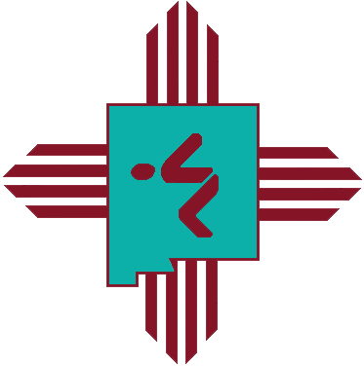

NEW MEXICO SWIMMING DIVERSITY CAMP
September 12, 2020
UNM Seidler Natatorium
Albuquerque, New Mexico

Purpose: Instill a vision of success and inspire athletes from under-represented populations to become leaders in the sport of swimming.

Site: UNM Seidler Natatorium, Albuquerque, New Mexico

Date: September 12, 2020

Application Deadline: August 3, 2020

Age: 11-14

Athlete Qualifications:
Preferred Qualifications: For our athletes, we will be selecting swimmers from a diverse or minority background in the single age groups of 11 year old, 12 year old, 13 year old, and 14 year old, with 4 boys and 4 girls being selected. Should there not be enough applications who have completed their IMX scores for selection, the Selection Committee will select the next eligible athletes. Applications should be turned in to Camp Coordinator Doug Forbes by August 3.
Secondary Qualifications: Should there not be enough applications who have completed their IMX scores for selection, the Selection Committee will select the next eligible athletes.

Applications should be turned in to Camp Coordinator Doug Forbes by August 3 – coachdforbes@aol.com.

Additional Information: If an athlete has attended a previous New Mexico Swimming Diversity Camp the athlete may not attend.

Athlete Eligibility: Swimmers must be from a diverse or minority background, and be in the age range of 11-14 years old.

Camp Schedule: The one day camp program will include a combination of pool training, motivational and education sessions, leadership skills, and team building activities.

Coaching Staff: The coaching staff will consist of Camp Head Coach Doug Forbes and other assistants

Application: Available from your club coaches or coordinator Doug Forbes.

Questions: Please contact Doug Forbes, coachdforbes@aol.com

