LEAD COACH – SENIOR 1 (15-18’s)
PART-TIME

Somerset Valley YMCA’s swim team, 2017 LC YMCA National Champions and 2018 SC NJYMCA State Champions, is currently seeking a dedicated swim coach for our Senior 1 practice group of 15-18 year old athletes. We are looking for an individual who shares our commitment in strengthening the community through youth development, healthy living, and social responsibility. We enable swimmers to grow as individuals, achieve their goals, and expand their overall potential in a safe and supportive environment.

The Senior 1 practice group has qualified multiple athletes for YMCA National Championships in each of the past six seasons. The growth of the Senior 1 practice group has been vital to the success of the 15-18 Senior program at SVY. The Senior 1 lead coach also serves as a YMCA National Team Assistant Coach, and will assist in coaching all athletes in the 13/Over program.

Benefits of working for the Somerset County YMCA include working in a diverse and inclusive environment, a supportive community, and a free membership to encourage a healthy spirit, mind, and body.

ESSENTIALS
- Motivates and develops individual team members
- In charge of all aspects of group season planning and individual goal setting
- Assists in year-round competitions in both YMCA and USA sanctioned swimming events
- Effectively communicates team information to Swim Team and parents

QUALIFICATIONS
- Must possess ASCA level 1 or higher
- Must have ARC Swim Coach Safety Training, CPR/AED and First Aid certifications
- LGI, WSI and CPO Licenses are a plus

HOURS: Mon – Fri (Tue off) 4-6:30p or 6:00-9:00p, Sat 11a-2p, Sun 7-9a, meet weekends as needed

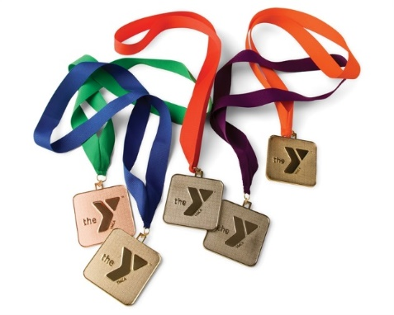
Send your application to
Dan Roth, Director of Competitive Aquatics
601 Garretson Road, Bridgewater, NJ 08807
E: droth@somersetcountyymca.org
W: www.somersetcountyymca.org/jobs

Click here for Employment Application

Deadline for applications: until filled

Somerset County YMCA is a drug free work environment. We are an Equal Opportunity Employer and welcome all applicants who share our values of Caring, Honesty, Respect and Responsibility

