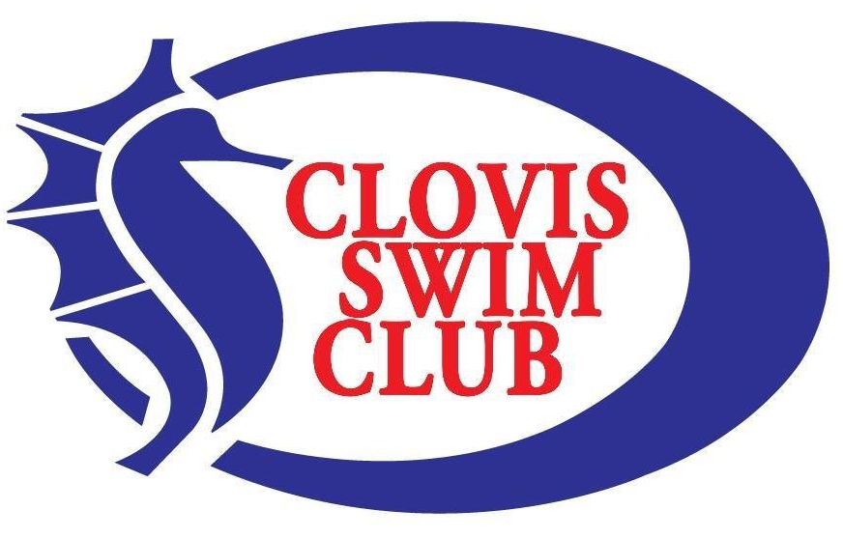Central California Swimming Junior Olympic Swimming Championships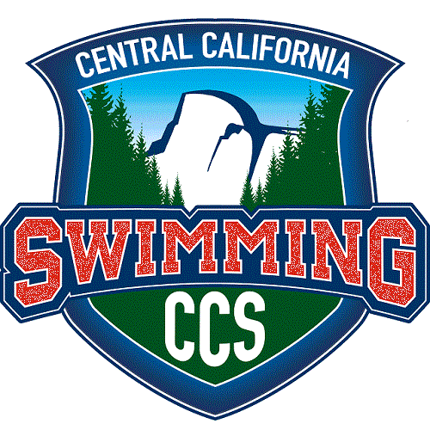

February 18-21, 2022
Hosted by Clovis Swim Club
Clovis North Aquatic Complex / Clovis North High School
Held under the Sanction of USA Swimming / Central California Swimming #S13721TL
See the Central California Swimming website for upcoming events and results. www.centralcalswim.org

Host: Clovis Swim Club
Location: Clovis North Aquatic Complex / Clovis North High School, 2770 E. International Ave., Fresno, CA 93730
Facility: Two 50 M x 25-yard pools. The main competition pool is all deep at 7 feet. The adjacent multipurpose pool will provide at least 10 x 25y lanes for continuous warm up and warm down. The competition pool has been certified according to articles 104.2.2 C (4) USAS rules and regulations.

Operation of a drone, or any other flying apparatus, is prohibited over the venue (pools, athlete/coach areas, spectator areas and open ceiling locker rooms) any time athletes, coaches, officials and/or spectators are present. Use of audio or visual recordings devices, including a cell phone, is not permitted in changing areas, rest rooms or locker rooms. Deck changes are prohibited. For Athlete Protection, Central California Swimming prohibits the use of photography and audio or visual recording devices, including a cell phone, behind the starting blocks during the start sequence throughout the meet.
    - The use of any propane heater(s) is strictly prohibited anywhere at this venue.
    - The sale and use of alcoholic beverages is prohibited in all areas of meet venue.
    - The presence and use of tobacco products, including vaping, is prohibited on CUSD property.
    - Overnight parking is not allowed on CUSD property.
No animals are allowed on school grounds, except for service animals. All paper work for service animals should be on file with the CUSD District Office before 5:00pm of Thursday, February 17, 2022.

Times: Friday, February 18: The facility will be open at 3:00 p.m. for to set up. Timed final warm-up begins at 4:00 p.m. Timed finals begin at 5:00 p.m. There will be at least 8 lanes of contiguous warm-up/warm-down space after 5:00 p.m. and until 7:30 p.m. or until the end of the timed final session, whichever is later.

Saturday, February 19 – Monday, February 21: Preliminaries warm-up at 7:30 a.m. Meet begins at 9:00 a.m. Final times will be established by the Meet Referee each day (no sooner than 2 hours after the completion of the preliminary session).
Membership &
Eligibility: Open to all swimmers who hold a 2022 USA Swimming “Premium” registration. Swimmers who hold a “Flex” membership must upgrade to the “Premium” registration to enter this LSC Championship meet. On-deck USAS membership registration will be allowed with a $20 fee payable by the swimmer’s club of record. All coaches and officials must be able to show proof that USA Swimming membership requirements are met as of the dates of competition. Deck Pass is acceptable proof of USA Swimming membership.

Rules: Current USA Swimming and CCS Rules will govern the meet. Swimmers must compete in their age group. Age on the first day of the meet determines age throughout the competition. Submitted entry times must be equal to or faster than the listed time standards. This is a proof of time meet. No converted times will be accepted. There are short course yards, short course meters, and long course meters time standards for this meet. Short course (conforming) entry times will be seeded first. Short course meters and long course meters (non-conforming) times, in that order, will be seeded after all conforming entry times. Verification of entered times should be available upon request from the Meet Referee.

The Central California Swimming missed event policy is as follows: swimmers who have not scratched from an individual event in preliminaries and are charged with a “no show” will be scratched from that event and their next preliminary or timed final individual event in the meet. Swimmers who are seeded into finals in an individual event and charged with a “no show” will be scratched from that event, any other individual finals events they are in that day, plus their first individual event on the next day. A swimmer who qualifies for finals and wishes to scratch their event must scratch or declare their intention to scratch within 30 minutes of the official announcement of the results for that event. No deck entries will be allowed for any relay or individual events (all relays and individual events will be sent in the initial electronic entry process).
All USAS athlete members must be under the supervision of a USAS member coach during warm up, competition and warm-down. Any swimmer entered in the meet must be certified by a USA Swimming member-coach as being proficient in performing a racing start or must start each race from within the water. When unaccompanied by a member-coach, it is the responsibility of the swimmer or the swimmer's legal guardian to ensure compliance with this requirement. All swimmers will enter the pool with a 3-point entry during warm-up and warm-down.
Unattached/Unaccompanied Athletes: Swimmers who do not have a USAS registered coach at the swim meet should report to the Meet Director or Meet Referee for assistance obtaining a lane and coach assignment. It is the swimmer’s responsibility to make such arrangements prior to the start of the meet.
Proof that all coach and official membership requirements are met, as of the dates of competition, shall be presented upon request by the Meet Referee. Proof will be in the form of the USA Swimming Deck Pass mobile app.
No technical suits shall be worn by any 12 & Under athlete member in competition as any sanctioned, approved, or observed CCS Meet. This includes any suit with bonded or taped seams regardless of its fabric or silhouette or any suit with woven fabric extending past the hips. (Note: Woven Fabric – A suit with woven fabric and sewn seems that does not extend below the hips is permitted. Knit fabric – A suit with knit fabric and sewn seams not extending below the knees is permitted). CLICK HERE for the USA Swimming FAQ page regarding technical suits and 12&Under athletes.
Meet Format: Preliminaries and finals will be swum in all individual events except for the following which will be timed finals: 11-12, 13-14, & 15-18 1000 and 1650 freestyles, the 11-12 400 IM, 10&Un 500 freestyle, and all 8 and under events. The 8 & Under events, including relays, will be timed finals conducted during preliminaries on Saturday and Sunday. All timed finals and preliminary events will be seeded as fastest to slowest. The fastest 3 heats of all non-timed final events will be championship (circle) seeded heats. There will be a championship and consolation final (A & B final) swum in that order for all other individual events except for the 15-18 age group. The 15-18 age division will have one championship final (A final) only. The 15-18 athletes are subject to a de-qualifying time and may not swim events and/or relay legs in which they have achieved the CCS 15-18 “Dequal” Time Standard.
Girls |  |  | 15&O JO “de-qual” | Boys
SCY | SCM | LCM |  | SCY | SCM | LCM
24.79 | 27.49 | 28.29 | 50 free | 22.19 | 24.69 | 25.49
53.39 | 59.29 | 1:00.89 | 100 free | 48.09 | 53.39 | 54.99
1:56.49 | 2:09.69 | 2:12.49 | 200 free | 1:46.09 | 1:57.69 | 2:00.89
5:12.69 | 4:32.69 | 4:39.09 | 400 free | 4:48.29 | 4:10.89 | 4:17.29
10:51.89 | 9:28.99 | 9:41.79 | 800 free | 10:05.19 | 8:47.29 | 9:00.09
18:18.09 | 18:16.09 | 18:40.09 | 1500 free | 17:05.79 | 17:02.39 | 17:26.39
1:01.79 | 1:08.69 | 1:09.89 | 100 back | 55.99 | 1:02.19 | 1:03.39
2:12.09 | 2:26.69 | 2:29.09 | 200 back | 2:01.29 | 2:14.69 | 2:17.09
1:10.29 | 1:18.09 | 1:20.09 | 100 breast | 1:02.09 | 1:09.09 | 1:11.09
2:32.39 | 2:47.19 | 2:51.19 | 200 breast | 2:15.29 | 2:30.19 | 2:34.19
59.39 | 1:05.99 | 1:07.39 | 100 fly | 53.19 | 59.09 | 1:00.49
2:12.99 | 2:27.69 | 2:30.49 | 200 fly | 1:59.89 | 2:13.09 | 2:15.89
2:13.09 | 2:27.69 | 2:30.89 | 200 IM | 1:59.99 | 2:13.19 | 2:16.19
4:41.79 | 5:12.79 | 5:19.19 | 400 IM | 4:18.69 | 4:47.19 | 4:53.59

Check-In: All swimmers will be automatically checked into their events in which they have been entered, if they have not scratched by the scratch deadline. If a swimmer is entered in more than 3 events in a day, that swimmer must scratch any additional events prior to the scratch deadline. If a swimmer fails to scratch events when more than 3 are entered, the swimmer will be seeded into the FIRST THREE (3) individual events in the event sequence and scratched from any events after the third event of the day. Scratch deadline for Friday’s events is Thursday, February 17, 2022, by 5:00 p.m., with scratches being accepted via email to the Admin Referee, Jennifer McDougal (jenmcdougal@sbcglobal.net). Scratch deadline for Saturday, Sunday, and Monday events is 5:00 p.m. on the respective preceding day. Scratches are to be made at the Clerk of Course Desk prior to the deadline. No deck entries will be accepted.
Distance
Events: The 11-12, 13-14, & 15-18 1650 free will be swum fastest to slowest, alternating between heats of girls and boys. The 11-12, 13-14, & 15-18 1000 free will be swum fastest to slowest at the end of preliminaries, with the girls’ event occurring on Sunday, and the boys’ event occurring on Monday. Swimmers in the 500, 1000 & 1650-yard freestyle events must provide two people to time and a person to count laps. Lap counting devices will be provided. The 1000-yard events on Sunday and Monday will immediately follow the respective 500-yard events on those days, unless the Meet Referee determines it is appropriate to use a “split course” to run both events concurrently, with one gender’s 500-yard free events being swum in one course and the other gender’s 1000 yard free event being swum in the other course.
Warm-Up: All warm-ups must be supervised by a USA Swimming registered coach. Any swimmer who does not have a USA Swimming registered coach present must report to the Deck Referee for coach and lane assignment. Warm-up procedures will be announced continuously by the Deck Referees.
GENERAL WARM-UP PERIOD - The first 30 minutes of warm-up will be for general warm-up in all lanes. There will be no diving allowed during general warm-up. A 3-point entry shall be used during warm up.
SPECIFIC WARM-UP PERIOD - The last 45 minutes of warm-up (last 15 minutes of the Friday Timed Final session) in each competition course there will be allocated lanes for specific warm-up. During the specific warm-up period, the Deck/Starter Referees will assign one-way dive lanes and designated pace lanes as they determine to be required. There will be at least eight SCY lanes in the warm-up pool for general warm-up and swim down. There will be no practicing starts in the warm-up area during the competition.
Entries: Swimmers may enter all of the events in which they qualify, but may compete in a maximum of seven (7) individual events for the meet, plus relays. Swimmers are limited to three (3) individual events per day.
Entries will be sent in a Hy-Tek CL2 entry file to the following email address: coachkacy@gmail.com Unattached swimmers affiliated with CCS may enter this meet on the CCS website, as long as the swimmer had registered on the CCS site for their USA Swimming membership. CCS Outreach swimmers who are entered in this meet will have their fees deducted by the Host Club. The Home Club or responsible individual of the Outreach swimmer is responsible for communicating with the Host Team of their roster and fees that need to be deducted. Names of the athletes who are receiving the Outreach incentive may be kept confidential at the discretion of the athletes’ Home Club. Full payment (single team check) for an e-mail entry must be postmarked within 48 hours of the e-mail entry.
ENTRY DEADLINES: The entry limit for this meet is 900 swimmers. CCS team and individual online entries must be received by Wednesday, February 2, 2022, to guarantee that the entries will be accepted. The entry period for non-CCS teams begins on February 3, 2022, and teams will be notified within 24 hours of submission regarding acceptance into the meet. Entries close on February 11, 2022, at 11:59 p.m. Entries received once the entry limit is reached will be rejected. If part of a team’s entries exceeds the entry limit, all of that team’s entries will be accepted. Newly achieved CCS JO qualifying times, (not improved times that already qualified) may be advanced by the Meet Referee from the CCS B/C Championships or other USAS sanctioned “Last Chance” competitions held on February 12-13, 2022. Such newly achieved qualifying times must be submitted to the CCS JO Admin Referee by February 13, 11:59 p.m. All other late entries will be rejected.
Relay Entries: All relay entries must be submitted by the entry deadline. Relay entries will not be accepted at the meet. Relays may be entered as part of the emailed CL2 entry file. Relay-only swimmers must enter the meet and pay the $10.00 athlete surcharge by the meet entry deadline. There are relay time standards provided for this meet. Each team will be allowed to enter one relay per relay event that does not meet the listed time standard (as long as it is the team’s only relay entry for the event. No B or above relays may be entered slower than the time standard.) Each team may enter as many relays, as desired, that make the time standard. Only the fastest two placing relays from each team will be eligible for scoring and awards. Eight (8) and Under relays are timed finals and will be swum during preliminaries. All relays, (except 8 & UNDER), will be timed finals swum in finals sessions. Athletes 15 & Over who have achieved a 2022 CCS “Senior De-Qual” Standard, in ANY course, in a corresponding leg of a relay is ineligible to swim that stroke and distance in any relay. Each swimmer is restricted to participating in ONLY ONE (1) relay in a specific distance and category (medley or freestyle), regardless of age group. All relays must be paid in full to the address listed below.
Entry Fees: $7.00 for each individual event, $8.00 per relay and $10.00 per swimmer facility surcharge. Entry Fees are non-refundable. Team checks should be made payable to Clovis Swim Club and mailed to Clovis Swim Club, 1690 David E Cook Way, Clovis, CA 93611.
Awards: Custom medals for 1st through 8th in individual events and 1st through 3rd in relay events. Team awards for 1st through 5th places. High point awarded for each age group and gender. Only 8 & under events will count toward the 8 & under high point award. Any 8 & under swimmers competing in 10 & under events will score points in the 10 & under division in those events.
Scoring: Individual events (15-18 age group only scores the top 8 places): 20-17-16-15-14-13-12-11-9-7-6-5-4-3-2-1
Relay events: 40-34-32-30-28-26-24-22-18-14-12-10-8-6-4-2
Directors: Andy Hill and Bree Wilber
Information: Kacy Ota coachkacy@gmail.com (805)490-2911
Meet Referees: Mike Carpenter
Admin Referee: Jennifer McDougal jenmcdougal@sbcglobal.net (559) 779-3095
Officials: All available USA Swimming member certified officials are welcomed and encouraged to work at this meet. There will be a briefing for all officials one hour prior to each session. As the number of certified officials allows, interested parents/trainees are also welcome to shadow working officials for education and/or mentoring.

Participating CCS clubs are asked to provide at least the following minimum number of certified and carded officials for each session:
Club swimmers entered in session: Trained and carded officials requested:
1-10 0
11-21 1
21-37 2
38-58 3
59-74 4
75 or more 5

Event Order and Time Standards

Friday, February 18, 2022
Women | SCY | SCM | LCM | Event | SCY | SCM | LCM | Men
1 | 23:07.29 | 22:25.19 | 23:55.39 | 11-12 1650 Free# | 22:37.49 | 22:29.59 | 23:25.49 | 2
1 | 21:43.19 | 21:35.69 | 22:23.09 | 13-14 1650 Free# | 20:43.19 | 20:35.99 | 21:27.39 | 2
1 | 21:26.19 | 21:18.69 | 22:02.19 | 15-18 1650 Free# | 20:02.89 | 19:55.89 | 20:33.99 | 2
3 | 5:06.79 | 5:37.69 | 5:57.39 | 12&Un 400 Medley Relay** | 5:05.59 | 5:39.59 | 5:54.69 | 4
5 | Must Meet 400 Medley QT |  |  | 14&Un 200 Medley Relay** | Must Meet 400 Medley QT |  |  | 6
7 | Must Meet 400 Medley QT |  |  | 18&Un 200 Medley Relay** | Must Meet 400 Medley QT |  |  | 8
9 | 1:57.59 | 2:08.39 | 2:13.59 | 14&Un 200 Free Relay** | 1:51.59 | 2:02.79 | 2:08.39 | 10
11 | 1:57.59 | 2:08.39 | 2:13.59 | 18&Un 200 Free Relay** | 1:45.19 | 1:57.99 | 2:01.19 | 12

Saturday, February 19, 2022
Women | SCY | SCM | LCM | Event | SCY | SCM | LCM | Men
13 | 2:03.99 | 2:16.39 | 2:20.79 | 12&Un 200 Free Relay** | 2:02.79 | 2:15.19 | 2:20.39 | 14
15 | 2:15.99 | 2:29.59 | 2:37.99 | 10&Un 200 Free Relay** | 2:18.79 | 2:32.79 | 2:39.99 | 16
17 | 1:34.59 | 1:44.99 | 1:46.59 | 8&Un 100 Free | 1:34.59 | 1:44.99 | 1:46.59 | 18
19 | 5:56.79 | 6:34.19 | 6:48.29 | 11-12 400 IM*** | 5:46.39 | 6:22.79 | 6:39.39 | 20
21 | 5:39.69 | 6:15.39 | 6:27.59 | 13-14 400 IM | 5:17.39 | 5:50.69 | 6:04.69 | 22
23 | 5:31.99 | 6:06.19 | 6:18.79 | 15-18 400 IM | 5:05.59 | 5:37.69 | 5:47.29 | 24
25 | 41.19 | 45.39 | 46.99 | 10&Un 50 Back | 41.79 | 45.99 | 48.39 | 26
27 | 49.89 | 53.09 | 55.99 | 8&Un 50 Back | 49.89 | 53.09 | 55.99 | 28
29 | 1:18.19 | 1:26.69 | 1:29.59 | 11-12 100 Back | 1:15.79 | 1:23.69 | 1:29.09 | 30
31 | 1:11.69 | 1:19.09 | 1:23.49 | 13-14 100 Back | 1:06.89 | 1:13.89 | 1:18.29 | 32
33 | 1:10.09 | 1:17.39 | 1:21.99 | 15-18 100 Back | 1:03.49 | 1:10.19 | 1:14.69 | 34
35 | 51.99 | 57.69 | 58.49 | 8&Un 50 Fly | 51.99 | 57.69 | 58.49 | 36
37 | 41.69 | 46.19 | 46.99 | 10&Un 50 Fly | 40.49 | 44.79 | 45.99 | 38
39 | 34.09 | 37.59 | 38.29 | 11-12 50 Fly | 34.19 | 37.79 | 38.69 | 40
41 | No Time Standard |  |  | 8&Un 100 Free Relay* | No Time Standard |  |  | 42
43 | 2:17.79 | 2:33.29 | 2:35.89 | 15-18 200 Free | 2:06.29 | 2:19.99 | 2:24.39 | 44
45 | 2:15.19 | 2:30.09 | 2:33.29 | 13-14 200 Free | 2:10.99 | 2:24.39 | 2:29.69 | 46
47 | 2:25.49 | 2:41.69 | 2:44.69 | 11-12 200 Free | 2:24.59 | 2:39.79 | 2:45.19 | 48
49 | 2:53.29 | 3:12.39 | 3:15.59 | 10&Un 200 Free | 2:47.99 | 3:05.49 | 3:09.49 | 50
51 | 2:54.69 | 3:13.09 | 3:20.79 | 15-18 200 Breast | 2:36.59 | 2:53.09 | 3:02.49 | 52
53 | 2:58.29 | 3:16.99 | 3:25.59 | 13-14 200 Breast | 2:45.59 | 3:02.99 | 3:11.59 | 54
55 | 3:08.59 | 3:28.39 | 3:36.09 | 11-12 200 Breast | 3:00.99 | 3:19.99 | 3:28.69 | 56
57 | 1:44.19 | 1:55.99 | 1:57.69 | 10&Un 100 Breast | 1:41.89 | 1:52.19 | 1:57.69 | 58
59 | 9:19.99 | 10:15.99 | 10:37.99 | 14&Un 800 Free Relay** | 8:33.59 | 9:25.19 | 9:51.59 | 60
61 | 9:18.79 | 10:21.19 | 10:35.59 | 18&Un 800 Free Relay** | 8:56.79 | 9:50.79 | 10:15.19 | 62

It is understood and agreed that USA Swimming shall be free from any liabilities or claims for damages arising by reason of injuries to anyone during the conduct of the event.

15-18 year-old athletes are subject to a de-qualifying time and may not swim events (or a relay leg of that stroke and distance) in which they have achieved the CCS JO “Dequal” Time Standards as listed.

*All relays for 8 & Under are Timed Final and will be swum with the preliminary session.
**All relays for 10 & Under, 12 & Under, 14 & Under, 18 & Under relays are timed finals and will be swum in the evening sessions.
***The 10&Un 500 Freestyle and 11-12 400 IM events are timed final. All heats will be swum with the preliminary session.
# The 11-12, 13-14, and 15-18 1000 and 1650 Freestyle events will be swum together but scored and awarded separately.
## The 11-12, 13-14, and 15-18 500 Freestyle events will be swum together in preliminaries but seeded and swum in finals separately.

All Swimmers in the 500 freestyle, 1000 freestyle, and 1650 freestyle events will need two (2) timers and a person to lap count.

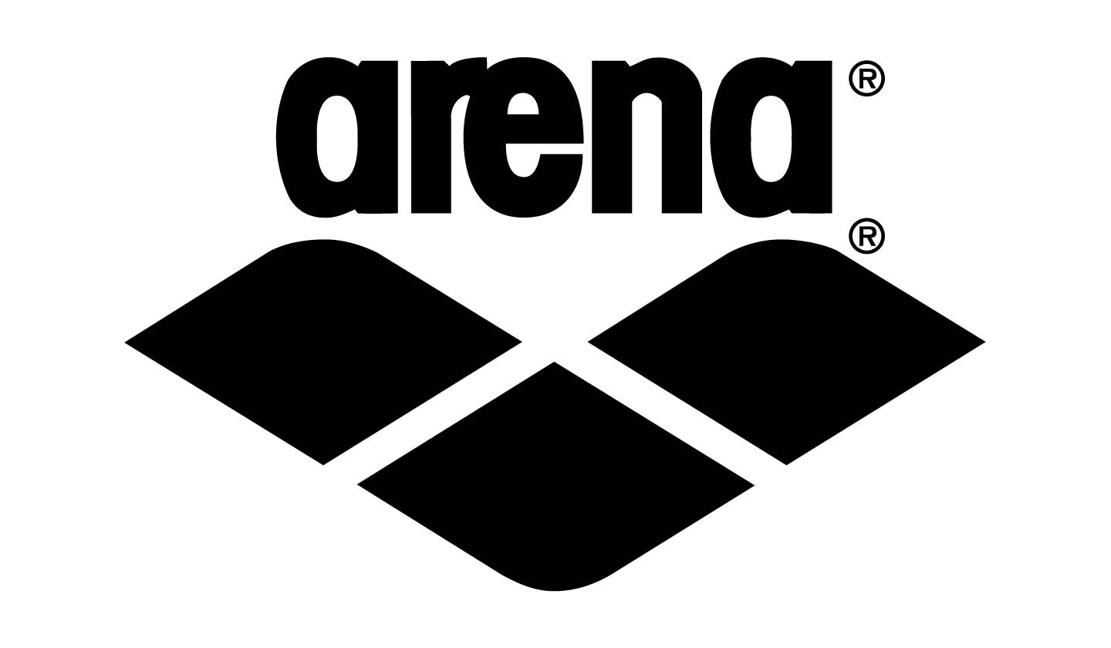

Sunday, February 20, 2022

Women | SCY | SCM | LCM | Event | SCY | SCM | LCM | Men
63 | 2:22.29 | 2:36.59 | 2:41.29 | 12&Un 200 Medley Relay** | 2:45.39 | 3:02.09 | 3:09.89 | 64
65 | 2:45.09 | 3:01.69 | 3:08.39 | 10&Un 200 Medley Relay** | 2:45.39 | 3:02.09 | 3:09.89 | 66
67 | 1:45.69 | 1:56.29 | NA | 8&Un 100 IM | 1:45.69 | 1:56.29 | NA | 68
69 | 35.59 | 39.29 | 41.69 | 11-12 50 Back | 35.29 | 38.99 | 40.89 | 70
71 | 1:30.69 | 1:40.19 | 1:42.09 | 10&Un 100 Back | 1:29.69 | 1:39.09 | 1:43.59 | 72
73 | 1:20.69 | 1:29.19 | 1:32.49 | 15-18 100 Breast | 1:12.09 | 1:19.59 | 1:23.49 | 74
75 | 1:22.19 | 1:29.79 | 1:34.29 | 13-14 100 Breast | 1:15.59 | 1:23.49 | 1:28.09 | 76
77 | 1:27.39 | 1:36.59 | 1:41.39 | 11-12 100 Breast | 1:25.49 | 1:34.39 | 1:38.49 | 78
79 | 47.49 | 52.49 | 54.39 | 10&Un 50 Breast | 46.59 | 51.39 | 53.29 | 80
81 | 55.09 | 1:00.59 | 1:02.89 | 8&Un 50 Breast | 55.09 | 1:00.59 | 1:02.89 | 82
83 | 28.99 | 32.39 | 32.99 | 15-18 50 Free | 26.29 | 29.49 | 30.19 | 84
85 | 28.59 | 31.29 | 32.29 | 13-14 50 Free | 27.29 | 30.29 | 31.09 | 86
87 | 29.99 | 33.29 | 34.09 | 11-12 50 Free | 30.29 | 34.29 | 34.69 | 88
89 | 33.99 | 37.39 | 39.49 | 10&Un 50 Free | 34.49 | 38.09 | 39.49 | 90
91 | 41.49 | 45.69 | 46.69 | 8&Un 50 Free | 41.49 | 45.69 | 46.69 | 92
93 | 2:47.89 | 3:05.59 | 3:10.19 | 11-12 200 Fly | 2:43.99 | 3:01.19 | 3:07.69 | 94
95 | 2:37.89 | 2:54.49 | 2:59.49 | 13-14 200 Fly | 2:26.99 | 2:42.49 | 2:49.19 | 96
97 | 2:34.89 | 2:50.39 | 2:54.79 | 15-18 200 Fly | 2:20.59 | 2:35.39 | 2:40.39 | 98
99 | 3:15.59 | 3:36.19 | 3:43.19 | 10&Un 200 IM | 3:13.19 | 3:33.49 | 3:40.79 | 100
101 | 1:16.79 | 1:25.79 | NA | 11-12 100 IM | 1:14.99 | 1:22.89 | NA | 102
103 | No Time Standard |  |  | 8&Un 100 Medley Relay* | No Time Standard |  |  | 104
 |  |  |  | 15-18 500 Free## | 5:45.99 | 5:02.79 | 5:09.89 | 106
 |  |  |  | 13-14 500 Free## | 5:57.89 | 5:13.19 | 5:19.49 | 106
 |  |  |  | 11-12 500 Free## | 6:27.49 | 5:39.09 | 5:48.69 | 106
 |  |  |  | 10&Un 500 Free*** | 7:26.99 | 6:31.19 | 6:44.59 | 108
109 | 13:44.69 | 12:01.69 | 12:29.19 | 11-12 1000 Free#
109 | 13:01.79 | 11:24.19 | 11:41.99 | 13-14 1000 Free#
109 | 12:49.99 | 11:13.89 | 11:28.39 | 15-18 1000 Free#
111 | 4:44.09 | 5:12.89 | 5:25.09 | 18&Un 400 Medley Relay** | 4:20.89 | 4:47.09 | 5:01.09 | 112
113 | 4:51.59 | 5:21.39 | 5:33.09 | 14&Un 400 Medley Relay** | 4:33.69 | 5:01.19 | 5:14.19 | 114

It is understood and agreed that USA Swimming shall be free from any liabilities or claims for damages arising by reason of injuries to anyone during the conduct of the event.

15-18 year-old athletes are subject to a de-qualifying time and may not swim events (or a relay leg of that stroke and distance) in which they have achieved the CCS JO “Dequal” Time Standards as listed.

*All relays for 8 & Under are Timed Final and will be swum with the preliminary session.
**All relays for 10 & Under, 12 & Under, 14 & Under, 18 & Under relays are timed finals and will be swum in the evening sessions.
***The 10&Un 500 Freestyle and 11-12 400 IM events are timed final. All heats will be swum with the preliminary session.
# The 11-12, 13-14, and 15-18 1000 and 1650 Freestyle events will be swum together but scored and awarded separately.
## The 11-12, 13-14, and 15-18 500 Freestyle events will be swum together in preliminaries but seeded and swum in finals separately.

All Swimmers in the 500 freestyle, 1000 freestyle, and 1650 freestyle events will need two (2) timers and a person to lap count.

Monday, February 21, 2022
Women | SCY | SCM | LCM | Event | SCY | SCM | LCM | Men
115 | 4:29.99 | 4:56.79 | 4:57.19 | 12&Un 400 Free Relay** | 4:27.99 | 4:54.79 | 5:05.19 | 116
117 | 4:14.79 | 4:39.59 | 4:40.39 | 14&Un 400 Free Relay** | 4:06.39 | 4:31.19 | 4:43.19 | 118
119 | 4:03.59 | 4:16.79 | 4:27.99 | 18&Un 400 Free Relay** | 3:54.79 | 4:18.39 | 4:29.59 | 120
121 | 39.99 | 44.19 | 45.49 | 11-12 50 Breast | 39.59 | 43.69 | 45.39 | 122
123 | 2:32.39 | 2:48.29 | 2:55.59 | 15-18 200 Back | 2:19.19 | 2:33.79 | 2:41.39 | 124
125 | 2:35.39 | 2:51.69 | 2:59.39 | 13-14 200 Back | 2:25.89 | 2:41.19 | 2:49.69 | 126
127 | 2:43.99 | 3:01.29 | 3:10.19 | 11-12 200 Back | 2:40.29 | 2:57.19 | 3:06.49 | 128
129 | 1:17.89 | 1:25.69 | 1:27.69 | 10&Un 100 Free | 1:18.79 | 1:26.99 | 1:30.29 | 130
131 | 1:06.49 | 1:14.89 | 1:15.49 | 11-12 100 Free | 1:05.89 | 1:12.89 | 1:15.69 | 132
133 | 1:02.09 | 1:08.99 | 1:10.59 | 13-14 100 Free | 1:00.69 | 1:07.09 | 1:09.19 | 134
135 | 1:00.89 | 1:06.99 | 1:08.89 | 15-18 100 Free | 57.59 | 1:03.99 | 1:05.99 | 136
137 | 1:29.09 | 1:41.29 | NA | 10&Un 100 IM | 1:29.39 | 1:38.79 | NA | 138
139 | 2:47.19 | 3:04.79 | 3:09.99 | 11-12 200 IM | 2:44.19 | 3:01.49 | 3:09.29 | 140
141 | 2:37.89 | 2:54.69 | 2:57.19 | 13-14 200 IM | 2:28.59 | 2:44.19 | 2:51.99 | 142
143 | 2:36.19 | 2:52.49 | 2:59.69 | 15-18 200 IM | 2:21.79 | 2:36.69 | 2:43.99 | 144
145 | 1:39.09 | 1:49.49 | 1:52.99 | 10&Un 100 Fly | 1:37.99 | 1:48.29 | 1:51.39 | 146
147 | 1:18.29 | 1:26.59 | 1:28.49 | 11-12 100 Fly | 1:16.49 | 1:24.49 | 1:26.29 | 148
149 | 1:11.39 | 1:18.89 | 1:19.49 | 13-14 100 Fly | 1:06.39 | 1:13.29 | 1:15.49 | 150
151 | 1:09.99 | 1:17.29 | 1:19.49 | 15-18 100 Fly | 1:03.39 | 1:10.09 | 1:11.79 | 152
153 | 7:35.49 | 6:38.59 | 6:51.09 | 10&Un 500 Free***
155 | 6:38.39 | 5:48.69 | 5:56.49 | 11-12 500 Free##
155 | 6:10.19 | 5:21.69 | 5:35.39 | 13-14 500 Free##
155 | 6:12.09 | 5:25.59 | 5:34.69 | 15-18 500 Free##
 |  |  |  | 11-12 1000 Free# | 13:30.19 | 11:49.09 | 12:15.19 | 156
 |  |  |  | 13-14 1000 Free# | 12:23.89 | 10:51.09 | 11:13.99 | 156
 |  |  |  | 15-18 1000 Free# | 11:57.79 | 10:28.19 | 10:50.39 | 156

It is understood and agreed that USA Swimming shall be free from any liabilities or claims for damages arising by reason of injuries to anyone during the conduct of the event.

15-18 year-old athletes are subject to a de-qualifying time and may not swim events (or a relay leg of that stroke and distance) in which they have achieved the CCS JO “Dequal” Time Standards as listed.

*All relays for 8 & Under are Timed Final and will be swum with the preliminary session.
**All relays for 10 & Under, 12 & Under, 14 & Under, 18 & Under relays are timed finals and will be swum in the evening sessions.
***The 10&Un 500 Freestyle and 11-12 400 IM events are timed final. All heats will be swum with the preliminary session.
# The 11-12, 13-14, and 15-18 1000 and 1650 Freestyle events will be swum together but scored and awarded separately.
## The 11-12, 13-14, and 15-18 500 Freestyle events will be swum together in preliminaries but seeded and swum in finals separately.

All Swimmers in the 500 freestyle, 1000 freestyle, and 1650 freestyle events will need two (2) timers and a person to lap count.

Additional Information, Disclosures, and Waivers Relative to COVID-19 Precautions

Assumption of Risk Disclaimer for Clovis Unified School District and Clovis Swim Club:

We have taken enhanced health and safety measures – for you and all other guests of our facilities. You must follow all posted instructions while visiting Clovis Unified School Campuses. An inherent risk of exposure to COVID-19 exists in any public place where people are present. COVID-19 is an extremely contagious disease that can lead to severe illness and death. According to the Centers for Disease Control and Prevention, senior citizens and guests with underlying medical conditions are especially vulnerable. By visiting any Clovis Unified School District campus, you voluntarily assume all risks related to exposure to COVID-19.

Liability Agreement for USA Swimming:

An inherent risk of exposure to COVID-19 exists in any public place where people are present. COVID-19 is an extremely contagious disease that can lead to severe illness and death. According to the Centers for Disease Control and Prevention, senior citizens and individuals with underlying medical conditions are especially vulnerable. USA Swimming, Inc., cannot prevent you (or your child(ren)) from becoming exposed to, contracting, or spreading COVID-19 while participating in USA Swimming sanctioned events.

It is not possible to prevent against the presence of the disease. Therefore, if you choose to participate in a USA Swimming sanctioned event, you may be exposing yourself to and/or increasing your risk of contracting or spreading COVID-19.

BY ATTENDING OR PARTICIPATING IN THIS COMPETITION, YOU VOLUNTARILY ASSUME ALL RISKS ASSOCIATED WITH EXPOSURE TO COVID-19 AND FOREVER RELEASE AND HOLD HARMLESS USA SWIMMING AND CENTRAL CALIFORNIA SWIMMING AND EACH OF THEIR OFFICERS, DIRECTORS, AGENTS, EMPLOYEES OR OTHER REPRESENTATIVES FROM ANY LIABILITY OR CLAIMS INCLUDING FOR PERSONAL INJURIES, DEATH, DISEASE OR PROPERTY LOSSES, OR ANY OTHER LOSS, INCLUDING BUT NOT LIMITED TO CLAIMS OF NEGLIGENCE AND GIVE UP ANY CLAIMS YOU MAY HAVE TO SEEK DAMAGES, WHETHER KNOWN OR UNKNOWN, FORESEEN OR UNFORESEEN, IN CONNECTION THEREWITH.

