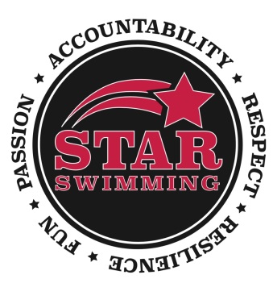

You are invited to the

2018 STAR Swimming Awards Banquet
Pearl Street Grill, 76 Pearl St, Buffalo
Canal View Room
Sunday, April 29, 2018
1:00 – 4:00 pm
Please join us for our annual Awards Banquet at Pearl Street Grill, 76 Pearl St., Buffalo – A time to celebrate our Senior, Sr. Prep, Blue and Red Team athletes and the hard work they invest all year in the pool. Trophies, gifts, the ever popular candy guessing jars and an incredible meal! We will also honor our graduating seniors and their parents. This is a special day for the team, and fun time to see what they look like in nice clothes and no swim caps! Hope you will join us!
You may start arriving after 12:45 pm. Awards Banquet will promptly begin at 1 pm and is $22 for ages 5 and over and free for under 4 years of age. Please register your swimmers and any guests accordingly.
Payments must be received no later than April 11th. Please mail this completed form and make your check payable to STAR Swimming. Mail to: Dorothy Maurer, 6230 Smith Rd, Hamburg, NY 14075. Questions, please call Dorothy Maurer at 646-0977. Please remember to pay for your athlete as well as any other family and friends who will attend with you.

Name _______________________________________ Phone ___________________________
Email _______________________________________ Circle Group(s): Sr, Sr Prep, Blue, Red_
Please list the names of each person attending ________________________________________
______________________________________________________________________________
# of adults and children ages 5 and over attending ________ x $22.00 = _________
# of children 4 & under ________ No charge
Total Enclosed: $___________

