The 2019 Summer Long Course Open
Meet Itinerary
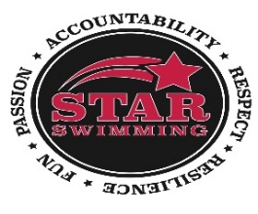

Friday, July 12, 2019: Events: 1-24
ALL AGES Timed Finals Warm-Up: 4:15 PM Meet Starts: 5:00 PM

Saturday, July 13, 2019: Events: 25-48
13 & Over Timed Finals Warm-Up: 9:00 AM Meet Starts: 10:00 AM

Events: 49-70
12 & Under Timed Finals Warm-Up: 12:00 PM Meet Starts: 1:00 PM

Sunday, July 14, 2019: Events: 71-94
13 & Over Timed Finals Warm-Up: 9:00 AM Meet Starts: 10:00 AM

Events: 95-116
12 & Under Timed Finals Warm-Up: 12:00 PM Meet Starts: 1:00 PM

Things to know:

- All swimmers must be on deck stretching at the start of their warm-up period. This time includes stretching time prior to getting in the water.
- This meet is timed finals for ALL events.
- This meet will be PRE-SEEDED.
- Please wear STAR apparel while at the meet. Swimmers should wear a speedo team suit. “Championship” suits are permitted.
- Location: Cheektowaga Town Park, Harlem Road, Cheektowaga, NY 14225

Goals:

- Focus on Race Strategy (See coaches before and after swims)
- Lead by Example: RESPECT, ACCOUNTABILITY, RESILIENCE, PASSION, FUN
- Take care of yourself! It’s a long weekend so make sure to eat well and staying hydrated.
- If we are having FUN, we are swimming FAST!!

