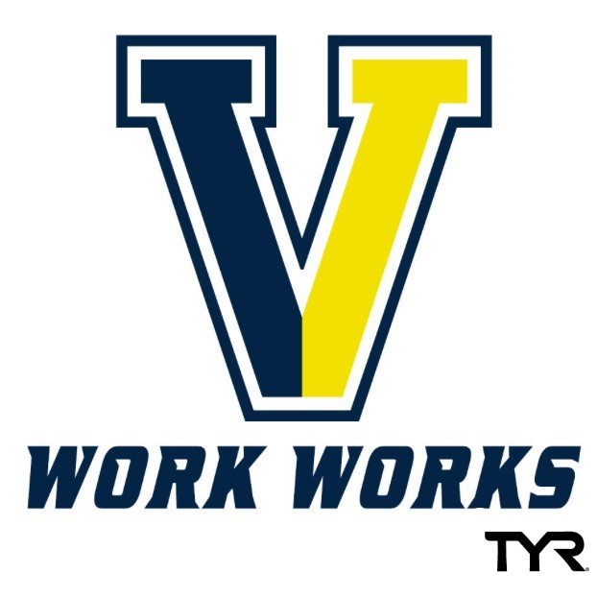

Victor Swim Club, Mission Statement

The Mission of The Victor Swim Club:
To offer a competitive USA Swimming program for our local community. We believe in providing a safe & healthy environment that promotes inclusive group dynamics and celebrates the diversity and uniqueness of our club membership. We strive to foster the enjoyment and love of competitive swimming to inspire excellence within our team. At Victor, we challenge our athletes to reach their full potential by encouraging participation in every stroke, event & distance; with a special focus on IM training and competition.

With these principles as our foundation, Victor excels at the Local, Regional and national level. In 2014 Our club was recognized as one of the TOP PERFORMING club teams in the country, earning a USA Swimming Level 4 Recognition & USA Swimming Bronze medal of excellence; signifying our success in the business of swimming.
Our club is a USA year-round competitive swim team offering high quality professional coaching and technique instruction for all ages and abilities. The goal of our team is to provide every member an opportunity to improve swimming skills and achieve success at his or her level of ability, from novice to international competitor.
All of our coaches, as members of the American Swim Coaches Association & Certified through USA Swimming, have access to the most comprehensive training and certification programs for youth coaches of any sport in the United States. They provide assurances that the time children spend in swimming will be safe & protected.
We are a team that is focused on teaching the best stroke mechanics as well as helping our swimmers to reach their fullest potential. If you are interested in becoming a Victor swimmer, please contact Head Coach Mike Murray, coachmurray3m@gmail.com.
Building Champions Worth Admiring.
Team Mission statement

Victor Swim Club
Authored by: Michael M. Murray

