Rules for Timing Adjustments
Adapted from Barb Ship

Beginning May 1, 2016, the USA Swimming rules for timing adjustments due to a lane malfunction change to the following:

102.24.4D Adjustment for Malfunction on a Lane — When a malfunction is confirmed on a lane, the back-up times for that lane shall be calculated in accordance with 102.24.4B and integrated with the accurate primary times in establishing the official time and determining the results.

With the adoption of this rule, timing adjustments will no longer require complicated calculations for lane malfunctions. The backup time, as determined by 102.24.4B, will be the official time. While the procedure for determining the official time has simplified, it remains the responsibility of the Administrative Official/Administrative Referee to determine if the primary time is valid. Note, the procedures to adjust times due to a heat malfunction (102.24.4D in the 2016 rulebook) have not changed.

Beginning May 1, Meet Manager (MM) must be configured to accommodate this change. Administrative Officials/Referees should confirm the proper setting for each meet. In MM 6 (Version 6.0Ce or later), the setting is found on the Meet Set-up screen. From the main screen, choose Set-up | Meet Set-up. In the lower right corner, select FINA rules for Timing Adjustment Method.

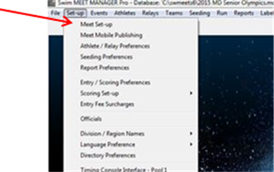
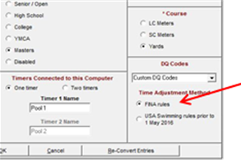

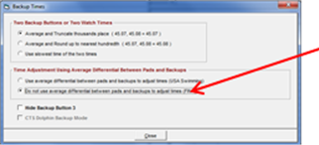
In MM 4 and MM 5, the setting for timing adjustments is configured by going to Preferences | Backup Times from the Run Screen. Select “Do not use average differential between pads and backups to adjust times (FINA)”.

If there is a failure of the primary timing system (pad), the official time is determined using back-up times. Below is the “Calc” screen:

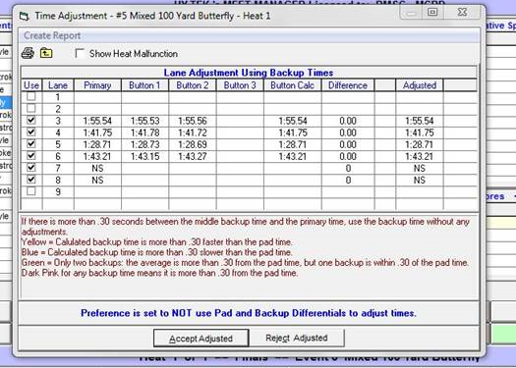

Note that the calculation that is performed above is simply an average of the button times (if using 2 buttons), dropping the digit representing the thousandth place with no rounding. Please also note that there is a reminder that the preference is set not to use Pad and Backup differentials to adjust times. If there are three buttons, Meet Manager selects the middle time. If there is no valid back-up button time, simply calculate the official time from the watch times according to 102.24.4B and enter that time into the Finals Time on the main run screen.

