YKPBSC

Return to Swimming
28 September 2020

Table of Contents
Legal Disclaimer 1
Introduction 2
Overview 3
Step 1 Gold, Silver, Bronze and Cubs 5
Step 2 Introduce Belugas and Sharks 8
Step 3 Introduce Dolphins3 and Dolphins 2 10
Step 4 - Steady State 12
Diagram of RIMP during Step 1 14
Diagram of RIMP during Step 2 15
Diagram of RIMP during Step 3 16
Diagram of RIMP during Step 4 17
Appendix A – Screening Checklist 18
Appendix B – Control Log 19
Appendix C – Equipment List 20
Appendix D – Swimmer Checklist 22
Appendix E – Coach Checklist 24
Appendix F - COVID-19 Response Coordinator Roles and Responsibilities 26

LEGAL DISCLAIMER
Yellowknife Polar Bear Swim Club here forward known as YKPBSC has prepared this document based on the latest information available to date from third-party sources, including Swimming Canada, Swim AB and GNWT Health and Social Services Authority. The document will be reviewed and updated periodically as the situation around the COVID-19 pandemic evolves and more information becomes available.
Additionally, it is an individual’s responsibility for assessing his or her personal risks in consultation with medical professionals and for the outcome of his or her decisions and actions.

INTRODUCTION
The coaches and Board of the YKPBSC acknowledge that it is the desire of the membership to return to swimming as a way of dealing with the physical and mental stressors of living in the post-COVID-19 environment. However, the priority has to be the safety of our members specifically the athletes, as well as the coaches, volunteers, and families involved in the sport.
Therefore, it has to be recognized that a return to swimming will require patience and support from all. It is essential that we follow a phased approach which is in line with all Municipal, Territorial, and National guidelines. In this way, we can hope to ensure the safety of our athletes and coaches, as well as, do our part to keep the swimming community and the collective community at large healthy and safe.

OVERVIEW
Keeping in mind the requirement to create and adjust the protocol for a return to swimming for YKPBSC, this document outlines a step by step approach that will need to be employed in order to reduce the risk of spreading COVID-19 to the membership of YKPBSC.
Progressing through each phase is contingent on the successful implementation of the preceding step. It is estimated that each step can take up to approximately 1 week to ensure its successfulness. In Step 1, only 2 swimmers per lane are identified. The athletes who are identified in this phase are mature swimmers who can easily follow instructions. They are also the senior groups which have athletes over the age of 13. Physical distancing within the groups is therefore required for Gold, Silver and Bronze. During Phase 1, Coaches are to focus on establishing consistent exit and entry routines as well as emphasizing visual cues to ensure physical distancing while in the lanes. This is an intentional week of solidifying strong physical distancing routines in the older swimmers to serve as an example to the younger groups that will subsequently enter into the Club.
In Step 2, younger swimmers aged 8-10 (Sharks and Belugas) are introduced into the pool lanes. They will remain in their groups and will not mingle with the other groups. They will follow similar floor pattern and will be accompanied at all times by 2-3 coaches to ensure that they fully understand their expectations and routines. These groups do not need to physically distance from each other while in the lanes, however they will be strictly supervised so that they are reminded to remain physically distant from other groups. They are expected to follow all entry and exit routines independent of parents as no parents will have access to the pool deck. The ratio of Coaches to swimmers is approximately 1 coach to 5 swimmers in order to maintain supervision throughout all transitions.
In Step 3, the youngest swimmers 6-9 (Dolphins 3 and Dolphins 2) are introduced to the pool lanes during the least congested swim sessions. Routines are established and the exit and entry times are staggered in order to facilitate physical distancing between groups. Currently, their Coach to Swimmer ratio is 1:3 which will enable the strictest of supervision.
The entire process Steps 1-4 will be implemented over a 4 week time period (13 October–7 November) in order to ensure the safety of all our swimmers, coaches, volunteers and parents. Although many of us have grown used to these types of procedures in our school and work environments, it is our responsibility as a Club to ensure the highest of standards are adhered to in order to reduce the risk to COVID 19 in our swimming community and the community at large.
There will be no available on deck dryland training space before or after swimming at Ruth Inch Memorial Pool (RIMP). Athletes are reminded to ensure appropriate stretching is done prior to and after leaving the pool. The hot tub will not be available for use at this time.

STEP 1

The athletes included in Step 1 are to be mature athletes capable of independently adhering to strict physical distancing guidelines. Only swimmers who can complete a swimming session without physical manipulation and who are not immunocompromised can be included in this step. This step will commence 13 October and conclude 19 October. It will be compromised of Gold Squad (10 swimmers, 2 coaches) in the morning and Cubs (10 swimmers, 2 coaches) at 4-4:50pm followed by Bronze (7 swimmers, 3 coaches) 5-5:40 pm and Silver (7 swimmers, 3 coaches) 5:45-6:25pm
YKPBSC will begin training using an iterative methodology which ensures that all swimmers, coaches and parents understand the expectations and requirements. To begin, there will be only 2 swimmers per 25 metre lane. We will move iteratively through 4 steps to having a steady state where there is no more than 5 swimmers per lane for swimmers over age 13 and 6 swimmers per lane for athletes 12 and under.
This step by step staggered start process focusses on introducing and maintaining a physical distance between each swim group as well as a temporal distance for entry and exit time. Additionally, athletes enter and exit the facility at physically separate egress points. Entering and exiting groups are physically separated by the width of the pool once they enter the RIMP.
Additionally, coaches are to focus on ensuring as much as possible that 13 and over athletes are physically separated during instruction using physical reminders such as lane ropes, backstroke flags, and the lane lines on the bottom of the pool.
Athletes who have answered NO to all questions on the Screening checklist (Appendix A) will arrive at the RIMP wearing a non-surgical face mask, with their completed Screening checklist in hand. They will proceed to their assigned entry station as outlined on the diagram where they will:
- Enter by the rear door wearing a non-surgical face mask and with shoes removed and placed in laundry basket for containment purposes
- Immediately use hand sanitizer provided
- Place completed Screening checklist in the receptacle identified
- Follow Appendix C – Equipment List and Appendix D –Swimmer checklist, swimmer shall carry laundry basket, follow traffic flow pattern to proceed to designated lane at the deep end
- Unmask, disrobe, place outdoor clothes in laundry basket and remove swimming equipment
- Enter into designated lane at the deep end with swim equipment identified in Appendix C and swim to appropriate end
- Place swim equipment in ready position at end of designated lane
Coaches will:
- Use hand sanitizer provided
- Place completed Screening checklist in the receptacle identified
- Complete control log/attendance sheet (Appendix B)
- Ensure athletes are following hygiene and traffic protocol ensuring no sharing of equipment
- Ensure that there is no mixing between groups
- Ensure social distancing protocols are being maintained, as much as possible
Once the training is complete, athletes will
- Collect all personal swimming equipment
- Swim to deep end and exit pool
- Collect laundry basket with towel, and all personal belongings
- Don masks
- Following traffic flow pattern, proceed to designated changing room station
- Dry off and change into outer wear as efficiently as possible
- Exit RIMP by front door
Coaches will
- Gather all personal belonging
- Don masks and ensure swimmers follow proper traffic pattern and ensure social distancing protocols are being followed during transition out of the pool, through to the change room and outside of the pool
- Exit RIMP once all swimmers have exited the building

Head Coach will
- Use hand-sanitizer and wear a mask
- Collect and store all screening checklists
- Sanitize swim blocks if utilized between training sessions
- Maintain the control log
- Monitor all protocol and gather feed-back to ensure best practices
- Be prepared to provide control logs to GNWT HSSA should required
- At all times, respect social distancing guidelines and ensure coaches and athletes are doing so, as well
- Act as Covid-19 Response Coordinator

STEP 2

At Step 2, YKPBSC will introduce younger swimmers into the pool. There will be physical separation between each group at all times. There is no requirement for the following groups (Cubs, Sharks, Belugas, Dolphins3, Dolphins2) to physically distance within their cohort as all are l2 years or less) however in order to reduce cross contamination of groups, they will be separated by groups at entry, changing and exit points as well as in their assigned lanes. This will be facilitated by having direction markings on the wall and the deck of the pool and reinforced by Coach lead routines introduced over a 4 week staggered start.
At Step 2 the Gold Swimmers will begin swimming in their allocated lanes, physically distanced with no more than 5 swimmers per lane.
Bronze and Silver move into their allocated 3 lanes and practice physical distancing with no more than 5 swimmers per lane.
Cubs take up residence in their allocated 2 lanes although physical distancing is not required within this cohort because of age.
Sharks (15 swimmers 3 coaches) and Belugas (10 swimmers 2 coaches.) are introduced to the pool lanes. Sharks share the pool with the Cubs and are entering the pool 10 minutes later and exiting 10 minutes earlier than the Cubs. Belugas will be swimming with the Bronze and Silver, they enter 35 minutes later and exit 5 minutes in advance of Bronze and Silver.
Within the pool, coaches are to encourage physical separation of groups by congregating on opposite ends of the pool for instruction and at the extremities of the lane dividers.
All instructions from Step 1 will remain in effect for Step 2 with the following additions.
- There will be group designated spaces along the walls and at the end of lanes to enable swimmers to contain their clothing and equipment. These spaces for the laundry baskets containing their personal clothes will be separated by 2 metres they will leave their masks on top to enable a quick re-masking upon exiting the water.
- Additionally, with up to 25 swimmers exiting the pool within 10 minutes of each other, there will be a requirement for a designated physically distanced waiting area on deck to ensure that change-room stations are not overwhelmed. This will be 3 rows of 5 seats outside of the change rooms to ensure no cross contamination of groups and to ensure physical distancing for the older groups. Only 5 people per change-room will be allowed at a time. Coaches will ensure seats remain at distance of 2 metres and help control the flow of traffic off of the pool deck and through to the exits.
- Waiting chairs will be cleaned between sessions.
- At no time will the entering swimmers be permitted onto the pool deck until all exiting swimmers have transitioned to the change-room or waiting area.
- Groups will be dismissed from the pool at staggered times in order to facilitate orderly and physically distanced traffic flow for all groups under strict Coach supervision.
- Hot tubs and steam rooms will not be in available for afternoon swimmers.

STEP 3

At Step 3, YKPBSC will introduce the youngest swimmers into the pool. There will be physical separation between each group at all times. There is no requirement for the following groups (Cubs, Sharks, Belugas, Dolphins3, Dolphins2) to physically distance within their cohort as all are l2 years or less) however in order to reduce cross contamination of groups, they will be separated by groups at entry, changing and exit points as well as in their assigned lanes. This will be facilitated by having direction markings on the wall and the deck of the pool and reinforced by Coach lead routines introduced over a 3 week staggered start.
The Dolphin 3s and Dolphin 2s are the youngest cohorts (6-9 years old.) The biggest challenge with this group is that in order to participate, they must do so without parental presence on deck. They must be confident enough to swim with their coaches only supervising and must be able to change independently into and out of their swimming suits. They will be introduced during the quietest session - the Friday afternoon session when there are only 15 swimmers in the lanes. This is deliberate so that the youngest swimmers can clearly see the expectations and slowly be introduced and reinforced. There are enough Coaches to help them to make the transitions safely and in accordance with physical distancing rules as the ratio is 1 Coach per 3 swimmers.

At Step 3 the Gold Swimmers are swimming in their allocated lanes, physically distanced with no more than 5 swimmers per lane.
Bronze and Silver are swimming in their allocated 3 lanes and practicing physical distancing with no more than 5 swimmers per lane.
Cubs are swimming in their allocated 2 lanes although physical distancing is not required within this cohort because of age.
Sharks and Belugas are now swimming in their allocated lanes. Although physical distancing is not required within this cohort because of age, Coaches are to encourage physical separation of groups by congregating on opposite ends of the pool for instruction and at the extremities of the lane dividers.
Dolphins 3 and Dolphins 2 are introduced to their lanes. Dolphins 2 and 3 may use the shallow “Dolphin Tank” for training purposes as their swimming abilities are still developing.

All instructions from Step 1 will remain in effect for Step 3 with the following additions.
- There will be group designated spaces along the walls and at the end of lanes to enable swimmers to contain their clothing and equipment.
- Additionally, with up to 25 swimmers exiting the pool within 10 minutes of each other, there will be a requirement for a designated physically distanced waiting area on deck to ensure that change-room stations are not overwhelmed. This will be 3 rows of 5 seats outside of the change rooms to ensure no cross contamination of groups and to ensure physical distancing for the older groups. Only 5 people per change-room will be allowed.
- Waiting chairs will be cleaned between sessions.
- At no time will the entering swimmers be permitted onto the pool deck until all exiting swimmers have transitioned to the change-room or waiting area.
- Groups will be dismissed from the pool at staggered times in order to facilitate orderly and physically distanced traffic flow for all groups under strict Coach supervision.
- Hot tubs and steam rooms will not be in available for afternoon swimmers.

STEP 4

Steady State enables the club to run at 80 % capacity. The following chart allocates the weekly schedule with timings, coaches, swimmers and maximum expected RIMP staff:

 | Monday | Tuesday | Wednesday | Thursday | Friday | Saturday | STEADY  STATE
5:50-7:25 am | Gold  10 Swimmers  1 Coach  6 RIMP Staff | Gold  10 Swimmers  1 Coach  6 RIMP Staff | Gold  10 Swimmers  1 Coach  6 RIMP Staff | Gold  10 Swimmers  1 Coach  6 RIMP Staff | Gold  10 Swimmers  1 Coach  6 RIMP Staff | G/S/B  15 Swimmers  2 Coaches  6 RIMP
7:50-9:00 am |  |  |  |  |  | Cubs/Sharks  23 Swimmers  5 Coaches  6 RIMP
3:50-4:55 pm | Cubs*  10 Swimmers  2 Coaches  6 RIMP staff |  | Cubs*  10 Swimmers  2 Coaches  6 RIMP staff |  | Cubs*  10 Swimmers  2 Coaches  6 RIMP staff
3:55-5:00 pm | Sharks*  15 Swimmers  3 Coaches  6 RIMP staff |  | Sharks*  15 Swimmers  3 Coaches  6 RIMP staff
5:00-6:25 | Bronze/Silver  15 Swimmers  3 Coaches  6 RIMP staff |  | Bronze/Silver 15  Swimmers  3 Coaches  6 RIMP staff |  | G/B/S  22 Swimmers  3 Coaches  6 RIMP staff
5:00-5:30 | Dolphins 3*  6 Swimmers  3 Coaches  6 RIMP staff |  | Dolphins 3*  6 Swimmers  3 Coaches  6 RIMP staff
5:05-5:40 pm | Dolphins 2*  10 Swimmers  3 Coaches  6 RIMP Staff |  | Dolphins 2*  10 Swimmers  2 Coaches  6 RIMP Staff
5:45-6:20 pm | Belugas*  10 Swimmers  2 Coaches  6 RIMP Staff |  | Belugas*  10 Swimmers  2 Coaches  6 RIMP Staff

All instructions from Step 1 will remain in effect for Step 4 with the following additions.
- There will be group designated spaces along the walls and at the end of lanes to enable swimmers to contain their clothing and equipment.
- Additionally, with up to 25 swimmers exiting the pool within 10 minutes of each other, there will be a requirement for a designated physically distanced waiting area on deck to ensure that change-room stations are not overwhelmed. This will be 3 rows of 5 seats outside of the change rooms to ensure no cross contamination of groups and to ensure physical distancing for the older groups. Only 5 people per change-room will be allowed.
- Waiting chairs will be cleaned between sessions.
- At no time will the entering swimmers be permitted onto the pool deck until all exiting swimmers have transitioned to the change-room or waiting area.
- Groups will be dismissed from the pool at staggered times in order to facilitate orderly and physically distanced traffic flow for all groups under strict Coach supervision.
- Hot tubs and steam rooms will not be in available for afternoon swimmers.

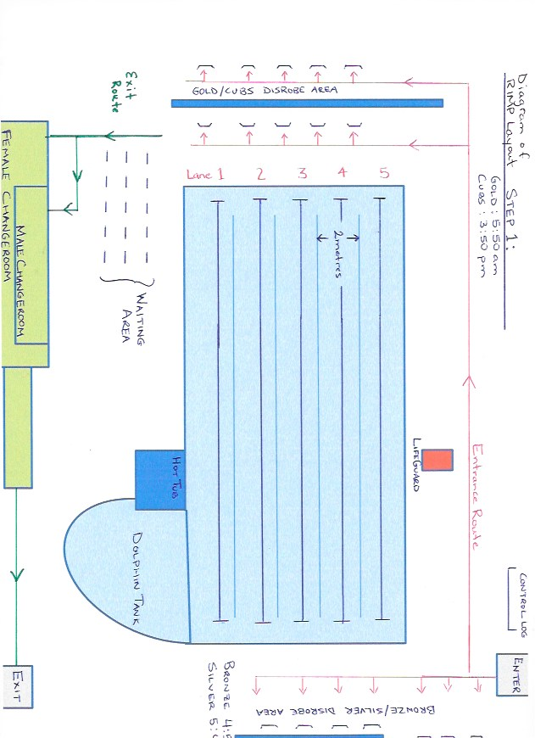
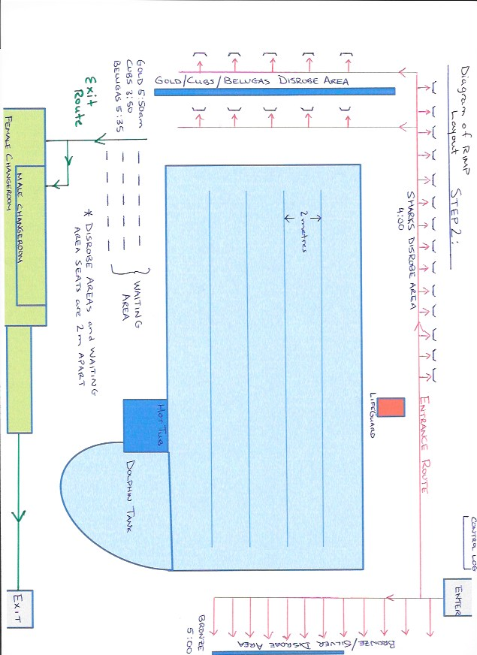
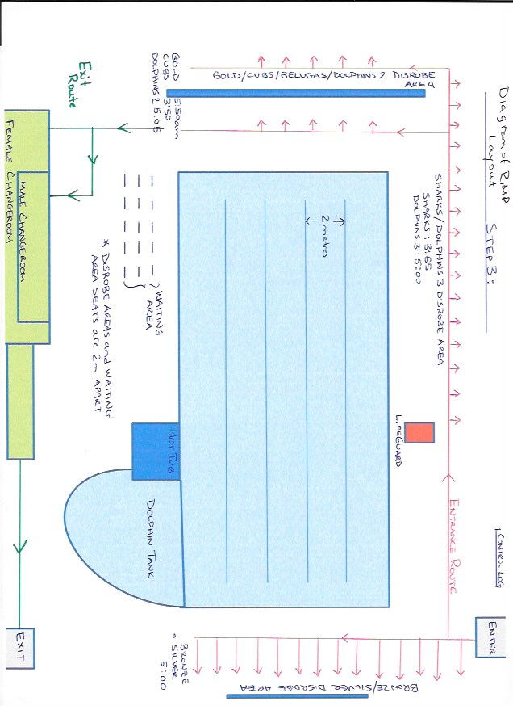
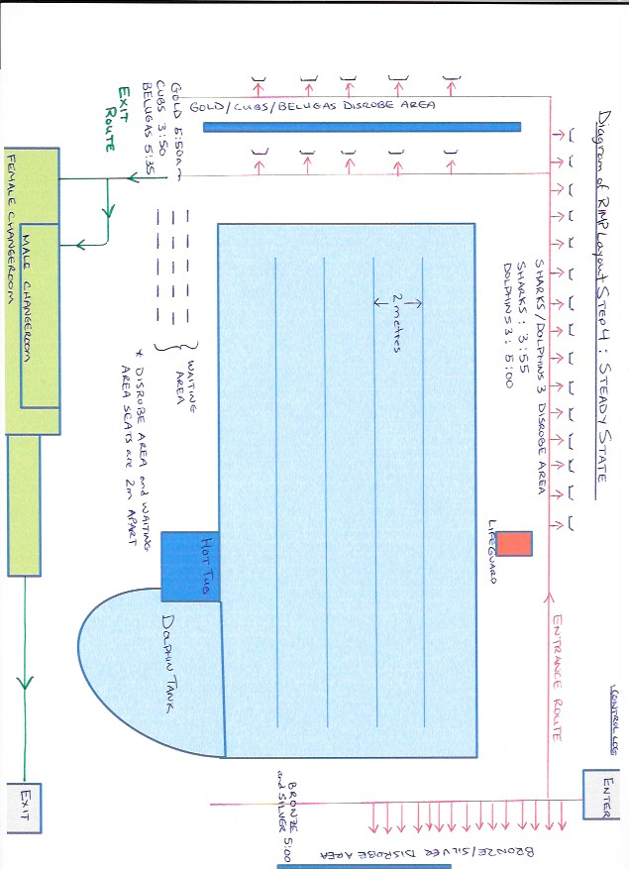

Appendix A - Screening Checklist
If an individual answer yes to any of the questions, they must not be allowed to enter RIMP. Children and youth will need a parent to assist them to complete this screening tool.

1. | Does the person attending the activity, have any of the below symptoms: |  | CIRCLE ONE
 |  | Fever | YES | NO
 |  | Cough | YES | NO
 |  | Shortness of Breath / Difficulty Breathing | YES | NO
 |  | Sore throat | YES | NO
 |  | Chills | YES | NO
 |  | Painful swallowing | YES | NO
 |  | Runny Nose / Nasal Congestion | YES | NO
 |  | Feeling unwell / Fatigued | YES | NO
 |  | Nausea / Vomiting / Diarrhea | YES | NO
 |  | Unexplained loss of appetite | YES | NO
 |  | Loss of sense of taste or smell | YES | NO
 |  | Muscle/ Joint aches | YES | NO
 |  | Headache | YES | NO
 |  | Conjunctivitis | YES | NO
2. | Have you, or anyone in your household, travelled outside of the Northwest Territories in the last 14 days? |  | YES | NO
3. | Have you or members of your household had close contact (face-to-face contact within 2 metres/6 feet) with someone who is ill with cough and/or fever? |  | YES | NO
4. | Have you or anyone in your household been in close contact in the last 14 days with someone who is being investigated or confirmed to be a case of COVID-19? |  | YES | NO

If you have answered “yes” to any of the above questions do not participate. Go home and use the GNWT Self Assessment Tool to determine if testing is recommended.

appendix B - YKPBSC control LOG
All swimmers and coaches must be included in the control log.
The information collected on this document is being collected to assist in the management of the COVID-19 pandemic. This information will be kept in a safe and secure location and will be provided to GNWTHSSA if it is requested for contact tracing services. This log must be provided to Swim Alberta upon request.
YKPBSC will not use this information for any other purpose and will destroy this record after two (2) weeks.
Under Privacy Regulations you have a right to access and correct any information that is held about you.
 | Date:
Full Name |  | Daily Health Monitoring Confirmation  Did you answer ‘no’ to all Health Monitoring questions prior to coming to practice? | Phone | Time-in | Time-out

Appendix C - PERSONAL EQUIPMENT LIST
Laundry Basket for containment
Printed Screening checklist Appendix A
Non-surgical face Mask
Filled Water bottle
Goggles
Swim Cap
Flutter-board
Hand-paddles
Fins

Appendix D - SWIMMER CHECKLIST
Before you Leave Home
☐ Complete the Screening Checklist Appendix A
☐ Eat before you come – no food on premises.
☐ Thoroughly wash your hands with soap and warm water for a minimum of 20 seconds.
☐ Thoroughly wash water bottles with soap and warm water.
☐ Bring laundry basket to contain outdoor clothes, shoes, towel and other possessions.
☐ Bring filled water bottle(s).
☐ Bring thoroughly washed swim equipment in mesh bag. (See Appendix C)
☐ Use the washroom at home.
☐ Bring a non-surgical face mask.
Arrival
☐ Meet at designated location wearing face mask. (Rear door entrance)
☐ Respect physical distancing guidelines.
☐ Register your attendance for contact tracing and provide your screening checklist.
☐ Sanitize hands at provided handwashing stations.
☐ DO NOT share water bottles.
☐ Follow traffic flow signs at your location.
After Swim Practice is Complete
☐ No Loitering
☐ Exit through established exits.
☐ Follow traffic flow signs out of your location.
☐ Respect physical distancing guidelines.
☐ Thoroughly wash clothing and sanitize equipment including water bottles and basket prior to next practice.

Appendix E – COACH CHECKLIST
Use this checklist to help prepare for practice safely.
Before you Leave Home
☐ Complete the Screening Checklist (Appendix A)
☐ Eat before you arrive.
☐ Thoroughly wash your hands with soap and warm water for a minimum of 20 seconds.
☐ Thoroughly wash water bottles with soap and warm water.
☐ Bring thoroughly washed / sanitized equipment (stopwatches, markers etc.)
☐ Use the washroom at home.
Arrival
☐ Set- up established entrances & exits with traffic flow considerations.
☐ Set-up traffic flow signs to your location.
☐ Set-up physical distancing ‘grids’ for participants at entrance and in changerooms.
☐ Respect physical distancing guidelines.
☐ Sanitize hands at provided handwashing stations.
☐ Take attendance for all coaches and swimmers, including confirmation of Screening checklist
☐ DO NOT share water bottles.
☐ DO NOT share personal coaching items. (e.g. stopwatches)
☐ Sanitize all shared equipment between sessions. (dry erase boards.)
☐ Consider wearing PPE (masks, gloves) at all times.
After activity is Complete
☐ Sanitize all shared equipment (blocks) and waiting chairs between group arrivals, if applicable, and at end of day.
☐ Take down established traffic flow signs, entrances & exits, if required.
☐ Respect physical distancing guidelines.
☐ Thoroughly wash water bottles with soap and warm water.
☐ Thoroughly wash equipment (clothing) each day.
☐ Ensure that Head Coach is in receipt of Control Log and Screening Checklists

COVID-19 RESPONSE COORDINATOR ROLES & RESPONSIBILITIES
The roles and responsibilities of the COVID-19 Response Coordinator include:
- Keeping updated on policies and procedures outlined by Territorial and Municipal governments and public health agencies, and monitoring local daily situation reports.
- Keeping updated on policies and procedures outlined by Swim Alberta and NWTHSSA.
- Working with RIMP staff to comply with all public health and facility requirements. Ensuring the Emergency Action Plan is current and complete for RIMP.
- Ensuring a Health & Safety Kit that includes alcohol-based hand sanitizer and Personal Protective Equipment (PPE) is available.
- Communicating with coaches on any training restrictions or recommendations. Implementing an attendance process at every practice to help with communication if a suspected or confirmed case of COVID-19 is reported.
- Ensuring training groups comply with public health agency requirements. Ensuring signage is in place so that all risk mitigation measures are easy to follow.
- Being responsible for responding to COVID-19 concerns. Everyone in the club should know who this person is and how to contact them.
- Being the primary contact for participants to self-report COVID-19 symptoms or exposure and notifying participants of possible exposure to COVID-19 in the instance that an individual with symptoms of COVID-19 attended training. Participants should be asked to stay home and self-monitor for symptoms.
- Modifying, restricting, postponing, or cancelling return to training due to an evolving COVID-19-related outbreak or emergency within YKPBSC or at the RIMP.
- If there is a COVID-19-related outbreak this must be reported to the Swim Alberta COVID-19 Response Coordinator. An outbreak is defined as 2 or more cases of COVID-19 diagnosed within a training group within a 14-day period.

The YKPBSC COVID-19 Response Coordinator is Carol Lockhart : (867) 445-1476
The Swim Alberta COVID-19 Response Coordinator is Kevin Dennis. kevin@swimalberta.ca

