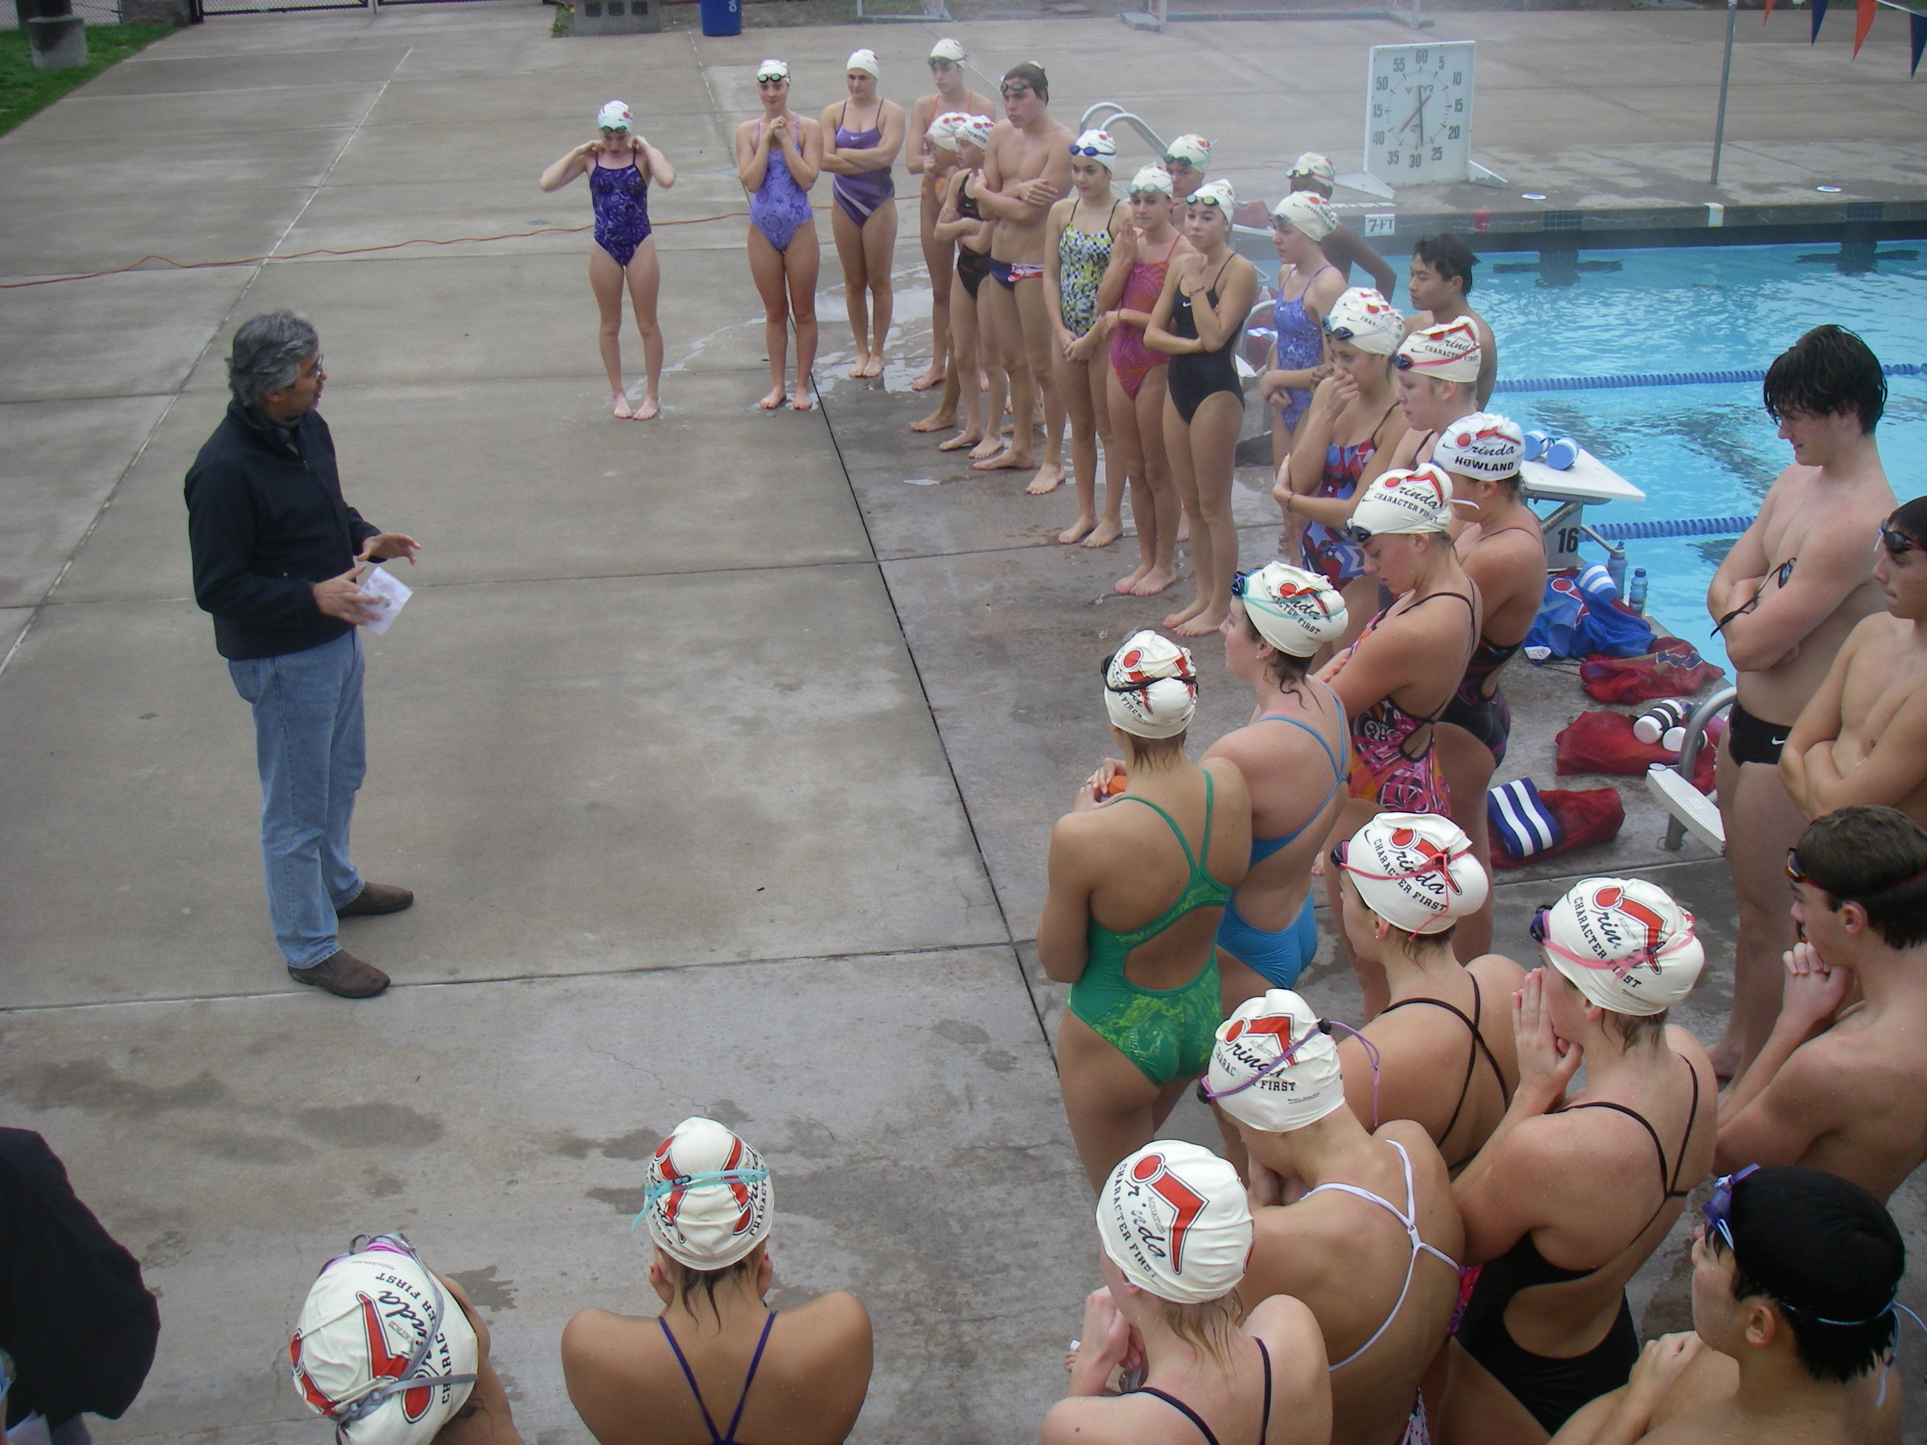
A Letter to the Senior Group from Donnie & Ronnie

Following possibly the strongest year of swimming development in the team’s history, Ronnie and I wanted to give an update on the team’s progress and standing, as well as talk about the extraordinary group that we are privileged to work with.

“The Big Picture”

As time and years go on, we become more convinced that what can and should be gained from sports, is truly invaluable and can be life-changing. For the countless hours committed, the physical, emotional, and financial commitment, and the sacrifices made, there has to be more than a time at the end of this process. Every time we see a youth sports team, from t-ball to collegiate athletics, we wonder what will be the real reward from all of this. After thirty years, we have no doubt that sports does have the ability to effect extraordinarily positive changes in an athlete’s life. From a general youth perspective, you can walk through any mall, high school campus, or pool deck for that matter and see foundations of character and integrity slipping away. In swimming, we see too many careers unravel from overzealous parents and kids obsessed with times or ego. Both miss the big picture and they ultimately lose out in the broader areas of personal development and team environment. Energy and effort seems to flow into areas that actually break down a career rather than support its longevity. We see this all too often in rec swimming with the emotional overload and even in USA swimming with training overload. Parents ask their kids who they beat in practice rather than who they helped in practice and seem to care more about their kid’s time and place rather than their effort and attitude. There was an article in a national newspaper recently about the fundamentals in AAU (youth) basketball disintegrating due to the drive to be a “star.” And one of the main reasons cited was the NBA, the pinnacle of basketball. No one wants to be a character role model, let alone fundamentally sound. The process is getting lost and with it, so are the virtues of team commitment, work ethic, sacrifice, and on and on. Regarding respect and discipline, we talk to coaches regularly about how they are “losing the battle” with kids. The pull of apathy, self-indulgement, drugs, alcohol, insecurity, and bravado seem to trump integrity, service, humility, and discipline. Too many sports teams are dominated by ego over humility, selfishness over selflessness, disrespect over respect, and doing the minimum rather than embracing work ethic. It is not simply that there are a few problematic athletes on a team, but rather there may only be a few true character leaders, which brings us to your children and our team.
Our Mission as Coaches
We would first though, like to reiterate our mission, philosophy, and intent, with regard to Orinda Aquatics, our coaching careers, and what we want to be doing with our lives. It is our intention and desire to be more than coaches, but rather partners with our swimmers on their athletic journey, and to a greater extent, partners on their life journey. Our ultimate goal is that four or eight years from now they are swimming at their very best, loving the sport, are leaders on their team, and are better people. And there is no one meet on that path that will define it more than the process reflected in the quote below, “it is produced in the great manufacture of daily duty.” We have always wanted this team and the environment to be different and to stand apart from the norm. The best and first way to achieve this is to care “intensely” about people and their well-being first and swimming second. We do not and have never viewed our relationship or support ending when practice ends or when we leave a meet. It is the least we can do for their commitment to swimming, to Orinda Aquatics, and to us. In short, your children have our unconditional support in the pool and out.
“Prepare the child for the path, not the path for the child.”

Our Team

We would like to attempt to describe the team environment and try to do justice to this group. This has been unequivocally the greatest “character group” we have seen in thirty years. It may sound redundant as we praise them often, but we really do believe that this group sets a standard that is unmatched by any high school athletic group in the country. As we see teen trends drift in troubling directions, this group is doing the opposite. Our swimmers, your children, demonstrate not some of the qualities, but all of the qualities you would hope to find in the finest person, let alone athlete.

They possess humility rarely seen in young adults, or actually anyone. It is humility almost to a fault, and to a person. Whether new to the group, a four-year veteran, a beginning swimmer or a national qualifier, there is no self-promotion, no spotlight, no ego. Attention and praise is always deflected. On too many teams one can tell the success of a swimmer by the way in which they carry themselves. On Orinda Aquatics, it almost seems to be a race to be the most humble as apposed to being the most celebrated.

As kids today are challenged with academicpressure, social pressure, and athletic demands, your children find balance, find a way to make it work, and succeed. They respect academics and embrace it as a foundation of their life. They are the community example, if not the national example of the quintessential student/athlete. While many can excel in one area, few can have the self-discipline to set an alarm at 4:45 in the morning, take pool covers off in the wind and rain, push themselves physically and emotionally every day (of the year), sacrifice countless opportunities, and simultaneously commit to the highest academic standards. It takes a special person to be a great student, a great athlete, and a great person in this day and yes, in this community.

Additionally, they could not be more respectful, helpful, supportive, and sincere. How many coaches, teachers, administrators, could walk away from fifty teenagers with complete confidence that there would be no drop-off in activity, effort, or focus, and that the thought of doing less would not enter anyone’s mind? How many coaches can have a fifty meter pool set up for every workout without ever asking anyone to do anything? There is never a “why me” or a “do I have to” attitude. It is incredibly refreshing and a great source of pride to see even the least glamorous parts of swimming treated with such respect, and with a positive attitude. How many coaches can take forty athletes (of any sport) on a four day travel trip and have absolute assurance that their behavior would be impeccable - from everyone? Our team continues to rebuff the notion that kids need to be chaperoned. To the contrary, mature, caring, respectful, young adults do not. Oversight is always a character issue and not an age issue. They clearly prove that. Whether it is an activity at the pool or a cross-country trip, their character does not change and neither does the respect or behavior. We honestly feel sorry for teams, coaches, and parents that do not get to experience this. Most teams look for “leaders” or high character kids with a team captain-like mentality, that special one or two that might improve the environment and make the team better. College coaches want “good, positive, kids”. That is our team. Not one, two, or five, but fifty.

A freshman boy climbs out of the pool asking to talk after he struggles through a hard set. Rather than making an excuse or complain because the interval or set was too hard, he apologizes for not doing better and vows to do better next time. A swimmer gives up a relay spot at a championship meet because he is “not at his best” and the relay goes on to win (and he had the fastest time of any swimmer in consideration). A swimmer, who when asked if she wanted to swim in college, replies, “I could not imagine my life without swimming,” swimmers stand in the wind and rain for a “meeting” during workout without complaining, swimmers persevere through injury – with a positive attitude, seniors fix broken lanes lines, and swimmers thank us everyday for the practice. And the random acts of kindness and respect are too numerous to mention. They are daily occurrences. As an example of self-discipline, earlier this season Ronnie could not be at a few workouts due to a conflict. I asked if he needed me to oversee his group. He said they would be fine and he would email them the workout. I watched in awe everyday at their focus, maturity, and punishing work ethic as they painstakingly went through every detail of the workout, with no “supervision”.

And this group rebuffs more myths than teen supervision. In a rec dominated community which that is sure that year-round swimming will only lead to “burn-out” and deficient academics, they again prove the opposite - that by doing something positive that you enjoy can actually be a good thing, and that strength in academics is really more about self-discipline than free time.

Another very unique characteristic on this team is the extraordinary maturity of our freshman (and eighth grade) group. They clearly swam incredibly well in league meets and North Coast , but more significantly they have demonstrated poise, respect, and sincerity that usually takes years to develop. Our freshmen could be team captains on any high school team. It is a testament to their character but also to the steady and uncompromising leadership of our upperclassmen. While it is common to haze, “initiate”, delegate to, or keep freshman on a lower level, our team and our seniors see everyone as an equal, and see the value in creating our future (leaders) today.
The drug and alcohol epidemic or crisis is not going to change or mitigate without inspirational young adults making an intelligent and conscious choice for a better, healthier, and more productive way of life. They are our hope. Your children represent much more than swimming. Regarding “life lessons”, they are life lessons and will be life’s leaders. They are inspirational stories, individually and collectively. While they will be successful, it will be their humility, character, and work ethic that drive their lives and impact others. We thank them for putting “character (and the team) first” and thank you for sharing them with us and allowing them to represent this team as the pinnacle of youth sports and young adults. And we want to thank you again for your support and hope that you share in the pride of this great organization.

Donnie & Ronnie

