Orinda Aquatics at its Very Best!
Clovis 2015 – Senior Travel Trip

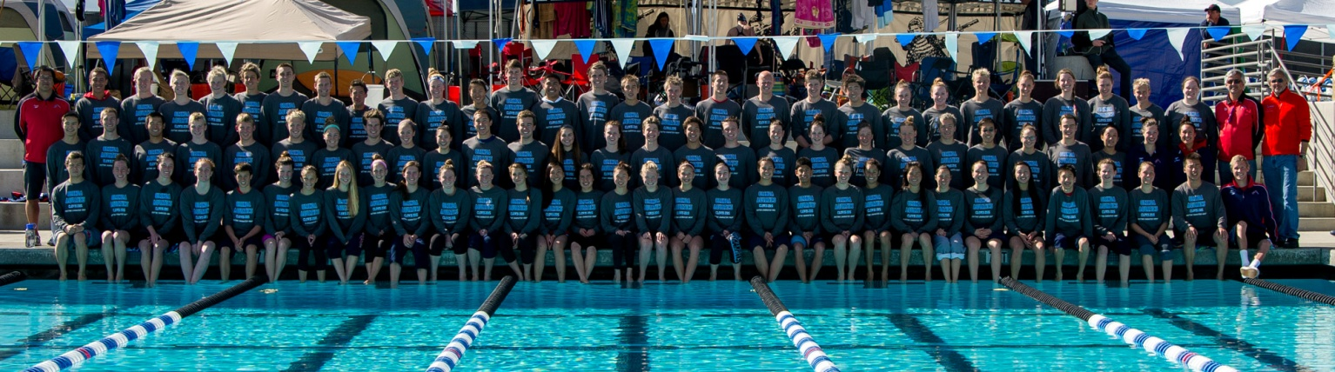
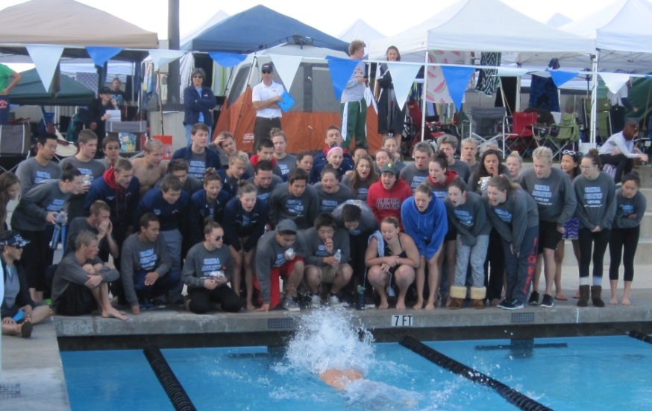

“No one has yet fully realized the wealth of sympathy, kindness and generosity hidden in the soul of a child. The effort of every true education should be to unlock that treasure.” Emma Goldman

Stat recap
- 91 swimmers/teenagers – most in team history
- 2 charter buses
- Over 30 first-time travelers
- 3 coaches
- 0 chaperones/0 bed checks
- 0 swimmers late for any departure
- 0 problems
- A “K” relay! (that’s 48 girls into 12 relays!) – maybe a national record!
- Nearly 400 best times!
- Nearly 1,000 points scored to win the meet
- Over 30 hotel rooms (on four floors)
- Over 600 meals (lunches and dinners) organized and served over 4 days
- 1 amazing team

OA we go!
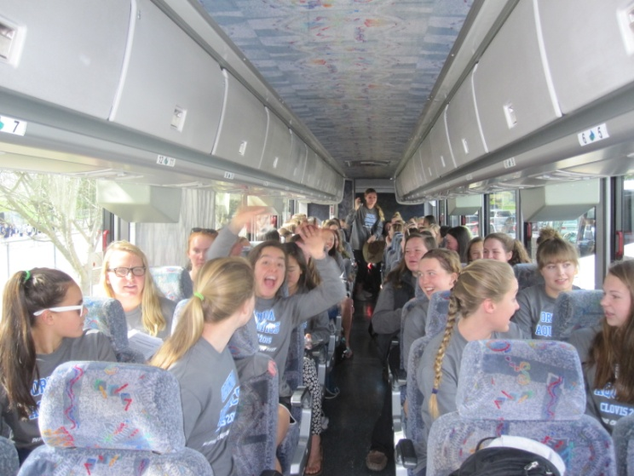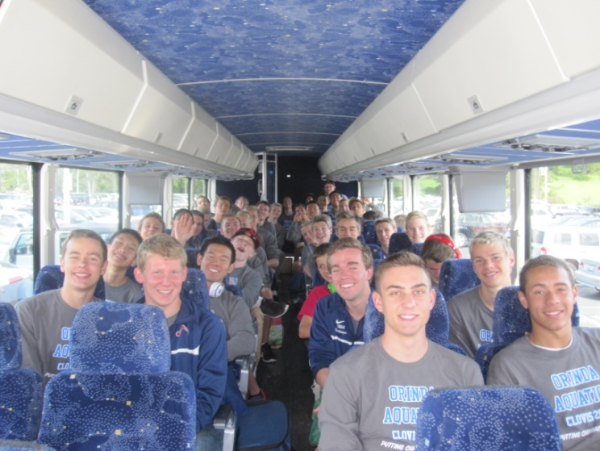

The following is a random email from a USA Swimming coach that reveals why this travel process is so significant:

Hi Coach Don & Ron,
Of all the talks you and Ron have given, I hope one point that people hear (I hope I got this correct) is that you do not need chaperones, not in the traditional sense anyway. Amen brother. Your culture and the expectation that it affords at "OA" of not needing chaperones (dorm police, baby sitters etc.) is spot on. We should all aspire to that. But it does not start at the competition. It is, as you teach, an outflow of the ongoing, clear, unwavering, nurturing of ideals and practices that make for a SAFE and TEAM focused environment. Who and where does anyone get the idea that rowdy acts or vandalism is cool or acceptable? As I read more about poor judgment in teams or on campuses, I am bewildered where the teaching is and reminded how much I respect what you all do at OA. I am sure it is not easy but I also do not think it is that complicated either - set a tone, teach a standard, and nurture belief and confidence that gets buy-in, so everyone can enjoy, and be proud of an incredible culture. Respectfully, AK

I was talking to one of the swimmers a few weeks ago and she mentioned that a new swimmer on the team was very excited about the upcoming Clovis trip. I thought a little about it, and while I was encouraged to hear that, I was a little surprised. It is in fact, a swim meet, and in this case, a swim meet in less than ideal weather, and we do nothing in terms of activities. Of the fifty plus waking hours in Clovis, only about six are not “meet” related. There is virtually no downtime or free time. And yet, kids come back talking about what a great experience it was. To most people, spending fifty hours at or around a swim meet in poor weather would not be considered “a great experience”. Yet for these kids, it is. And the reason is not watching hundreds of heats. It is in being with an extraordinary peer group, in a positive, caring culture, and being a part of a great swimming and team effort. And the critical piece in all of this is leadership and integrity, and the pursuit of a perpetual leadership model where upperclassmen are impeccable role models and younger swimmers aspire to that role in the future.
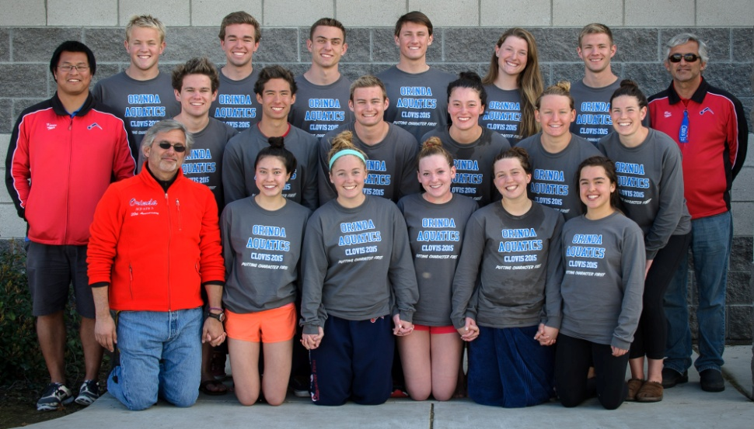
Leadership (OA Senior Class) at its Best
Overview

Imagine being a nervous freshman sharing a hotel room with a senior in high school who is sincerely interested in who you are as person and as an athlete and is unduly committed to being a mentor and role model to you. Imagine being on your first travel trip, swimming a time trial race at the end of the meet and having 40 swimmers at the end of the pool cheering for you – that is 40 at EACH end! Imagine being the youngest in a hotel room with a queen bed and a pull-out couch and having the room captain tell you that you have the queen bed. Imagine wondering whose job it is to clean up a team area occupied by ninety swimmers, or to load the tents and coolers on the bus, only to see the captains and seniors proactively taking care of it. This is leadership.
“The purpose of leaders is to produce more leaders.”

After the trip we ask the kids a few questions: who did you get to know (well)? And who did you reach out to? And the answers are always heartwarming and reveal one of the core reasons for the trip – to integrate three training groups, swimmers of different ages, swimmers from twelve different high schools, and swimmers from a national level with those have recently joined the team, all to create a people-first mindset and culture. An example of this is the “Secret Clovis Buddy” arrangement set up by the captains where each swimmer is randomly assigned someone to secretly support prior to and during the trip. Support included a rap song in front of the group and a locker room lined with posters of encouragement.

“Our duty is not to see through one another but to see one another through.”

While we may have tested the limits on capacity, we were far from it on behavior. What these kids (young adults) did would be unheard of in today’s society, and challenge all conventional “wisdom”. In our meeting with the kids prior to the trip, we told them that few teams in the country, if any, would even entertain this – a coach run/managed trip with ninety plus teenagers and no chaperones (and no bed checks). In a sense, our objective, beyond swimming well, is to show that this can be done and to prove that a large group of teenagers traveling is not a recipe for disaster and does not even have to be a challenge, but can be, dare we say, highly enjoyable. And it does not matter whether you have one or ninety, “bad kids” will do bad things and chaperones only empower their will. Respect, accountability, and purpose have empowered this team to embody real leadership and absolute integrity, and that does not need supervision. We hope that in some way this may inspire other clubs to cultivate such behavior and travel standards and create accountability with athletes. With all that is going on around us and in society in general, these young adults are a beacon of light and hope for youth and sports.

“Integrity has no need of rules.”

We have attended the Clovis Swim Club/Juanita Allington Senior Championship for several years. This is the largest group we have taken to date, and it may very well be the best. The kids were near perfect in every way: punctuality, attitude, support, attire, respect, behavior, not to mention swimming. They were painfully humble and supportive of everyone. They bussed tables, cleaned up the team area, offered to help with...everything, thanked the bus drivers (ninety times each trip), and supported their teammates like no other. It may sound like a cliché to say that it is a privilege and a pleasure to coach them, but it is.

A large part of what makes the trip work is structure and expectations. Ronnie does a tremendous amount of work in preparing the trip well in advance: buses, vans, hotel, entries, t-shirts, and countless spreadsheets. Over ninety swimmers are placed strategically in buses, and they are assigned rooms with a room captain at the hotel. But as mentioned in the earlier email, the real work and oversight has been done years in advance by OA swimmers, leaders, and mentors who made a decision to ground their life, their behavior, and their travel in maturity, leadership, integrity, and team, and not in self and team-destructive behavior.

During the trip, we leave each morning at 7:15 and with seating assignments and room captains, swimmer count is easy. We arrive at the pool, do a team stretch, warm-up, have a meeting, swim trials which run from 9:00 to approximately 1:00, swim time trials, have lunch (which was made to order and brought to the meet by our parents), head back to the hotel at about 2:00 with about two hours to rest (in rooms or in the lobby), and then we head back to the pool at about 4:00. At finals, kids either race or cheer (they must always be team-committed). We all swim (a lot of) relays, and arrive back at the hotel at about 8:00 for a catered dinner, a detailed meeting, a meet recap, and bed. If kids need to leave their room for any reason, they must call us. Room captains are accountable for everyone and everything. Team attire is mandatory (meet shirt in the morning and red shirt the evening). Another key to a successful meet is support. We are fortunate to have kids that care about the team and want to be a part of the process. Sophie Catalanello could not compete but assisted the coaches and the swimmers throughout the trip. We are very appreciative that she could join us, and thankful for her help.

Thank you!
We would like to sincerely thank Beth Campbell and Carol Therien for their extraordinary support with meals, snacks and water at the hotel and at the meet. They organized and transported three made-to-order lunches for 96, and organized all team dinners. Their efforts, and the parents who assisted in this process, were monumental in allowing this trip to flow and work efficiently. We also want to thank Michael Wright for creating and editing an inspiring video recap of the trip, and Katie Nagle and Will Gittings for the great footage. Also, thank you to Les Hata and Bob Ashby for the incredible photos. And finally, thank you to you, the parents, for supporting your children to be students-athletes, for allowing them to travel with us, and for creating such incredible representatives of this team.

Acknowledgements:
- Parents (and kids) who came down mid-trip to be with the team
- Swimmers who swam through illness (and never complained)
- Swimmers who have come back from extended periods of “PT”, demonstrating patience and fortitude
- Audrey Chang – while “unattached” was able to attach herself to every relay through cheering
- Great captain leadership, both on the deck and in the pool: Collin English, Lucy Faust, Claire Therien, Katie Erickson, Ryan Birdsall, Ryan Shaw, Jolen Griffin, Mary Ashby, and Matt Lennon
- And the 34 first-time travelers who fully embraced everything the team stands for, and will without question continue the leadership tradition

The Performance Side: USA Swimming’s Virtual Club Championships Update
On a somewhat related note, we would like to mention the team’s performance in the USA Swimming Virtual Club Championships. USA Swimming calculates daily the performance of every USA Swimming team (nearly 3,000) in ages 11-18, for all events in all events, assigning points for each time. Our performance in Clovis increased our score by over 12,000 points to 217,700, an all-time high for Orinda Aquatics and places us at 37th in the United States, 11th in the western United States, 8th in California, 3rd in Pacific Swimming, and most likely the top team in our size range (teams under 200 members) nationally. This is a true measure of team performance and one that we should all be proud of. It also serves the notion that you can have both performance and culture. Thank you again and congratulations to everyone.

Sincerely, Donnie, Ronnie, & Kevin
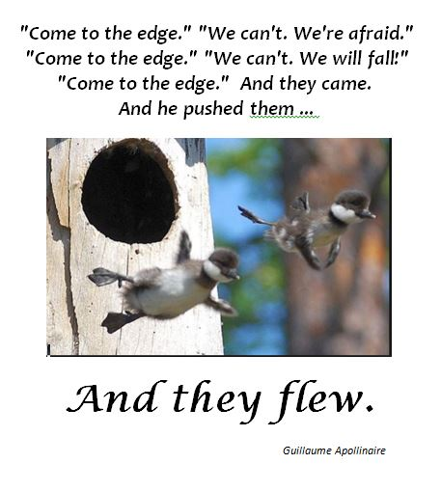
The edge of humility, compassion, integrity, and leadership

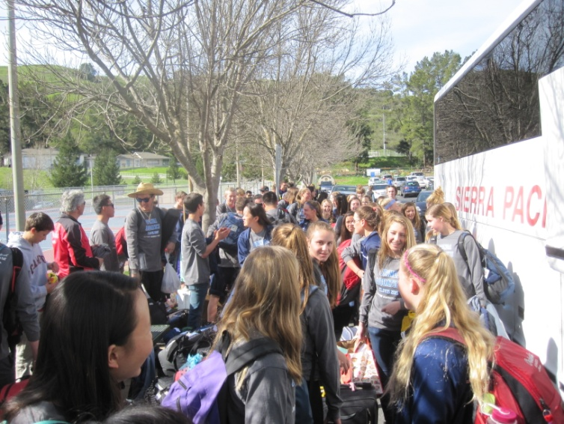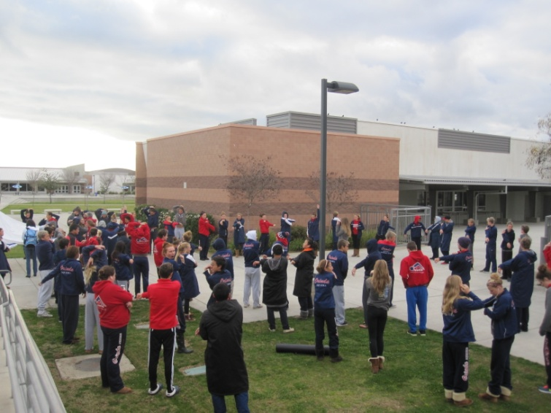
Loading up Stretching
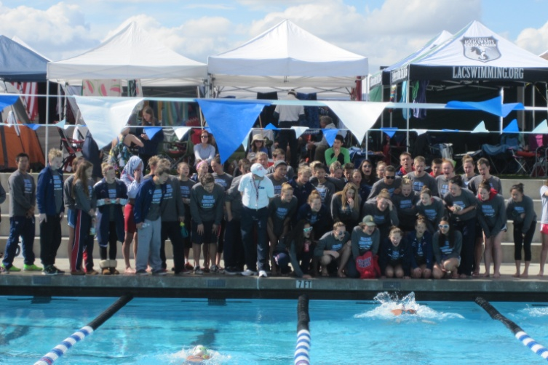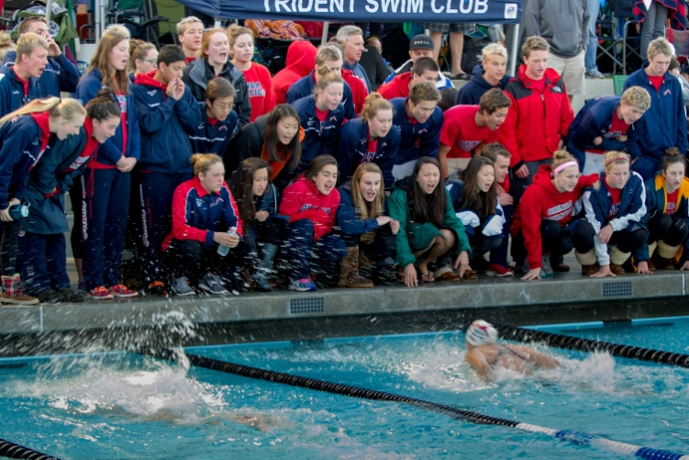
Cheering AM (gray) Cheering PM (red)
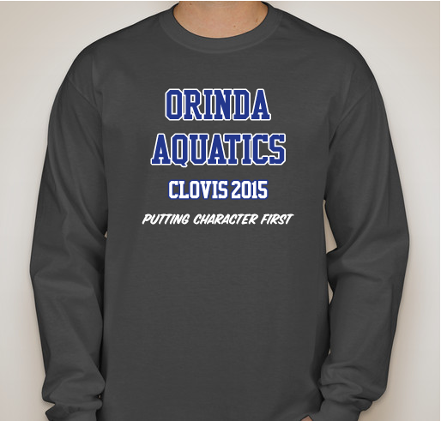
T-shirt front T-shirt back

Critical Elements of an Extraordinary Culture
(given to kids prior to trip)

Build Leadership
Every team and athlete must know that the younger members are future leaders and role models. Therefore, from day one, swimmers are made aware of the standards and responsibilities and what is expected of them now and in the future. Hazing or “tradition” as it is euphemistically put, that makes people feel less or inferior is not tolerated in any form and has no place in building young leaders. If we want extraordinary and inspirational leaders in the future, they must see that play out in front of them and aspire to be that. Through swimmers (captains, seniors, and anyone of influence), and coaches, young athletes must see role models and leaders. They must see a demonstration of work ethic, integrity, and a resiliency that inspires. We must develop in young athletes, the “uncommon professional”, and an understanding of the moral foundation that drives the culture, the day to day operations, and the success of the program.

Travel Lightly - “Integrity has no need of rules.” Albert Camus
That is, travel with the absence of attitude, ego, or indiscretion. Our travel policy is very simple. If you need to be watched (or babysat), you need another team. We fully expect that our swimmers carry themselves as mature, dedicated athletes (and individuals) on a “business” trip. They owe this to the rest of the team, the culture that defines us, and their parents who pay and support them. We would even say that neutral behavior is not acceptable. They must add value. And if they can’t do that, not only should they not be on the team, they really have no business being an athlete.

The Team Concept
The team concept is a life concept and there is no better place to learn it than in an athletic setting. “Team” is family, friends, students, co-workers, community, and on and on. It is co-existing and co-producing. The ability to be a good team person or a leader can be developed in the pool, at a meet, and the locker room every day. It requires empathy, sacrifice, and an unconditional commitment to a greater cause. This ability and understanding will serve athletes long after their careers have ended.

Team Attire
Team attire is and should be a statement of pride and not a policy in and of itself. Your team attire is your representation of the team. We believe there is a correlation between one’s commitment to wear team attire and one’s general feeling about the team. Our swimmers do not compete in a meet or travel with the team if they are not in team attire. It is not about the clothes, or the rule, it is about what statement they are making with their appearance.

