Orinda Aquatics at its Very Best!
Clovis/Sectionals 2017
Two Trips – 100 Swimmers (75/25)
Extraordinary success in the pool and on the deck
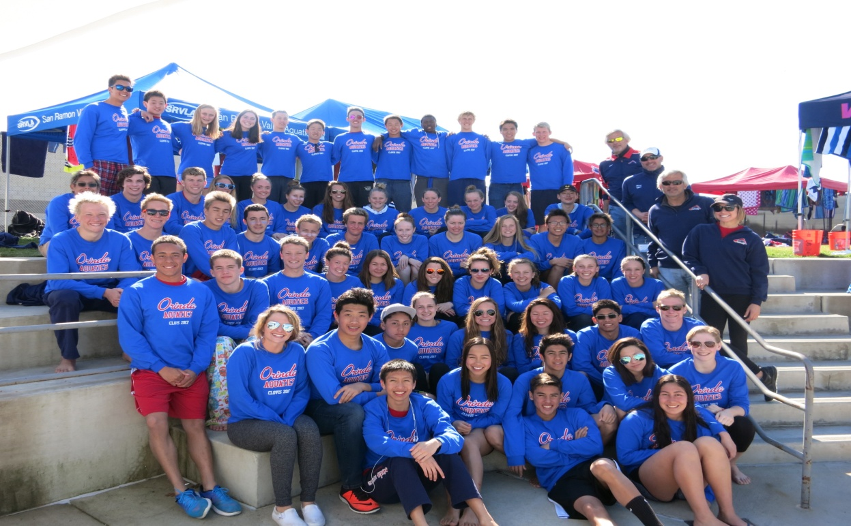
“No one has yet fully realized the wealth of sympathy, kindness and generosity hidden in the soul of a child. The effort of every true education should be to unlock that treasure.” Emma Goldman

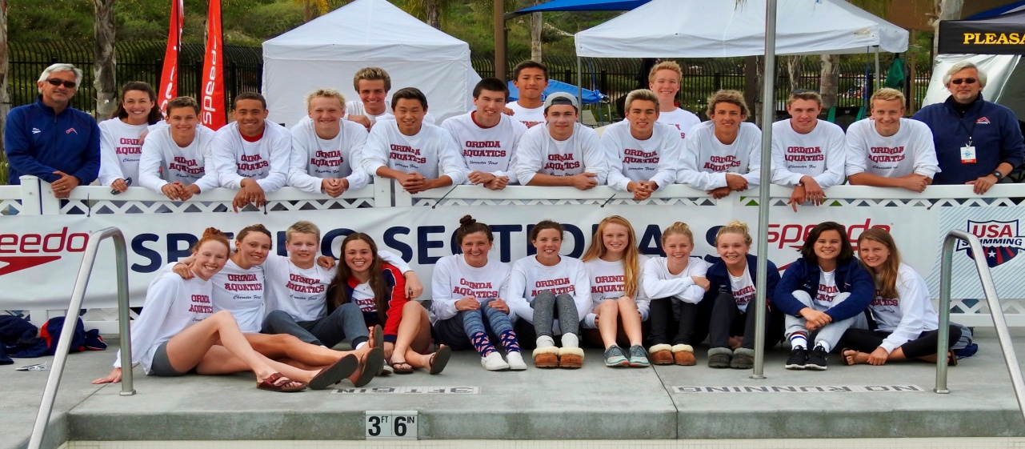
Please see attached performance report

With the recent Clovis and Sectional trips, Orinda Aquatics did what our team has been known to do so well, travel with a (very) large group with unparalleled organization, discipline, respect, support, spirit, and commeraderie, and of course, great swimming. Clovis was very impressive across all groups, and the Sectional meet was one of the most successful swimming displays we have seen in the past five years, setting the stage for a strong national presence in the coming years.

Quick Recap
- Two trips
- 100 swimmers (teenagers) – all coach-run and managed
- One charter bus, five vans, and twenty eight plane flights
- Over 35 first-time travelers
- 4 coaches
- 0 chaperones/0 bed checks
- 0 swimmers late for any departure
- 0 problems / 0 issues
- Over 400 best times!
- 9 new futures qualifiers/5 Sectional qualifiers
- OA finished second to host Clovis and eighth at Sectionals
- #1 presence on the deck (by far), in both meets

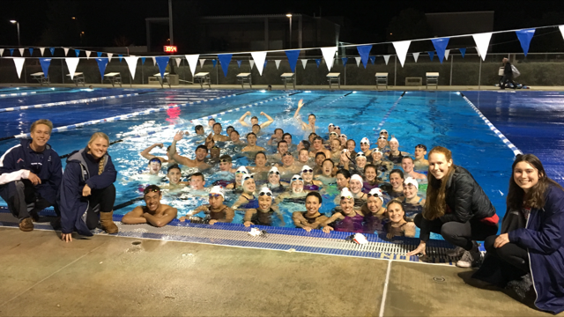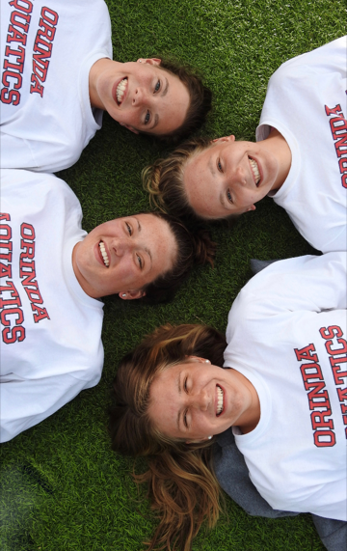
Aren’t they supposed to be warming down? Always looking up!

The following is an email (reprint) from a USA Swimming coach that reveals why this travel process is so significant:

Hi Coach Don & Ron,
Of all the talks you have given, I hope one point that people hear (I hope I got this correct) is that you do not need chaperones, not in the traditional sense anyway. Amen brother. Your culture and the expectation that it affords at "OA" of not needing chaperones (dorm police, baby sitters etc.) is spot on. We should all aspire to that. But it does not start at the competition. It is, as you teach, an outflow of the ongoing, clear, unwavering, nurturing of ideals and practices that make for a SAFE and TEAM-focused environment. How does anyone get the idea that rowdy acts or vandalism is cool or acceptable? As I read more about poor judgment in teams or on campuses, I am bewildered where the teaching is and am reminded how much I respect what you all do at OA. I am sure it is not easy but I also do not think it is that complicated either - set a tone, teach a standard, and nurture belief and confidence that gets buy-in, so everyone can enjoy, and be proud of an incredible culture.
Respectfully, Allan

Overview

Imagine being a nervous freshman sharing a hotel room with a senior in high school who is sincerely interested in who you are as person and as an athlete and is unduly committed to being a mentor and role model to you. Imagine being on your first travel trip, swimming a time trial race at the end of the meet and having fifty swimmers at the end of the pool cheering for you! Imagine being the youngest in a hotel room with a queen bed and a pull-out couch and having the room captain tell you that you have the queen bed. Imagine wondering whose job it is to clean up a team area occupied by 75 swimmers, or to load the tents and coolers on the bus, only to see the seniors proactively taking care of it. This is leadership.

“The purpose of leaders is to produce more leaders.” Ralph Nader

After the trip we ask the kids a few questions: who did you get to know (well)? And who did you reach out to? How did you support the team process (add value)? And the answers are always heartwarming and reveal one of the core reasons for the trip – to integrate four training groups, swimmers of different ages, swimmers from twelve different high schools, and swimmers from a national level with those have recently joined the team, all to create a people-first, team-first mindset and culture. An example of this is the “Secret Clovis Buddy” arrangement set up by the coaches where each swimmer is randomly assigned someone to secretly support prior to and during the trip.

“Our duty is not to see through one another but to see one another through.” Amish Proverb

What these kids (young adults) did would be unheard of in today’s society, and challenge all conventional “wisdom”. In our meeting with the kids prior to the trip, we told them that few teams in the country, if any, would even entertain this – a coach run/managed trip with over seventy-five teenagers and no chaperones (and no bed checks). In a sense, our objective, beyond swimming well, is to show that this can be done and to prove that a large group of unchaperoned teenagers traveling is not a recipe for disaster and does not even have to be a challenge, but can be, dare we say, highly enjoyable. And it does not matter whether you have one or one hundred, “bad kids” will do bad things and chaperones only empower their will. Respect, accountability, and purpose have empowered this team to embody real leadership and absolute integrity, and that does not need supervision. We hope that in some way this may inspire other clubs to cultivate such behavior and travel standards and create accountability with athletes. With all that is going on around us and in society in general, these young adults are a beacon of light and hope for youth and sports.

“Integrity has no need of rules.” Albert Camus

We have attended the Clovis Swim Club/Juanita Allington Senior Championship for several years. This is one of the largest groups we have taken, and it may very well be the best. The kids were near perfect in every way: punctuality, attitude, support, attire, respect, behavior, not to mention swimming. They were painfully humble and supportive of everyone. They bussed tables, cleaned up the team area, offered to help with... everything, thanked Rich the bus driver (75 times each trip), and supported their teammates like no other. It may sound like a cliché to say that it is a privilege and a pleasure to coach them, but it is. PS: Rich (the bus driver) said it was the most well-behaved youth group he has every driven.

A large part of what makes the trip work is structure and expectations. Ronnie does a tremendous amount of work in preparing the trip well in advance: buses, vans, hotel, entries, t-shirts, and countless spreadsheets. Over 75 swimmers are organized in a bus and 2 vans, and they are assigned rooms with a room captain at the hotel. But as mentioned earlier, the real work and oversight has been done years in advance by OA swimmers, leaders, and mentors who made a decision to ground their life, their behavior, and their travel in maturity, leadership, integrity, and team; and not in self and team-destructive behavior.

“To lead people, walk behind them.” Lao Tzu

During the trip, we leave each morning at 7:10 and with bus seating assignments and room captain checks, the swimmer count is done in about thirty seconds. We arrive at the pool, do a team stretch, warm-up, have a meeting, swim trials which run from 9:00 to approximately 12:00, swim time trials, have lunch (which was pre-ordered and brought to the meet by Mrs. Griffin), head back to the hotel at about 2:00 with about two hours to rest (in rooms or in the lobby), and then we head back to the pool at about 4:00. At finals, kids either race or cheer (they must always be team-committed). We swim a lot of relays (“J”), and arrive back at the hotel at about 8:30 for a catered dinner, a detailed meeting, a meet recap, and bed. If kids need to leave their room for any reason, they must call us. Room captains are accountable for everyone and everything. Team attire is mandatory (meet shirt in the morning and red shirt the evening). Another key to a successful meet is support. We are fortunate to have kids that care about the team and want to be a part of the process. Simone Ostler could not compete but volunteered to come on the trip and assist the coaches and the swimmers throughout the trip. We are very appreciative that she could join us, and thankful for her help (and for holding everything together!)

Acknowledgements/notables
- Sectional swimmers who came down mid-trip to be with the team
- Jolen for creating the meet shirt (both)
- Stephanie Griffin for facilitating all of the Clovis lunches and dinners
- Simone Ostler for her support of the team and the staff
- Contest winners!
- Those who lead the way cheering – Miya Drain and James Chen, and on and on!
- Lydia Percin for the team pop-up and the photographs at Sectionals
- Kat Cane and Tay Thomas for putting together memorable Clovis videos
- Jill Jones for her inspiring “player-coach” performances!
- Matt Armanini for bringing his tremendous passion and commitment to the kids and the team
- Ronnie for the countless hours of preparation (bus, hotel, entries, spreadsheets, handouts, etc., etc.)
- Our athletes for the way they carry themselves on travel trips and the standards they set

Critical Elements of an Extraordinary Culture
(given to kids prior to trip)
Build Leadership
Every team and athlete must know that the younger members are future leaders and role models. Therefore, from day one, swimmers are made aware of the standards and responsibilities and what is expected of them now and in the future. Hazing or “tradition” as it is euphemistically put, that makes people feel less or inferior is not tolerated in any form and has no place in building young leaders. If we want extraordinary and inspirational leaders in the future, they must see that play out in front of them and aspire to be that. Through swimmers (captains, seniors, and anyone of influence), and coaches, young athletes must see role models and leaders. They must see a demonstration of work ethic, integrity, and a resiliency that inspires. We must develop in young athletes, the “uncommon professional”, and an understanding of the moral foundation that drives the culture, the day to day operations, and the success of the program.

Travel Lightly
That is, travel with the absence of attitude, ego, or indiscretion. Our travel policy is very simple. If you need to be watched (or babysat), you need another team. We fully expect that our swimmers carry themselves as mature, dedicated athletes (and individuals) on a “business” trip. They owe this to the rest of the team, the culture that defines us, and their parents who pay and support them. We would even say that neutral behavior is not acceptable. They must add value. And if they can’t do that, not only should they not be on the team, they really have no business being an athlete.

The Team Concept
The team concept is a life concept and there is no better place to learn it than in an athletic setting. “Team” is family, friends, students, co-workers, community, and on and on. It is co-existing and co-producing. The ability to be a good team person or a leader can be developed in the pool, at a meet, and the locker room every day. It requires empathy, sacrifice, and an unconditional commitment to a greater cause. This ability and understanding will serve athletes long after their careers have ended.

Team Attire
Team attire is and should be a statement of pride and not a policy in and of itself. Your team attire is your representation of the team. We believe there is a correlation between one’s commitment to wear team attire and one’s general feeling about the team. Our swimmers do not compete in a meet or travel with the team if they are not in team attire. It is not about the clothes, or the rule, it is about what statement they are making with their appearance.

Please look for the Clovis videos!

